🖎 Marked Questions may have for Revision Questions.

OBJECTIVE QUESTIONS
OBJECTIVE QUESTIONS

Section (A) : Equilibrium and its properties

A-1. In a reaction A + B  C + D the rate constant of forward reaction & backward reaction is k₁ and k₂ then the equilibrium constant (k) for reaction is expressed as –
(1) K_{C} =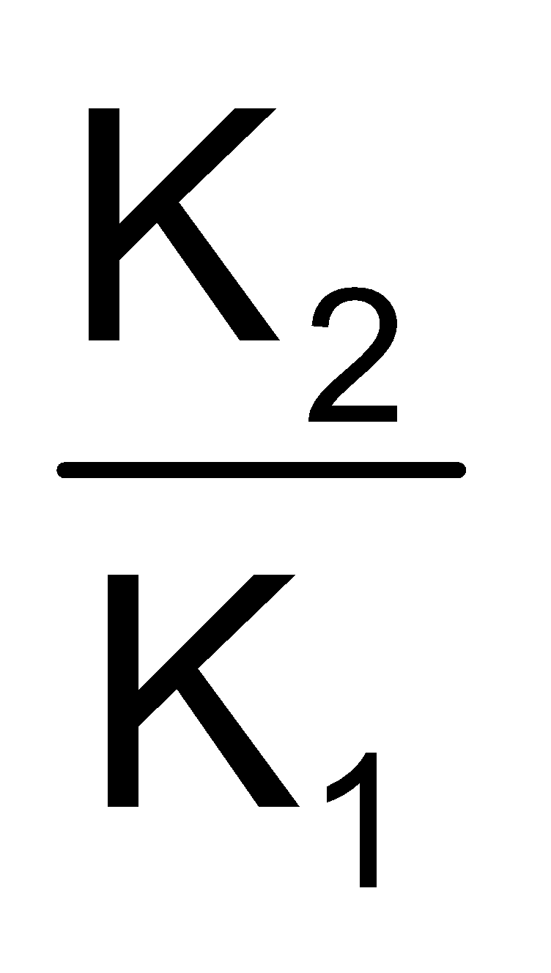 (2*) K_{C} = 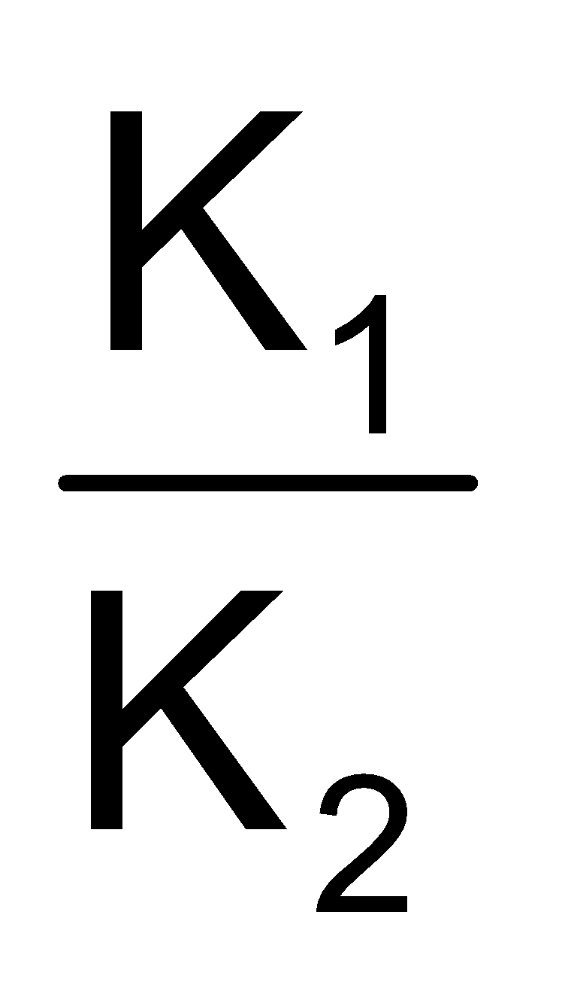 (3) K_{C} = K₁ x K₂ (4) K_{C} = K₁ + K₂

Sol. Forward reaction rate (r_{f}) [A] [B] = K₁ [A] [B]
Backward reaction rate (r_{f}) = K_{b} [C] [D] = K₂ [C] [D]
At equilibrium, r_{f} = r_{b}
∴ K₁ [A] [B] = K₂ [C] [D]
The concentration of reactents & products at equilibrium are related by
K ==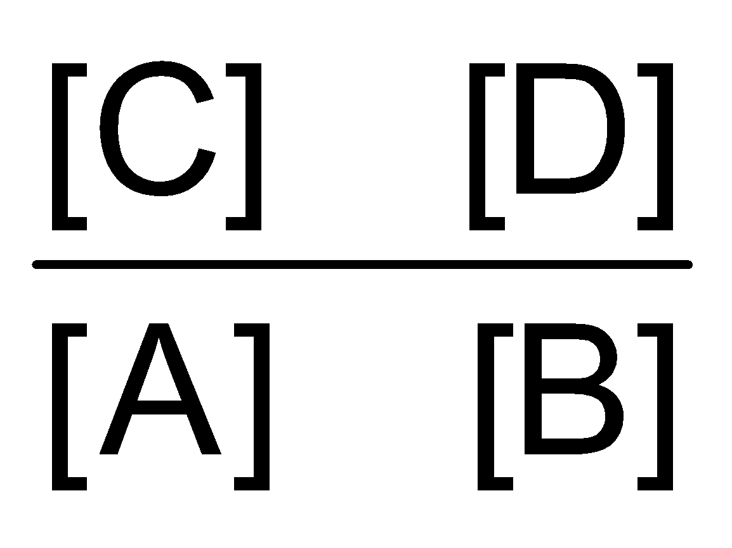
∴ K(K_{c}) =

A-2. Molar concentration of 96 g of O₂ contained in a 2 litre vessel is -
(1) 16 mol/litre (2*) 1.5 mol/litre (3) 4 mol/litre (4) 24 mol/litre

Sol. Molar conc. =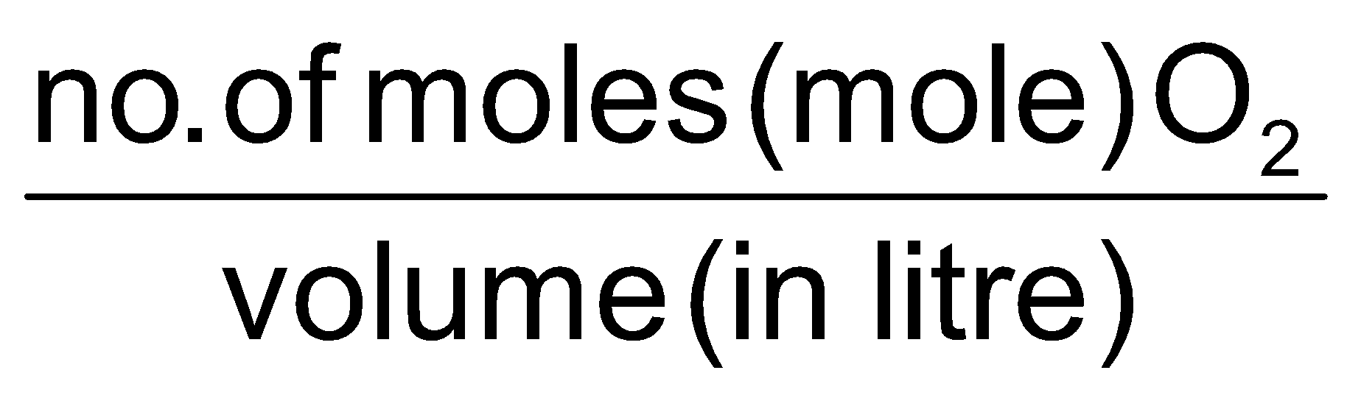= 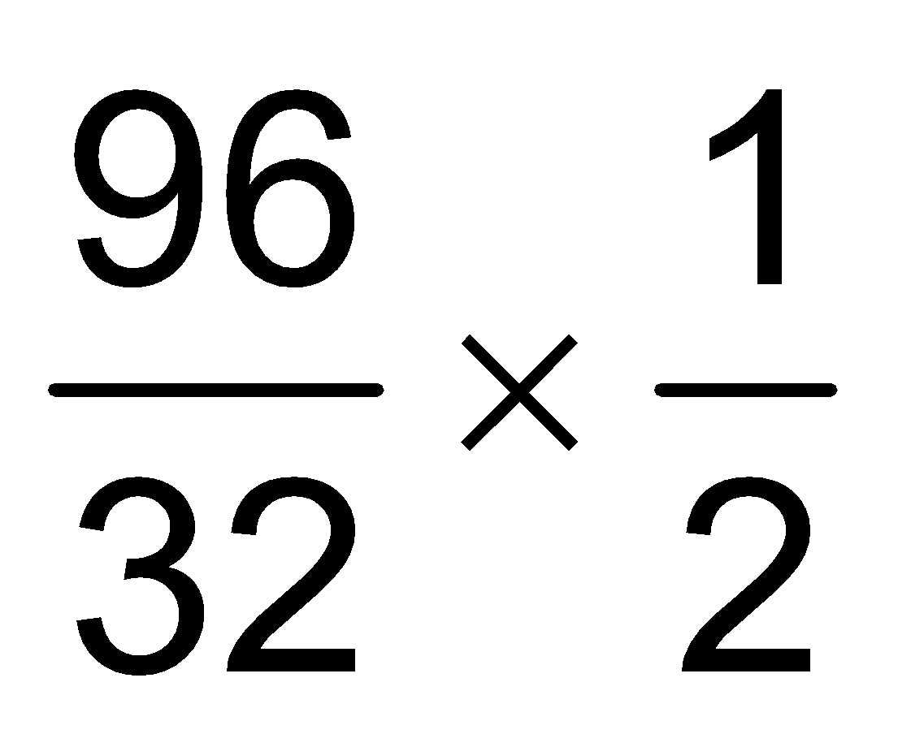× 2 = 1.5 mol/litre

A-3. log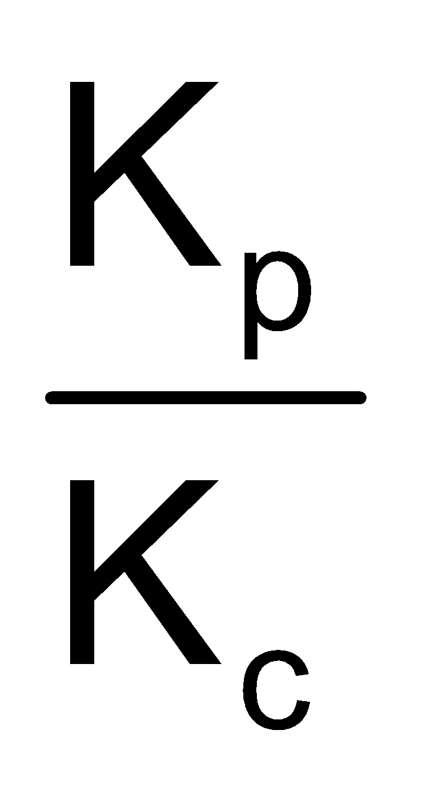+ log RT = 0 is a relationship for the reaction :

(1) PCl₅ PCl₃ + Cl₂ (2*) 2SO₂ + O₂ 2SO₃
(3) H₂ + Ι₂ 2HΙ (4) N₂ + 3H₂ 2NH₃

Sol. log 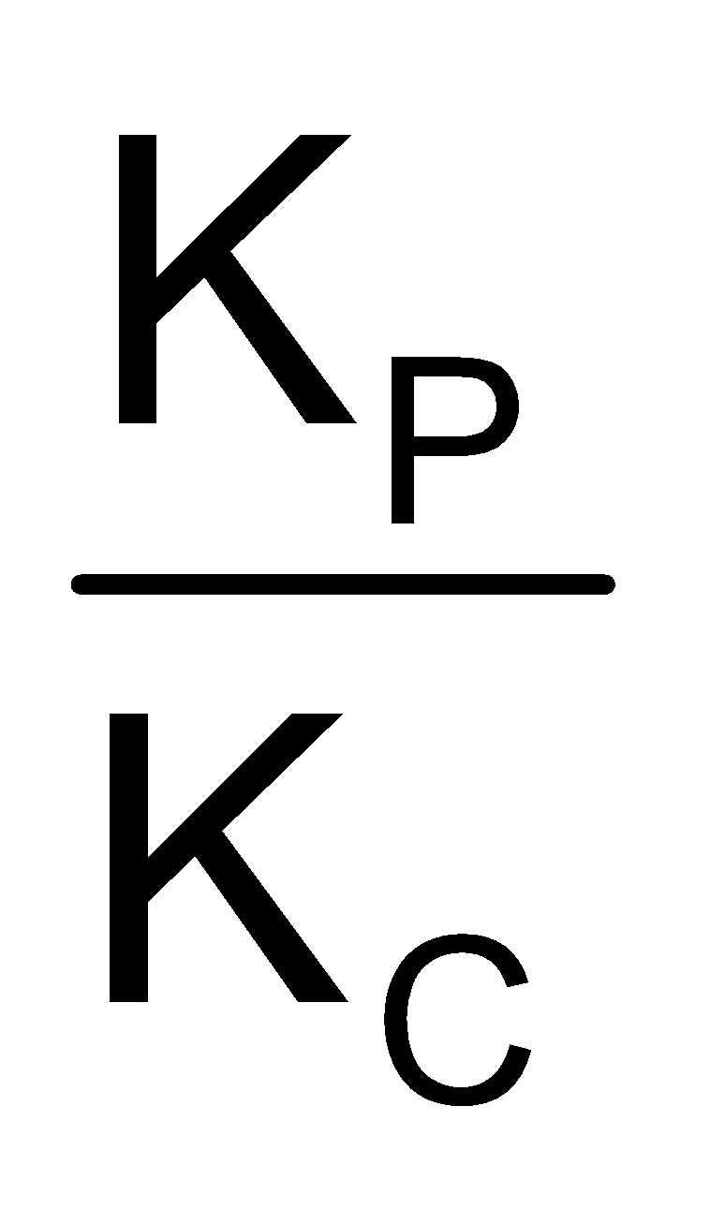+ log RT = 0
log 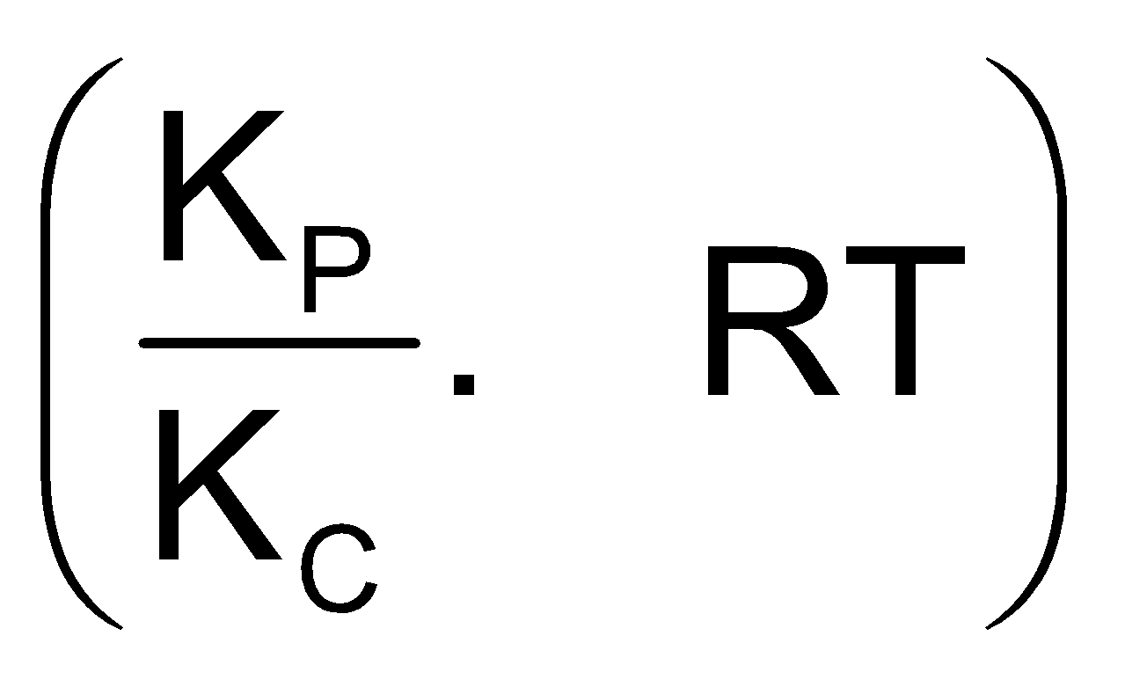= 0
K_{P} = K_{C} (RT)^{–1}
 K_{P} = K_{C} (RT)^{Δn} ; Δn = –1
This is possible one for option (2)

A-4. The equilibrium concentration of [B]_{eq} for the reversible reaction AB can be evaluated by the expression:
(1) K_{C}[A]_{e}^{–1} (2) 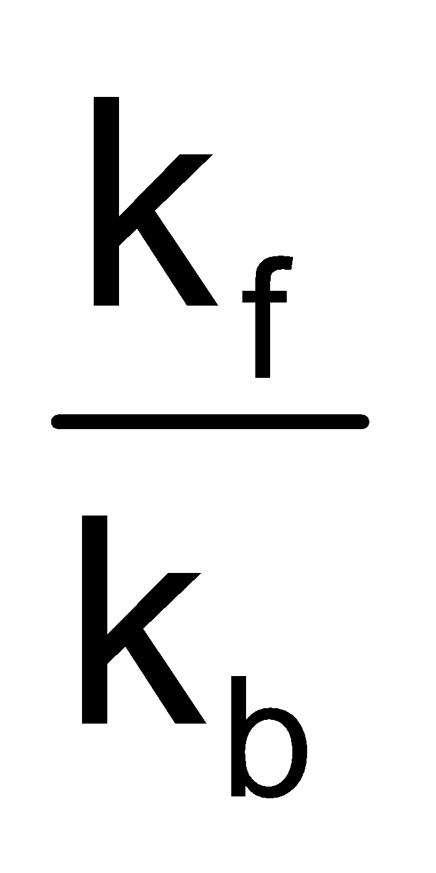 [A]_{e}^{–1} (3*) k_{f}k_{b}^{–1}[A]_{e} (4) k_{f}k_{b}[A]^{–1}

Sol. At equilibrium, r_{f} = r_{b}
∴ K_{f}[A]_{en} = K_{b}[B]_{en}
[B]_{eq} = K_{f}K_{b}^{–1} [A]_{eq}

A-5. In a chemical equilibrium, the rate constant for the backward reaction is 7.5 × 10^{–4} and the equilibrium constant is 1.5 the rate constant for the forward reaction is :

(1) 2 × 10^{–3} (2) 5 × 10^{–4} (3*) 1.12 × 10^{–3} (4) 9.0 × 10^{–4}

Sol. K =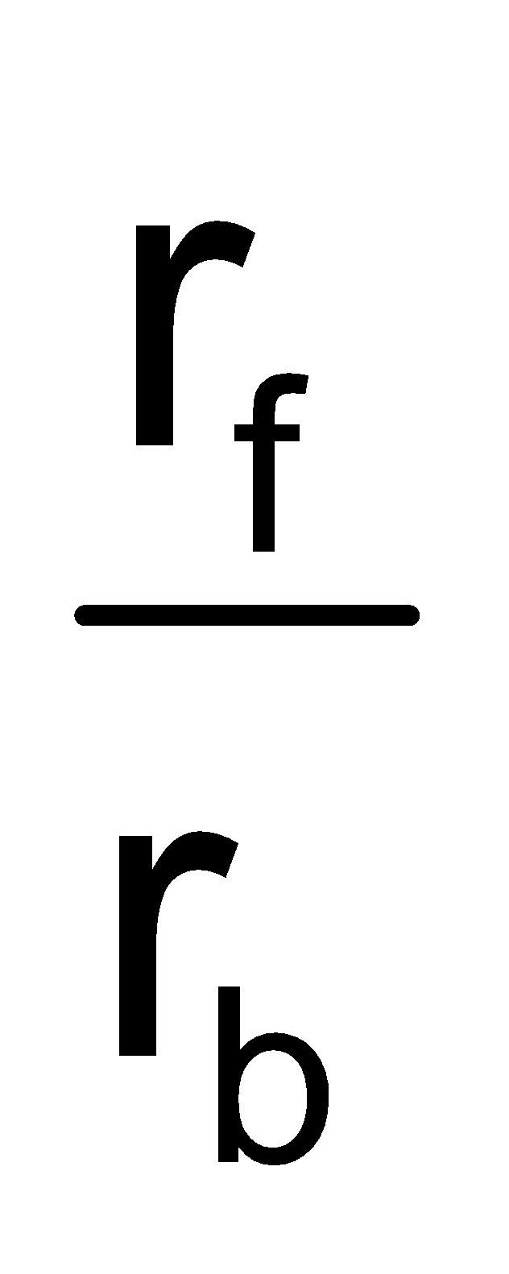 ⇒ 1.5 =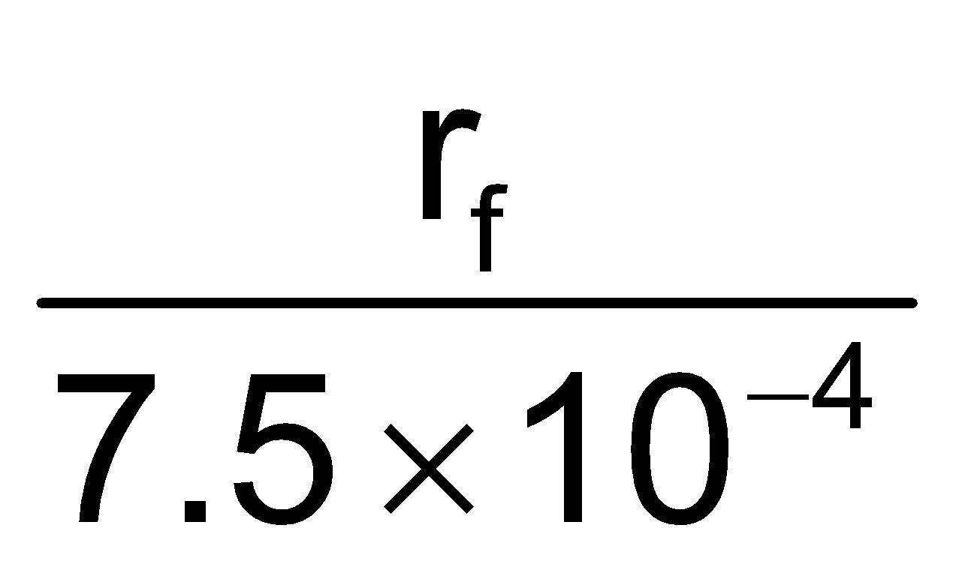 ⇒ r_{f} = 1.12 × 10^{–3}.

A-6. For the reaction, CuSO₄.5H₂O(s)CuSO₄.3H₂O(s) + 2H₂O(g). Which one is correct representation
(1) K_{P} =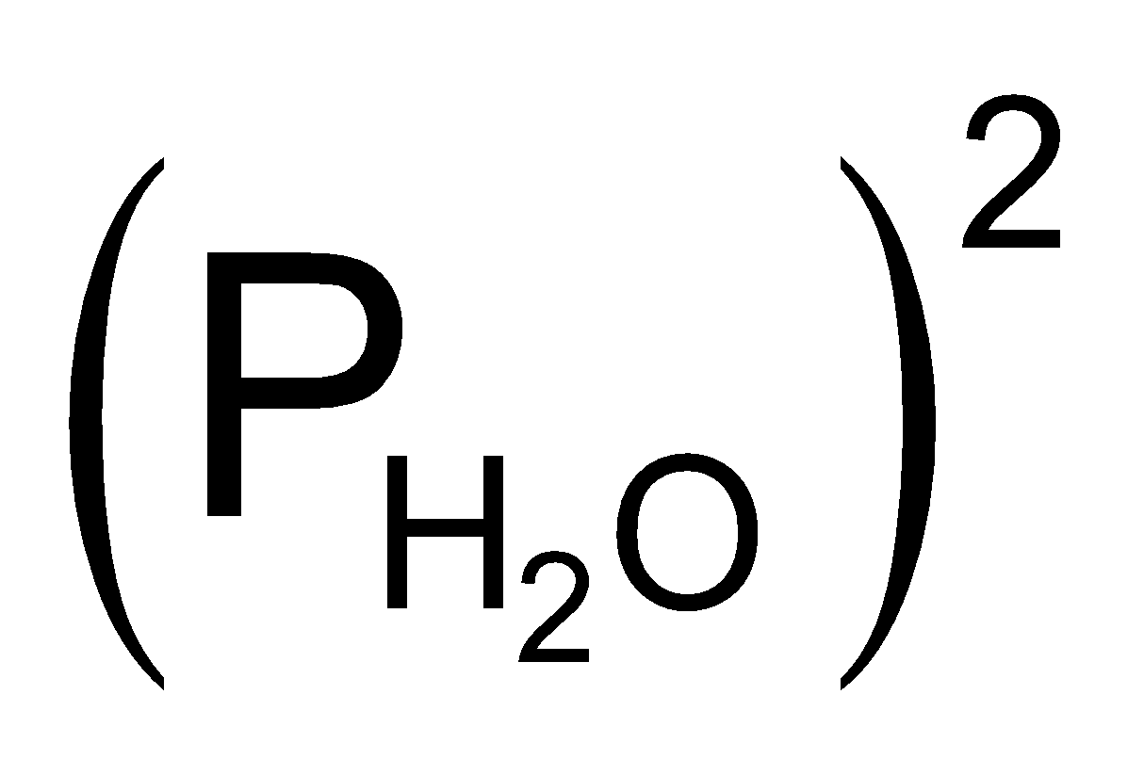 (2) K_{C} = [H₂O]² (3) K_{P} = K_{C}(RT)² (4*) All

Sol. For pure solids & pure liquids, although they have their own active masses but they remain const, during a chemical change.
K_{C} & K_{P} are equilibrium const. in terms of concentration & partical pressures.
All options are correct.

A-7. For a reaction N₂ + 3H₂ 2NH₃, the value of K_{C} does not depends upon :
(a) Initial concentration of the reactants (b) Pressure
(c) Temperature (d) catalyst

(1) Only c (2) a,b,c (3*) a,b,d (4) a,b,c,d
Sol. Equilibrium const. is temp. dependent only.

A-8. At 1000 K, the value of K_{p} for the reactionm, A(g) + 2B(g) 3C(g) + D(g) is 0.05 atmosphere. The value of K_{C} in terms of R would be :

(1) 20000 R (2) 0.02 R (3) 5 × 10^{–5} R (4*) 5 × 10^{–5} × R^{–1}
Sol. K_{p} = K_{c} (RT)^{Δn}, Δn² 4 – 3 = 1
.05 = K_{c} R × 1000
K_{c} = 5 × 10^{–5} × R^{–1}
K_{c} = 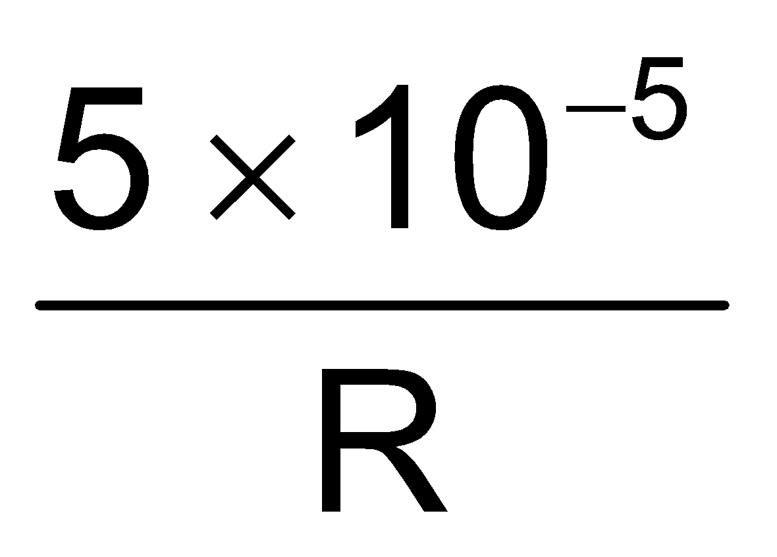

A-9. Rate of reaction curve for equilibrium can be like : [r_{f} = forward rate , r_{b} = backward rate]
(1*) 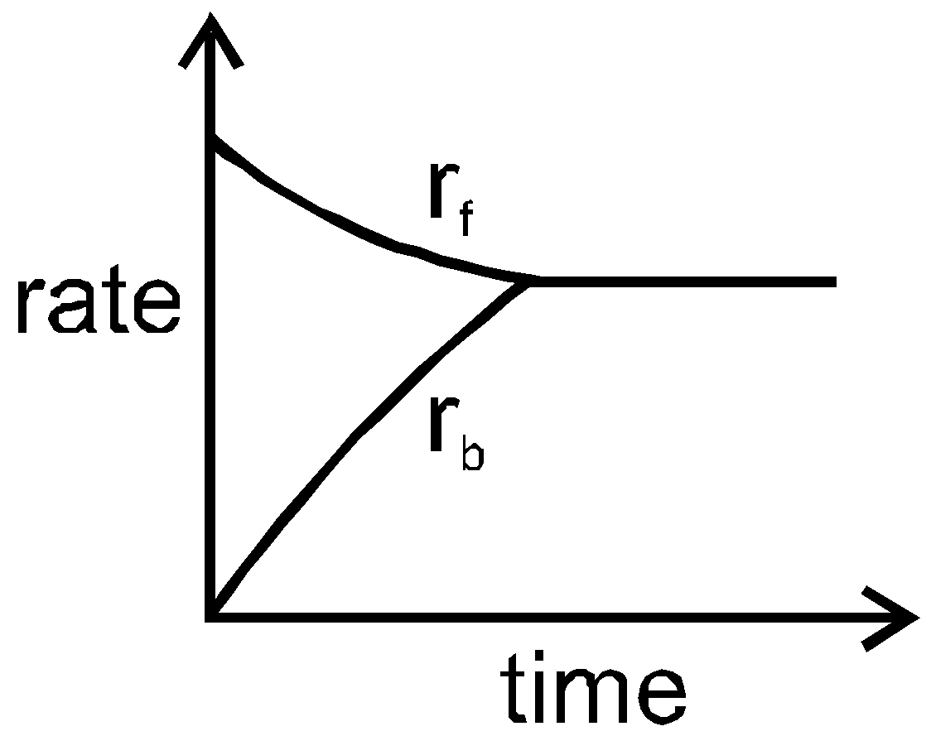 (2) 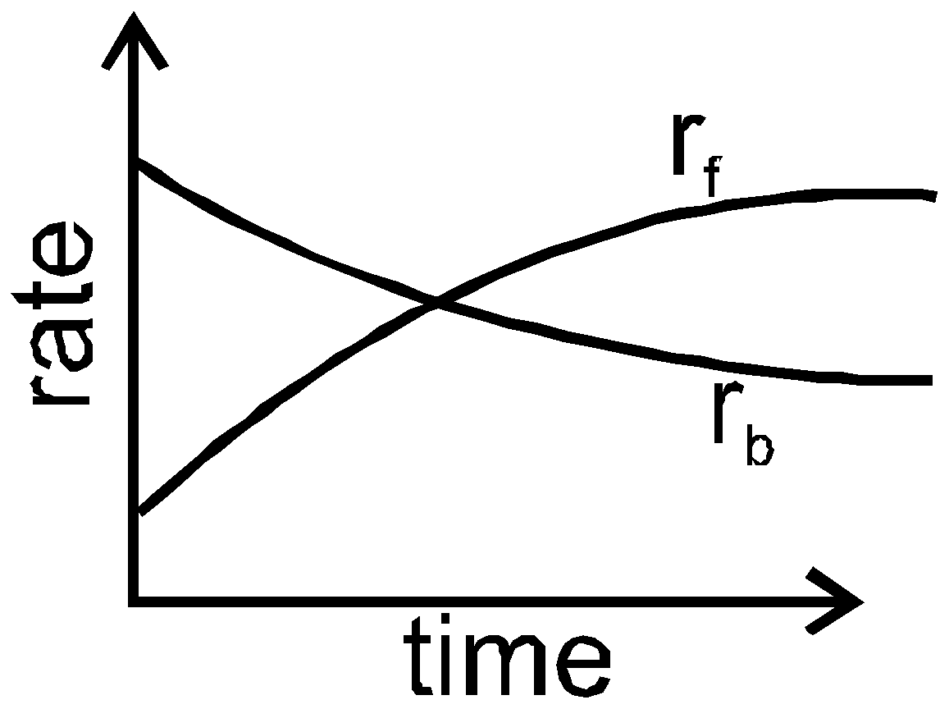 (3) 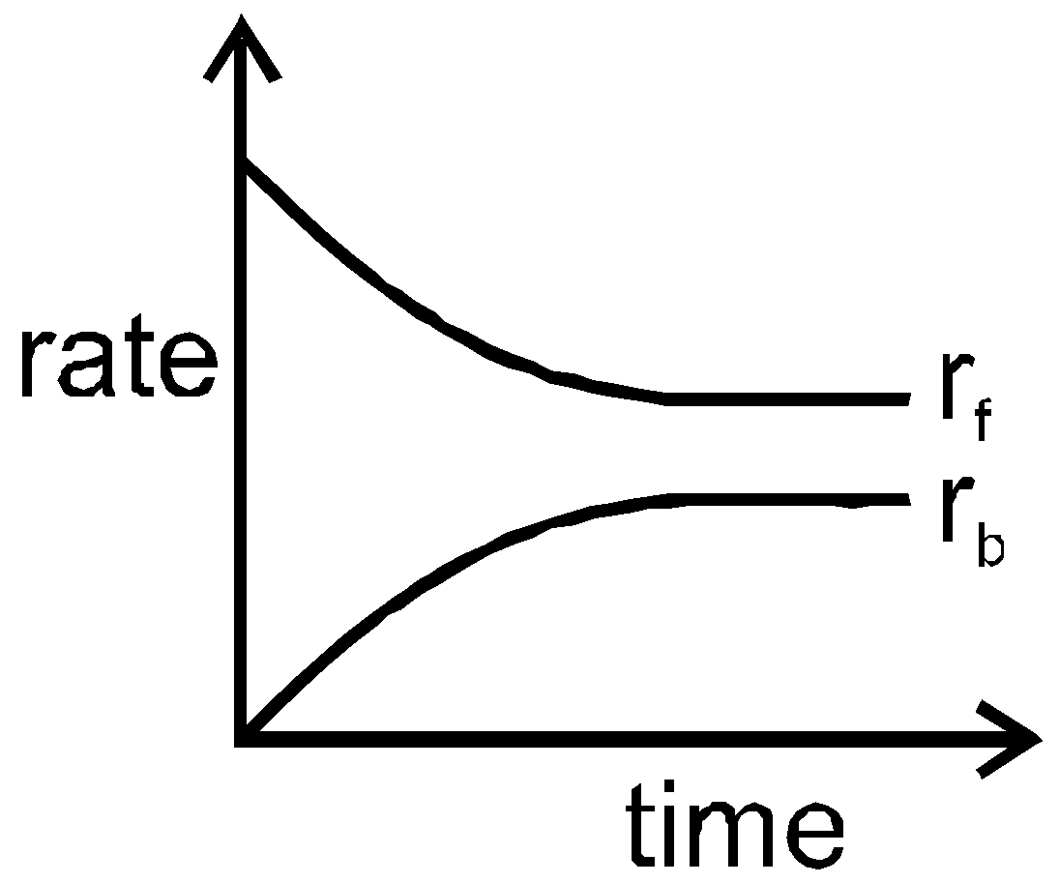 (4) 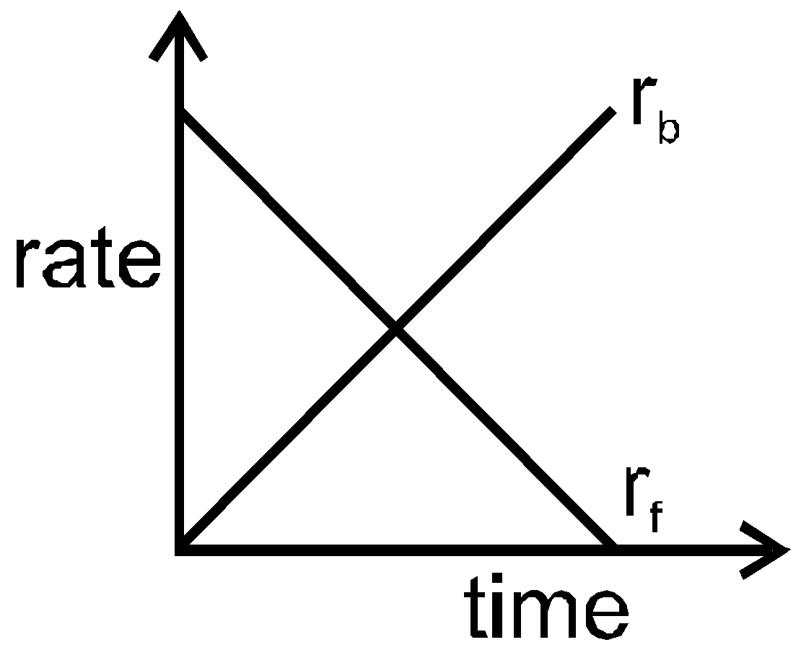

Sol. Concentration of reactant & product remains const. w.r.t time.
And, rate of [AT EQUILIBRIUM] forward reaction (r_{f}) = rate of backward reaction.

A-10. The equilibrium constant of the reaction SO₂(g) + ½O₂(g) SO₃(g) is 4 × 10^{–3} atm^{–1/2}. The equilibrium constant of the reaction 2SO₃(g) 2SO₂(g) + O₂(g) would be :

(1) 250 atm (2) 4 × 10³ atm (3) 0.25 × 10⁴ atm (4*) 6.25 × 10⁴ atm
Sol. SO₂(g) +O₂(g) SO₃(g) K_{p} = 4×10^{–3}
SO₃ SO₂(g) + O₂(g) K¹_{p} = 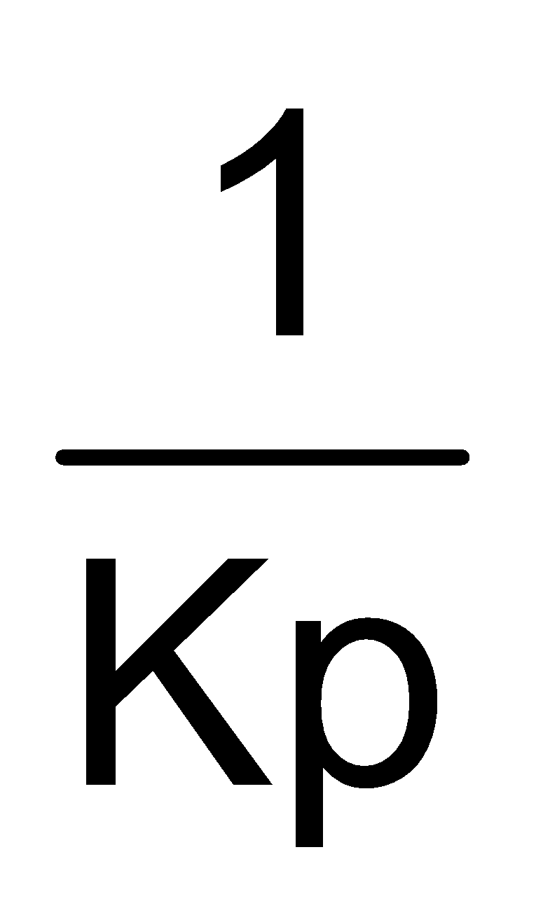
K¹_{p} = 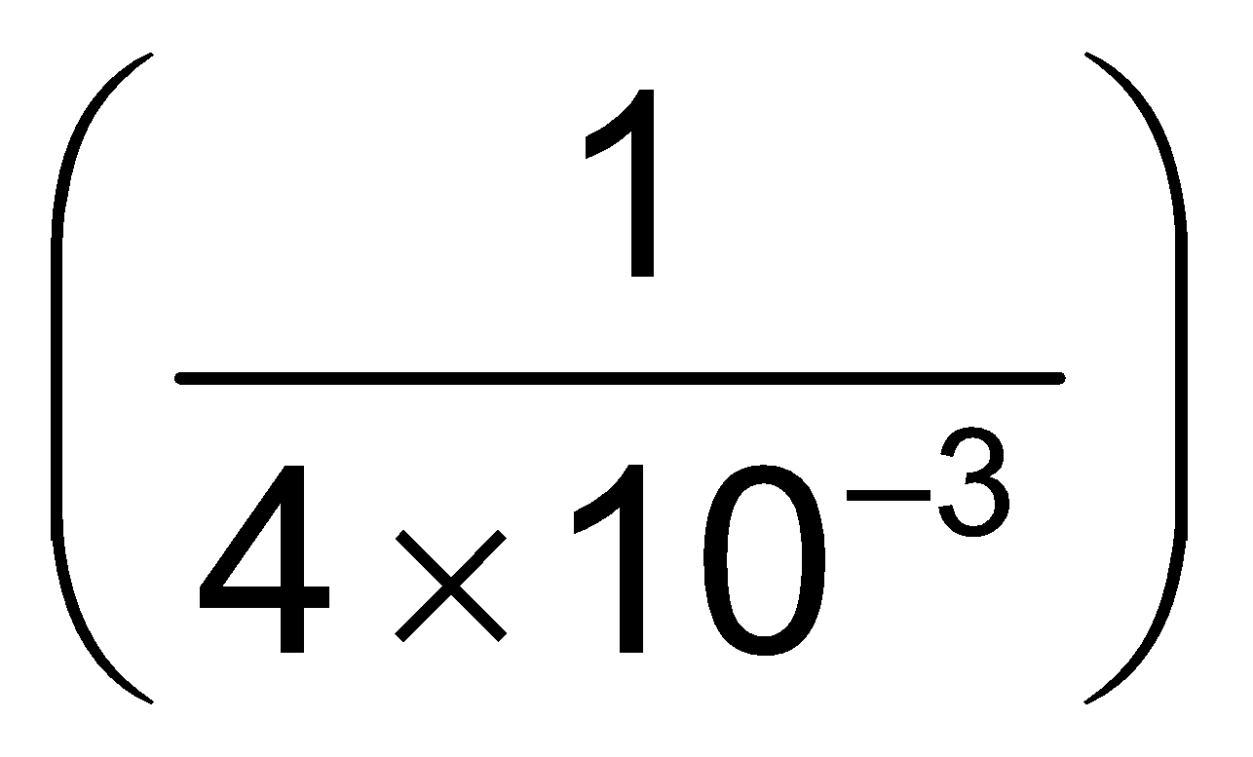
2SO₃  2SO₂ + O₂(g)
K^{II}_{p} = (K^{I}_{p})² =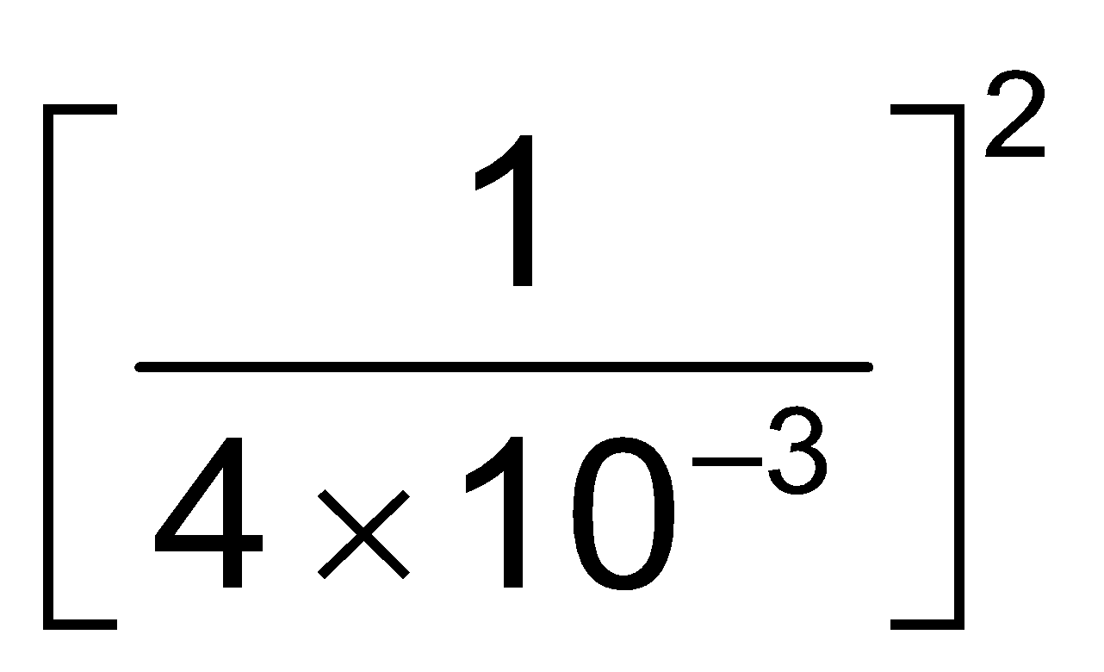=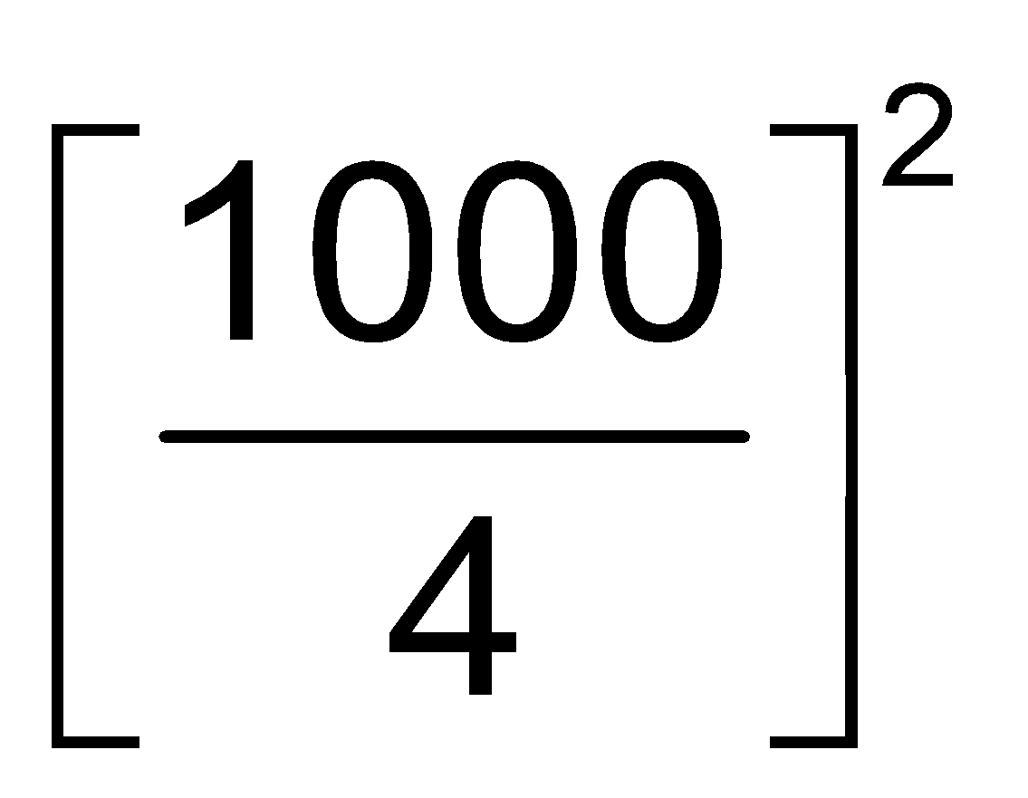= 6250 = 625×10² 6.25×10⁴ atm.

Section (B) : Calculation of KP & KC in homogenous equilibrium
B-1. For the reaction 3 A (g) + B (g) 2 C(g) at a given temperature, K_{c} = 9.0. What must be the volume of the flask, if a mixture of 2.0 mol each of A, B and C exist in equilibrium?
(1*) 6 L (2) 9 L (3) 36 L (4) None of these

Sol. K_{C} =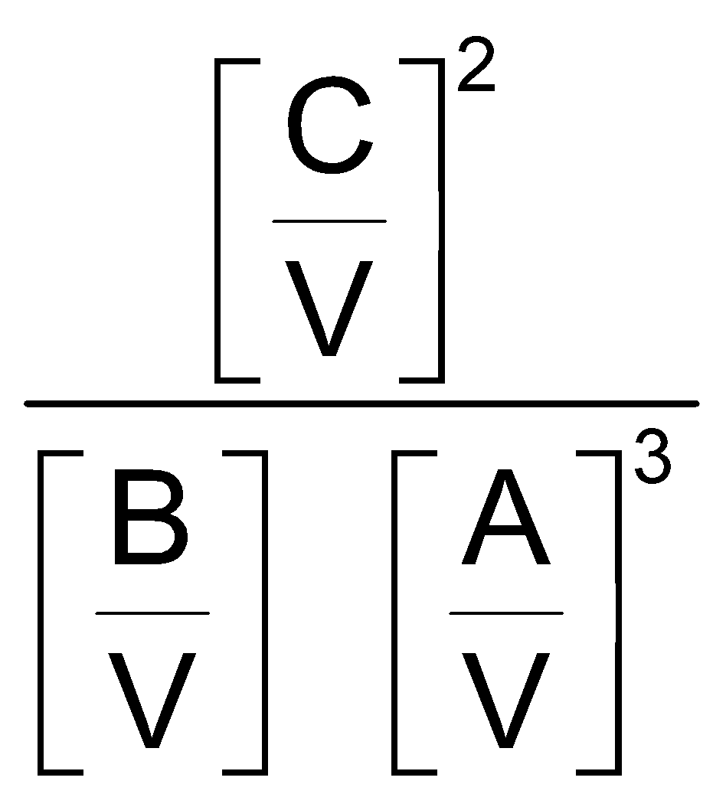  9 =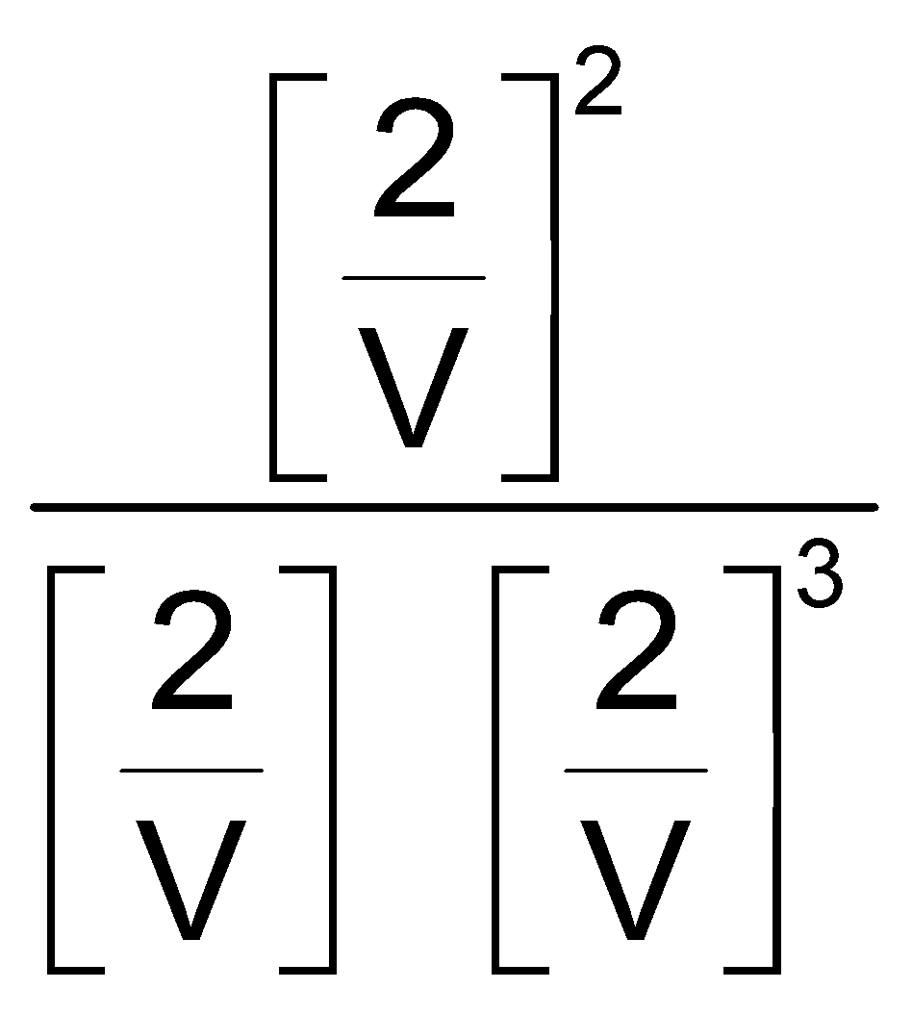 V = 6 L

B-2. The equilibrium constant (K_{p}) for the reaction PCl₅(g) PCl₃(g) + Cl₂(g) is 16. If the volume of the container is reduced to one half its original volume, the value of K_{p} for the reaction at the same temperature will be :

(1) 32 (2) 64 (3*) 16 (4) 4
Sol. Since, K_{p} is temperature dependent only.

B-3. The equilibrium constant for the reaction : N₂(g) + O₂(g) 2NO(g) at 2000 K is 4 × 10⁴ In presence of a catalyst the equilibrium is established ten times faster at the same temperature. What is the value of equilibrium constant in presence of catalyst : -
(1) 40 × 10⁴ (2) 4 × 10^{–4} (3*) 4 × 10⁴ (4) None

Sol. 4 × 10⁴, Since Equilibrium const. is temp. dependent only.

B-4. The equilibrium constant for the reaction : H₂(g) + I₂(g) 2HI(g) is 64. If the volume of the container is reduced to one fourth of its original volume, the value of the equilibrium constant will be :
(1) 16 (2) 32 (3*) 64 (4) 128

B-5. A₃(g)3A (g)
In the above reaction, the initial concentration of A₃ is "a" moles/lit. If x is degree of dissociation of A₃. The total number of moles at equilibrium will be :
A₃(g) 3A (g)

(1) a –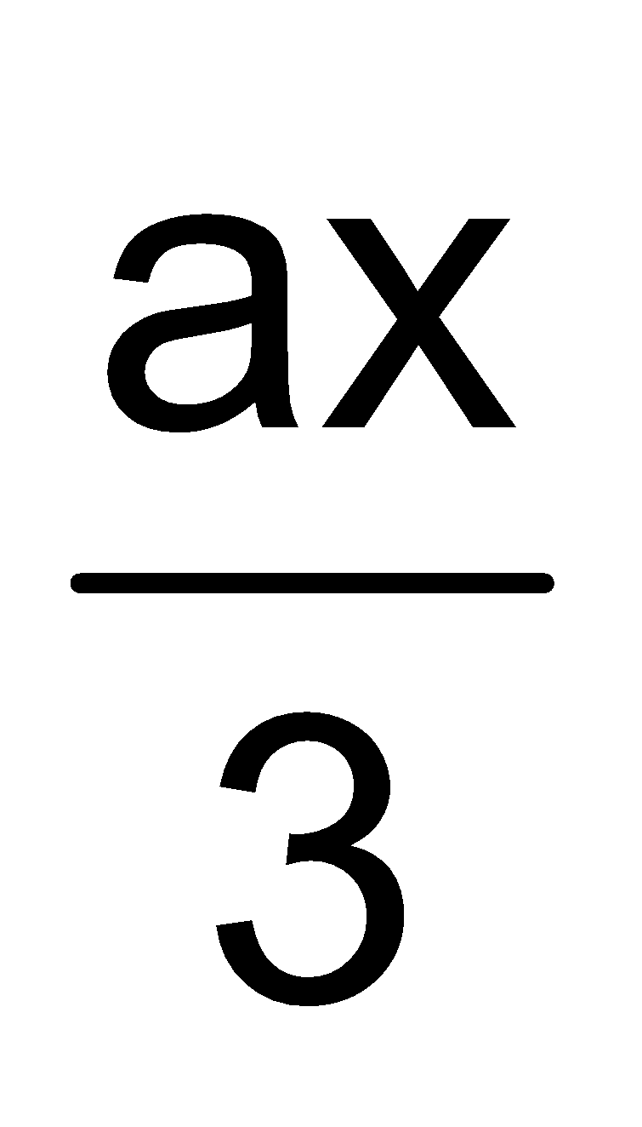 (2) – ax (3) 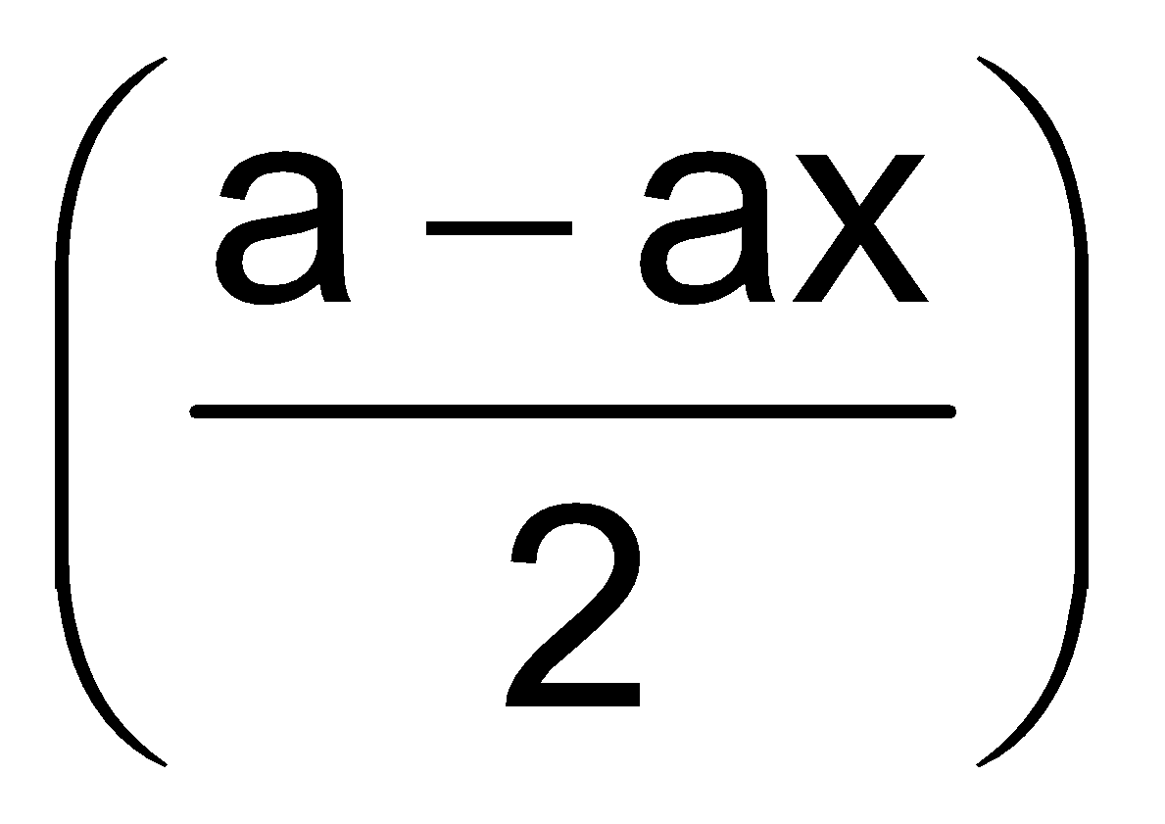 (4*) a + 2ax
Sol. A₃(g) 3A(g)
t = 0 a 0
t = t_{eq} a – ax 3ax
Total moles = a – ax + 3ax = a + 2ax

B-6. The reaction A(g) + B(g) C(g) + D(g) is studied in a one litre vessel at 250°C. The initial concentration of A was 3n and that of B was n. When equilibrium was attained, equilibrium concentration of C was found to the equal to the equilibrium concentration of B. What is the concentration of D at equilibrium?

(1*) n/2 (2) (3n – 1/2) (3) (n – n/3) (4) n
Sol. A + B C + D
3n n 0 0 t = 0
(3n—x) (n—x) x x t = teq.
(n—x) = x
n = 2x x = 

B-7. When alcohol (C₂H₅OH) and acetic acid are mixed together in equimolar ratio at 27ºC , 33% is converted into ester. Then the K_{C} for the equilibrium
C₂H₅OH() + CH₃COOH ()CH₃COOC₂H₅ () + H₂O().

(1) 4 (2*) 1/4 (3) 9 (4) 1/9
Sol. C₂H₅OH () + CH₃COOH ()CH₃COOC₂H₅ () + H₂O ().
a a 0 0
a 0.33a a – 0.33a 0.33a 0.33a
K_{C} =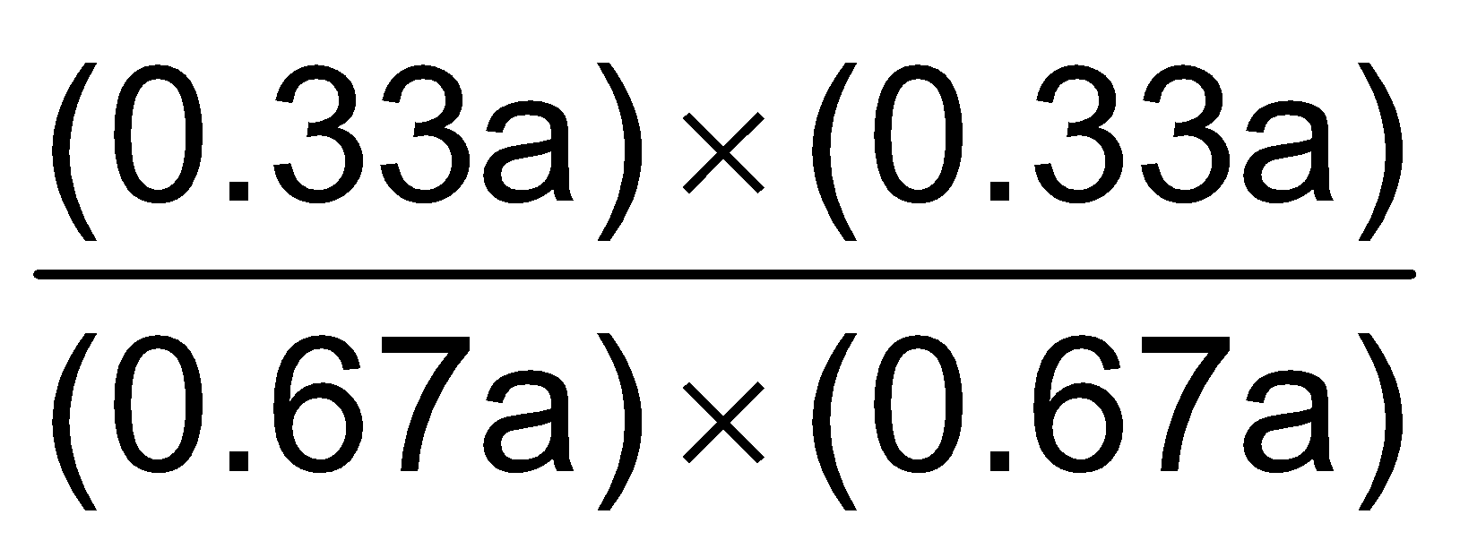= K_{C} = 1/4.

B-8. 'a' moles of PCl₅, undergoes, thermal dissociation as : PCl₅ PCl₃ + Cl₂, the mole fraction of PCl₃ at equilibrium is 0.25 and the total pressure is 2.0 atmosphere. The partial pressure of Cl₂ at equilibrium is :
(1) 2.5 (2) 1.0 (3*) 0.5 (4) None

Sol. P(K PCl₃ + Cl₂
at t = 0 a 0 0
t_{eq} a – x x x
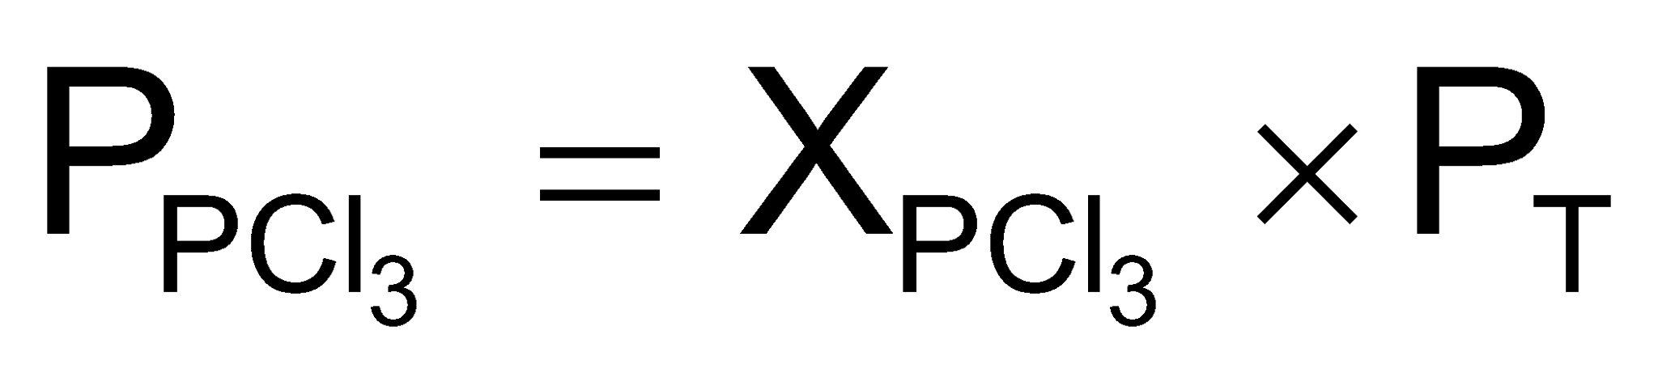= .25 × 2 = 0.5 atm
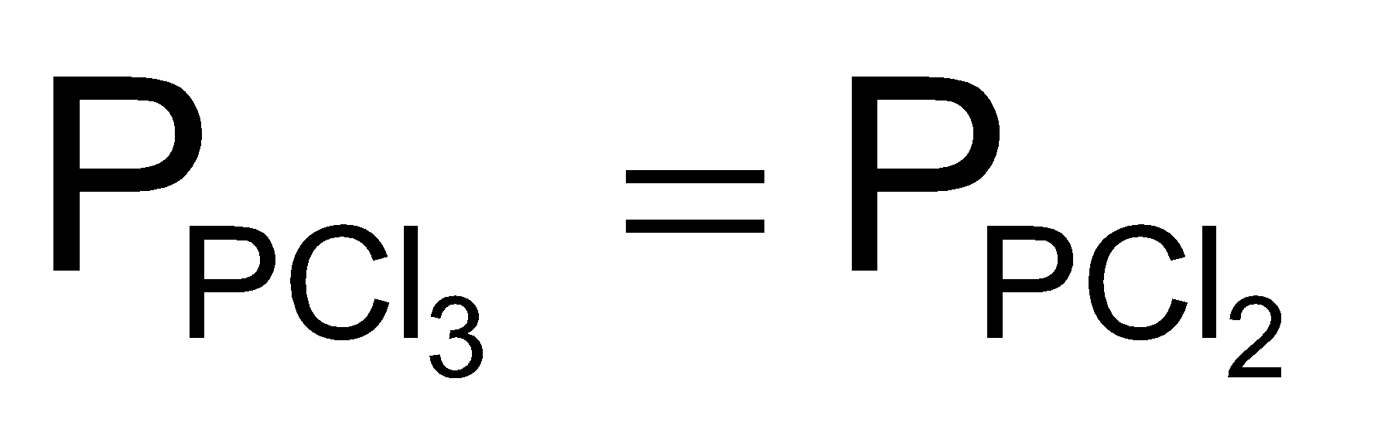 = 0.5

B-9. 4.5 moles each of hydrogen and iodine heated in a sealed ten litre vessel. At equilibrium 3 moles of HI were found. The equilibrium constant for H₂(g) + I₂(g) 2HI(g) is :

(1*) 1 (2) 10 (3) 5 (4) 0.33
Sol. H₂(g) + I₂(g)  2HI(g)
t = 0 4.5 4.5 0
t = t_{eq}. 4.5 – x 4.5 – x 2x
put x = 1.5
4.5 – 1.5 4.5 – 1.5 2 × 1.5 = 3
↓ ↓ ↓
3 3 3
K_{C} =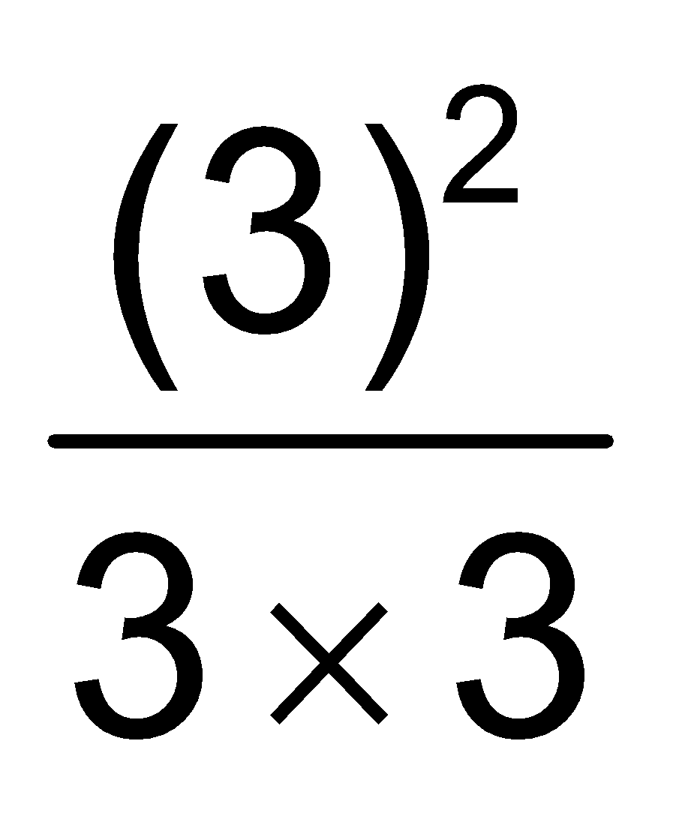= 1

B-10. 1.50 moles each of hydrogen and iodine were placed in a sealed 10 litre container maintained at 717 K. At equilibrium 1.25 moles each of hydrogen and iodine were left behind. The equilibrium constant, K_{c} for the reaction. H₂(g) + I₂(g) 2HI(g) at 717 K is

(1) 0.4 (2*) 0.16 (3) 25 (4) 50
Sol. H₂(g) + I₂(g) 2HI(g)
t = 0 1.5 1.5 0
t = t_{eq} 1.5 – x 1.5 – x 2x
We know, 1.5 – x = 1.25, or x = .25
K_{c} =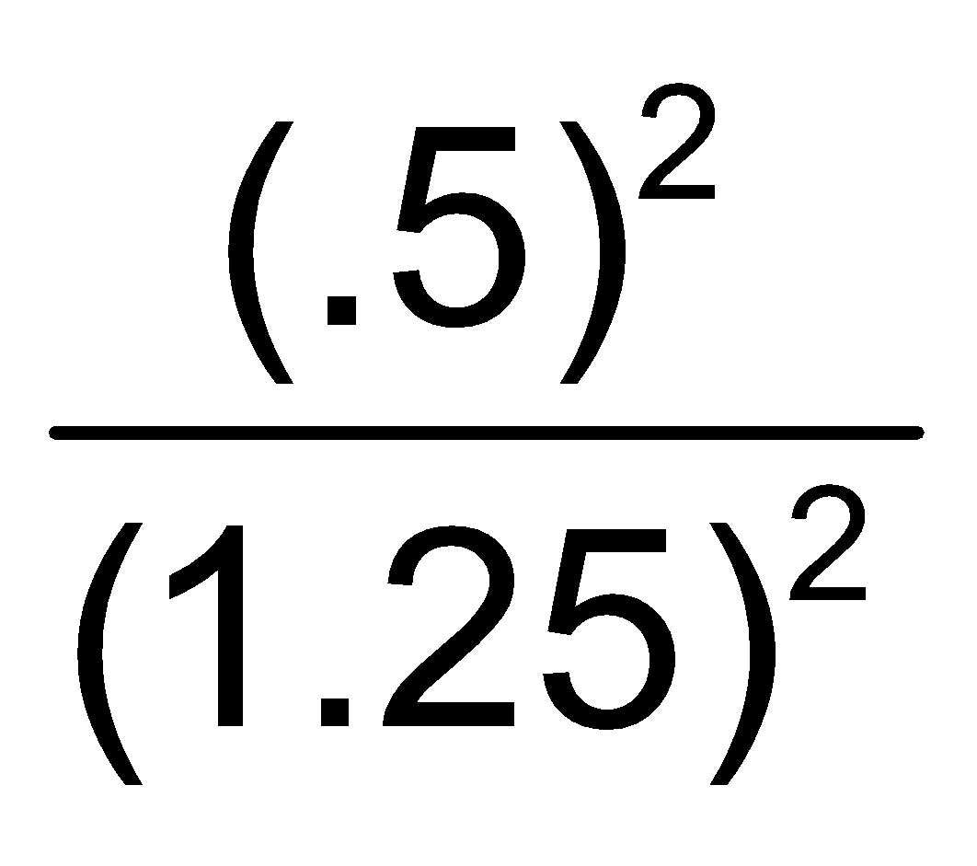= .16

B-11. 500 ml vessel contains 1.5 M each of A,B, C and D at equilibrium. If 0.5 M each of C and D are taken out, the value of K_{C} for A + B C + D will be [DCE 2000]

(1*) 1.0 (2) 1/9 (3) 4/9 (4) 8/9

B-12. The relation between K_{p} and K_{c} in equilibrium is : [RPMT 2001]
(1*) K_{p} = K_{c} (RT)^{Δng} (2) K_{p} = K_{c} × RT (3) K_{c} = K_{p} (RT)^{Δn} (4) K_{c} = K_{p} × Δn
[Correction by AGA_25.9.17]
Sol. Relation between K_{p} and K_{c} is :
K_{p} = K_{c} (RT)^{Δn}

Section (C) : Reaction quotient
C-1. In a 20 litre vessel initially 1 – 1 mole CO, H₂O CO₂ is present, then for the equilibrium of
CO + H₂O CO₂ + H₂ following is true :
(1) H₂, more then 1 mole (2*) CO, H₂O, H₂ less then 1 mole
(3) CO₂ & H₂O both more than 1 mole (4) All of these

Sol. Co + H₂O CO₂ + H₂
t = 0 1 1 1 0
t = teq 1 – x 1 – x 1 + x x
at equilibrium, only CO₂ has (1 + x) moles.

C-2. Vapour density of PCl₅ is 104.16 but when heated to 230°C its vapour density is reduced to 62.. The degree of dissociation of PCl₅ at this temperature will be :

(1) 6.8 % (2*) 68% (3) 46% (4) 64%
Sol. VD_{Minorobs} =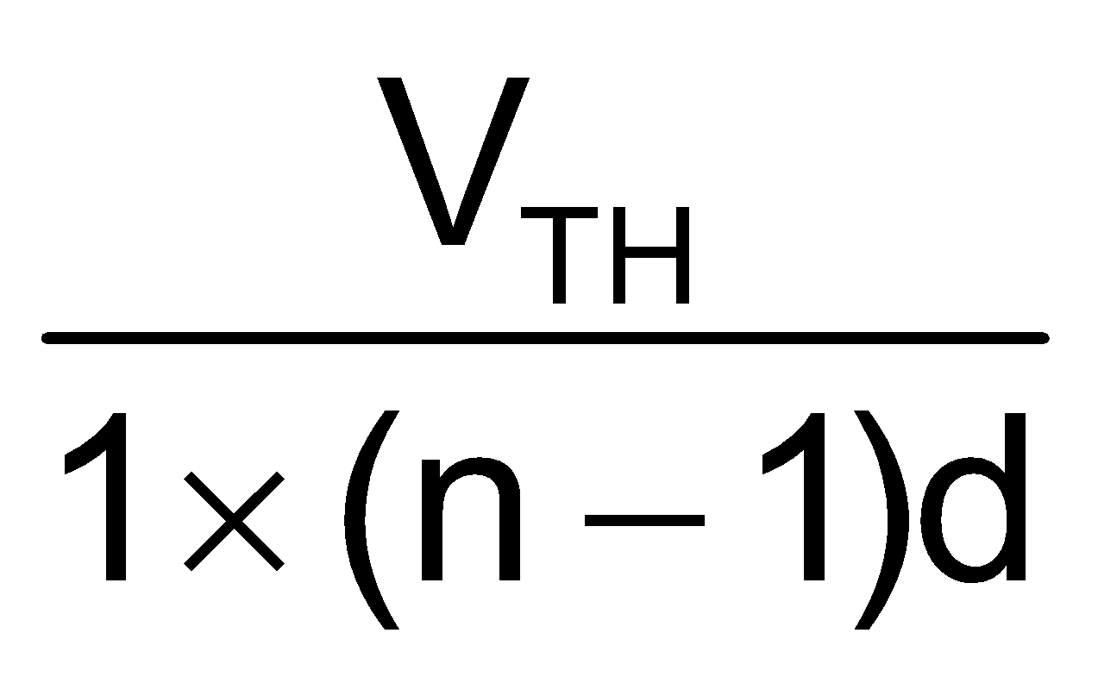
VD_{obs} = 62, 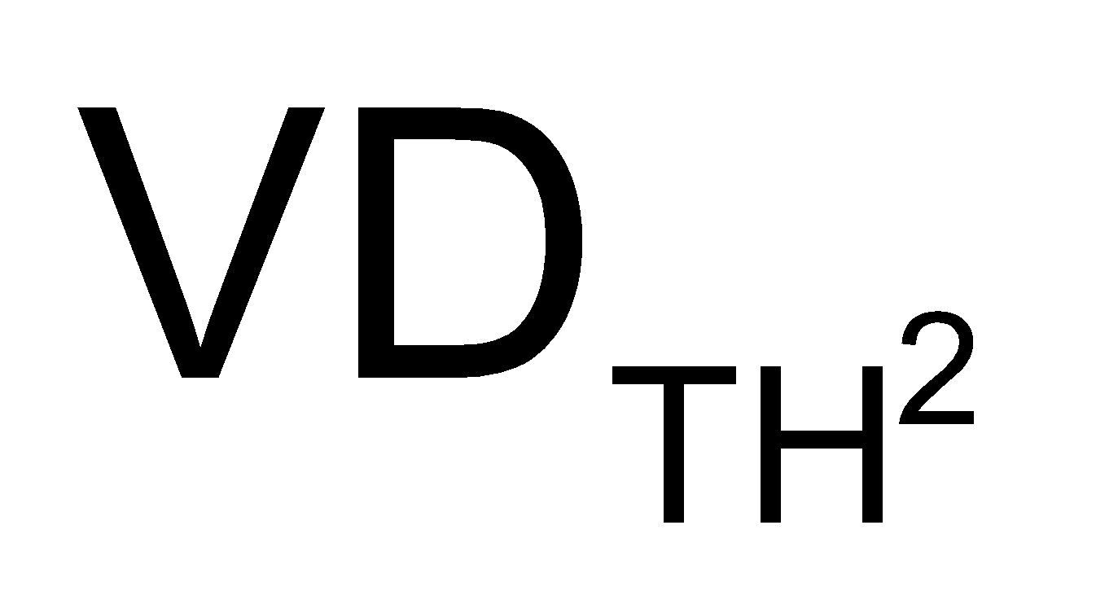= 104.16, n = 2
α = 68%

C-3. A reaction mixture containing H₂, N₂ and NH₃ has partial pressure 2 atm, 1 atm and 3 atm respectively at 725 K. If the value of K_{P} for the reaction, N₂ + 3H₂2NH₃ is 4.28 × 10^{–5} atm^{–2} at 725 K, in which direction the net reaction will go :
(1) Forward (2*) Backward
(3) No net reaction (4) Direction of reaction cannot be predicted

Sol. N₂ + 3H₂ 2NH₃, K_{P} = 4.28 × 10^{–5} atm^{–2}
Reaction Quotient, Q_{P} =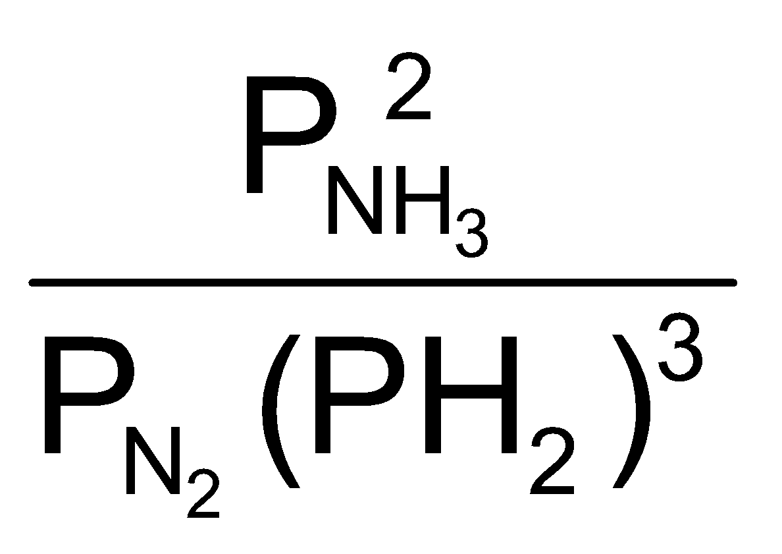=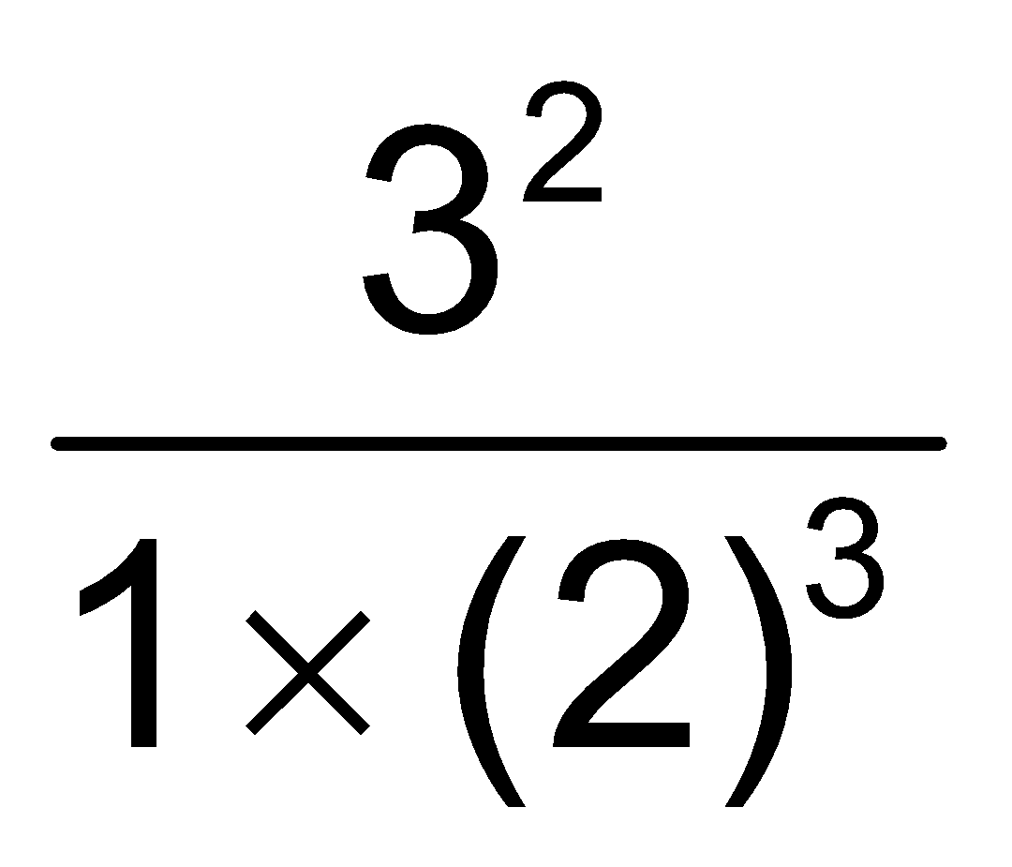= 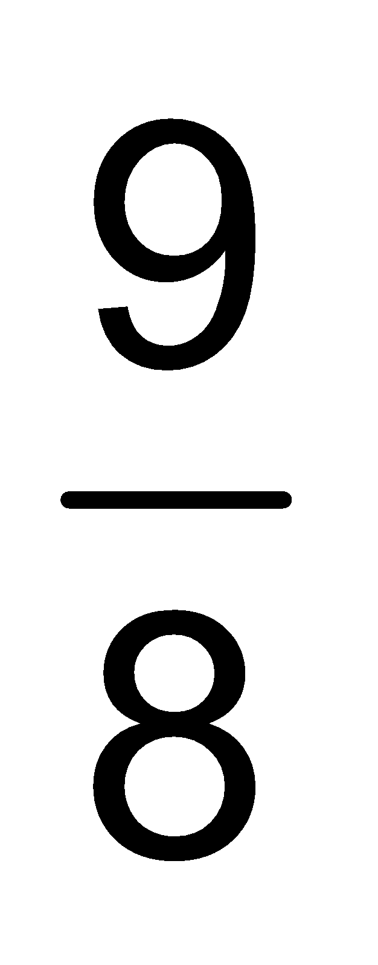
Q_{P} > K_{P}, ∴ Reaction will go Backward.

C-4. 2 mole each of SO₃, CO, SO₂ and CO₂ is taken in a one lit. vessel. If K_{C} for
SO₃(g) + CO(g) SO₂(g) + CO₂(g) is 1/9 then
(1) total no. of moles at equilibrium are less than 8
(2) n(SO₃) + n(CO₂) = 4
(3) [n(SO₂)/n(CO)] < 1
(4*) Both (2) and (3).

Sol. SO₃(g) + CO(g) SO₂ (g) + CO₂ (g) 9 =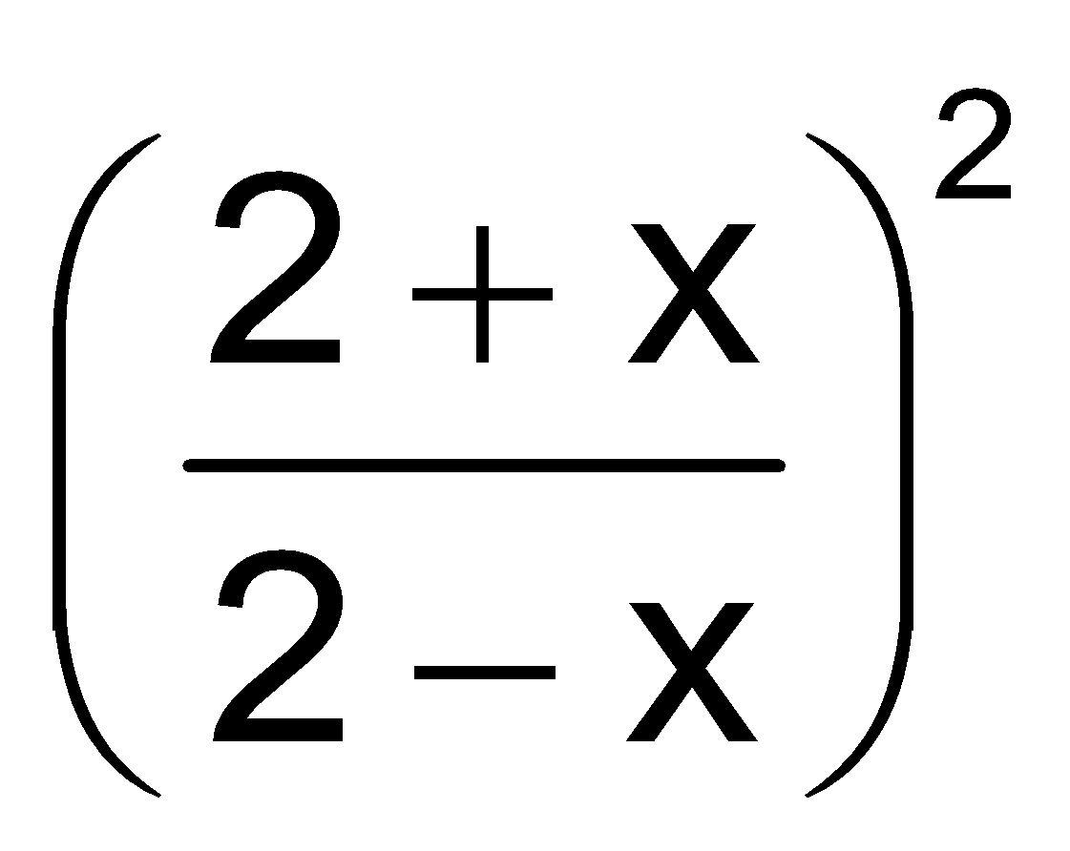
2 2 2 2
2+x 2+x 2-x 2-x x = 1
n_{eq} = 3 + 3 + 1 + 1 = 8 n(SO₃) + n(CO₂) = 4 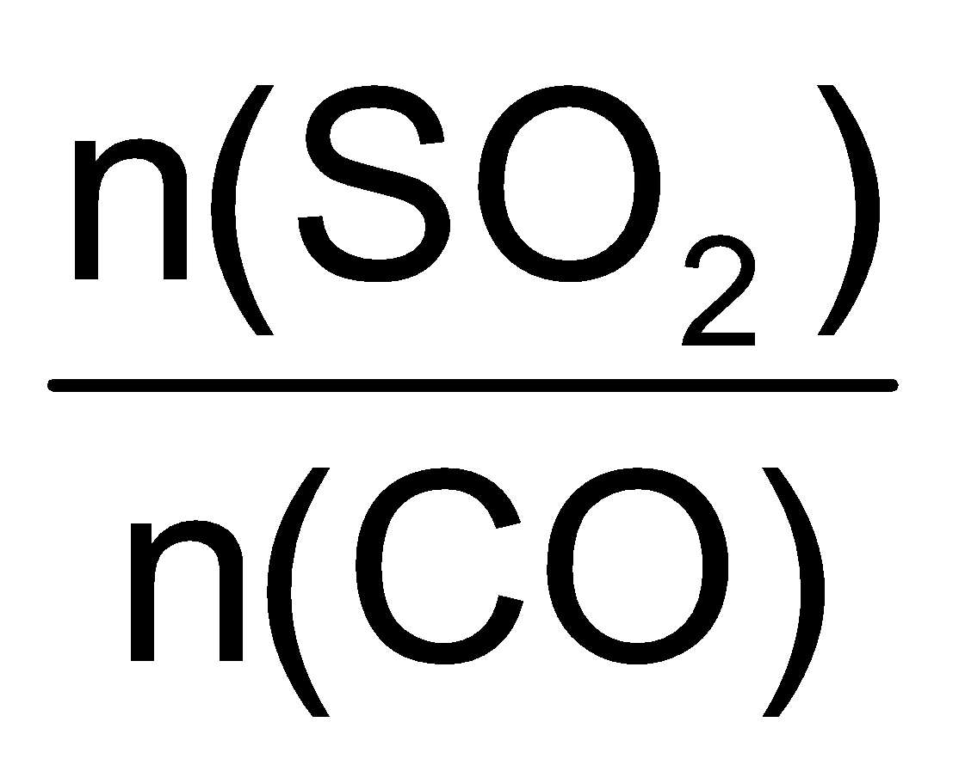= < 1
Therefore, (4) option is correct.

C-5. The reaction quotient Q for N₂(g) + 3H₂(g) 2NH₃(g) is given by Q = 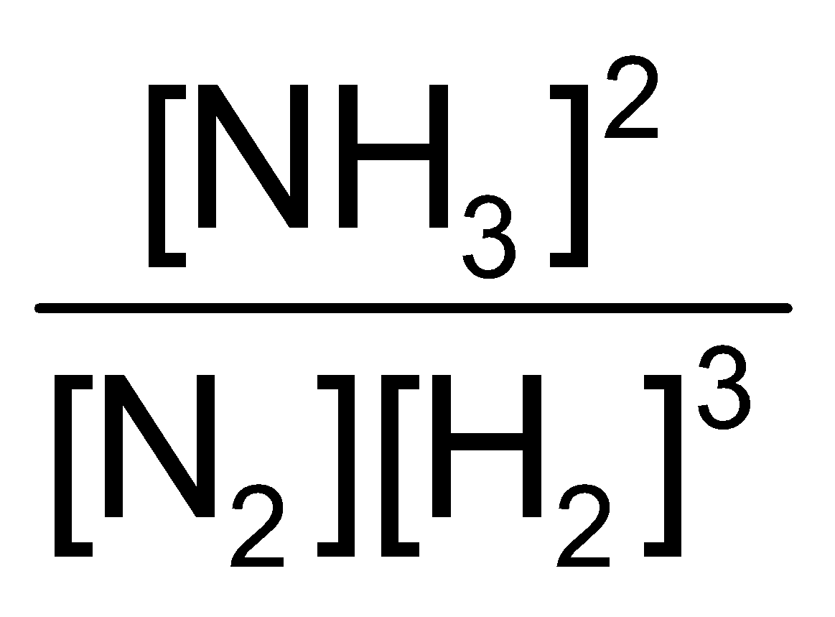. The reaction will proceed in backward direction, when (SID Sir) (CEQ–RQ) (SCQ) (M)

(1) Q = K_{C} (2) Q < K_{C} (3*) Q > K_{C} (4) A = 0
Sol. When Q > K_{C}, the reaction will proceed in backward direction to attain equilibrium.

C-6. For the reaction, (SID Sir) (CEQ–RQ) (SCQ) (E)
2A + B 3C at 298 K, K_{C} = 49
A 3L vessel contains 2, 1 and 3 moles of A, B and C respectively. The reaction at the same temperature
(1*) must proceed in forward direction (2) must proceed in backward direction
(3) must be equilibrium (4) can not be predicted

Sol. Q = 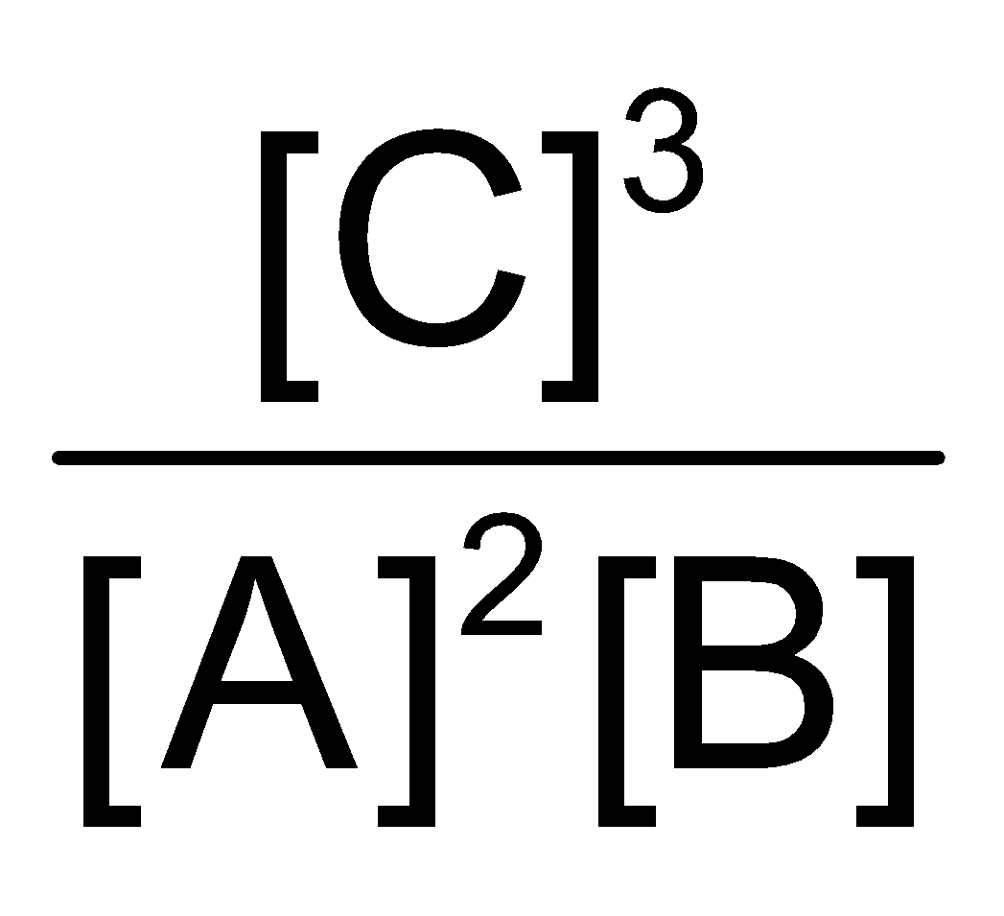=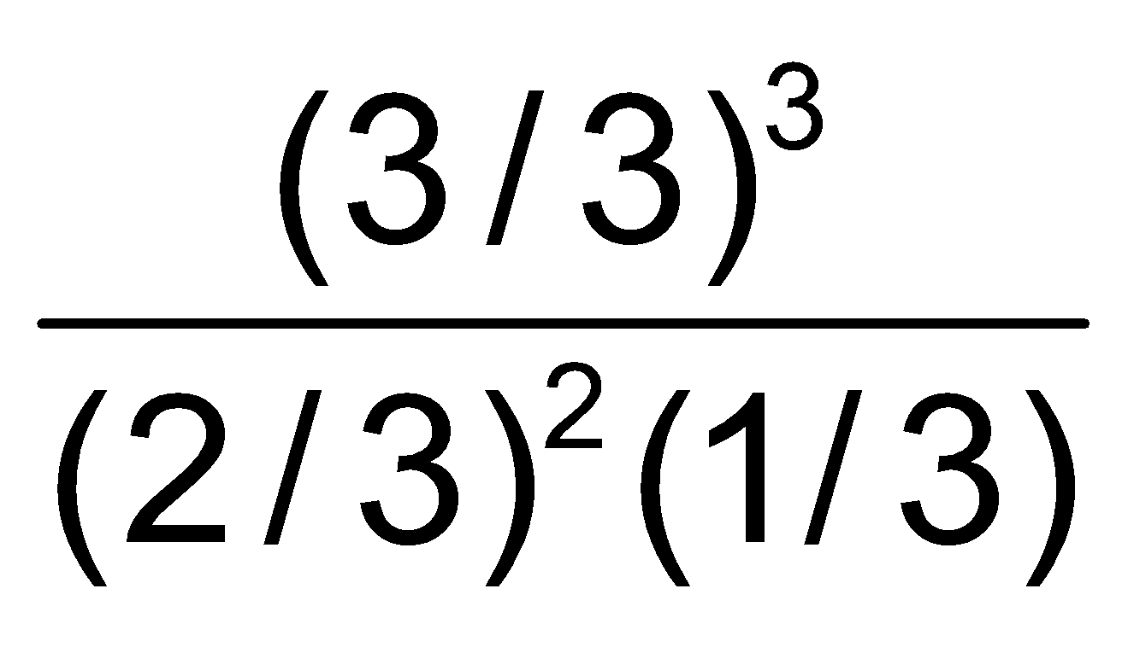= 6.75
Q < K_{C}
The reaction will proceed in forward direction to attain equilibrium.

Section (D) : Degree of dissociation
D-1. In a container equilibrium N₂O₄ (g) 2NO₂ (g)
is attained at 25°C. The total equilibrium pressure in container is 380 torr. If equilibrium constant of above equilibrium is 0.667 atm, then degree of dissociation of N₂O₄ at this temperature will be

(1)  (2*) (3)  (4) 
Sol. N₂O₄(g) 2NO₂(g)
initially, t = 0 a 0
a – a–α 2aα
K_{P} =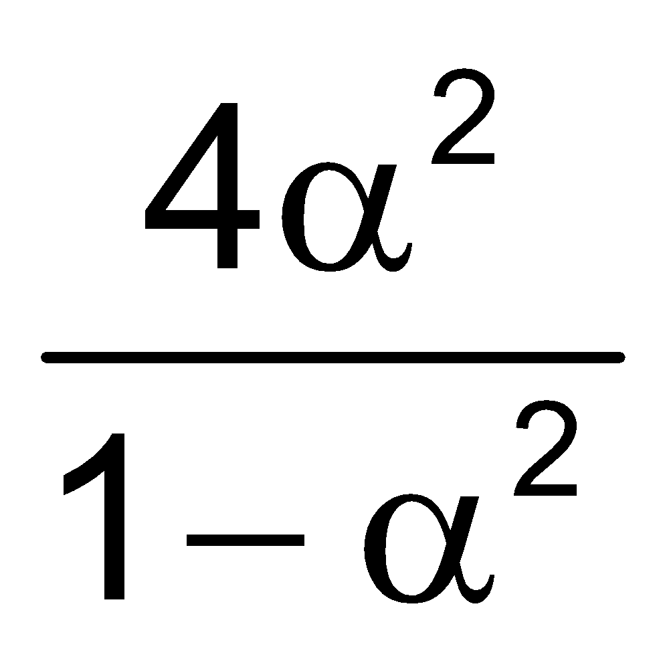 P = 380 toor =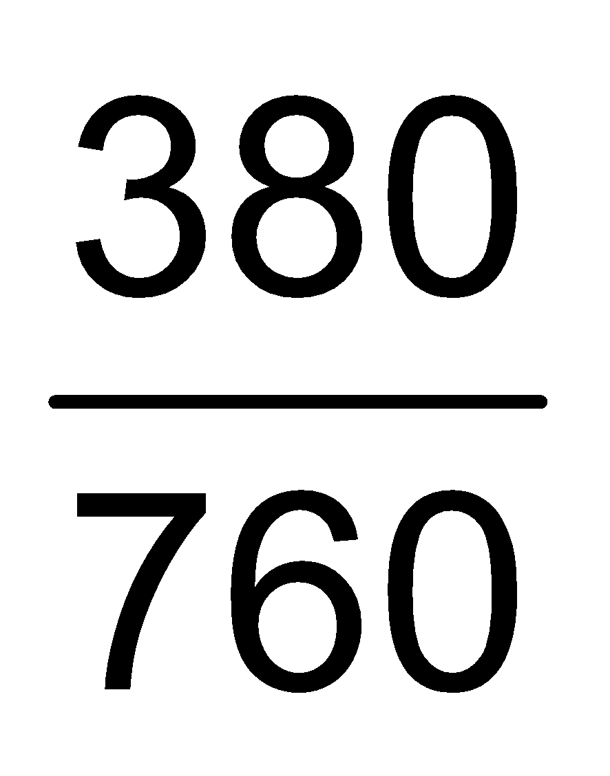= .5 atm
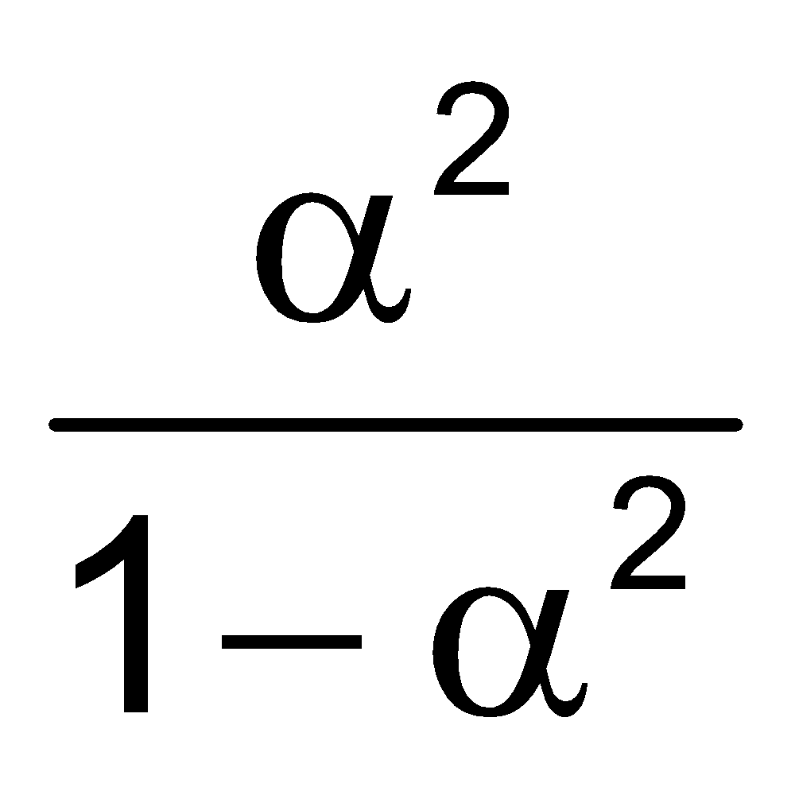= .335, α² = .25, α = .5
D-2. The extent of dissociation of PCl₅ at a certain temperature is 20 % at one atm pressure . Calculate the pressure at which this substance is half dissociated at the same temperature.

(1*) 0.123 (2) 0.246 (3) 0.826 (4) 0.111
Sol. PCl₅ PCl₃ + Cl₂
α = .2, initially, K_{P} = P = 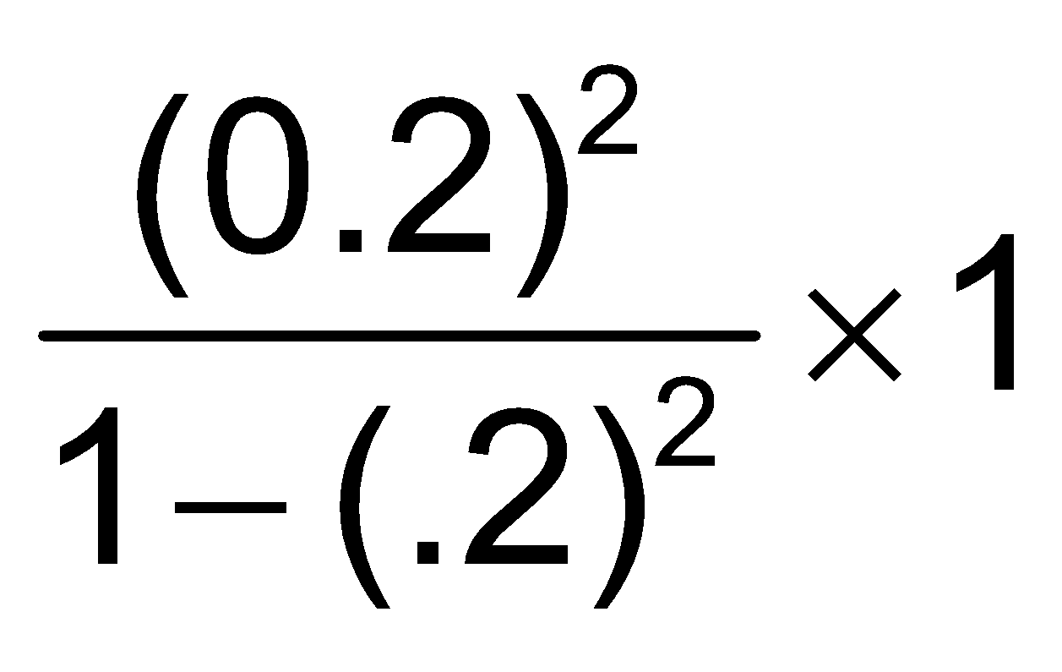=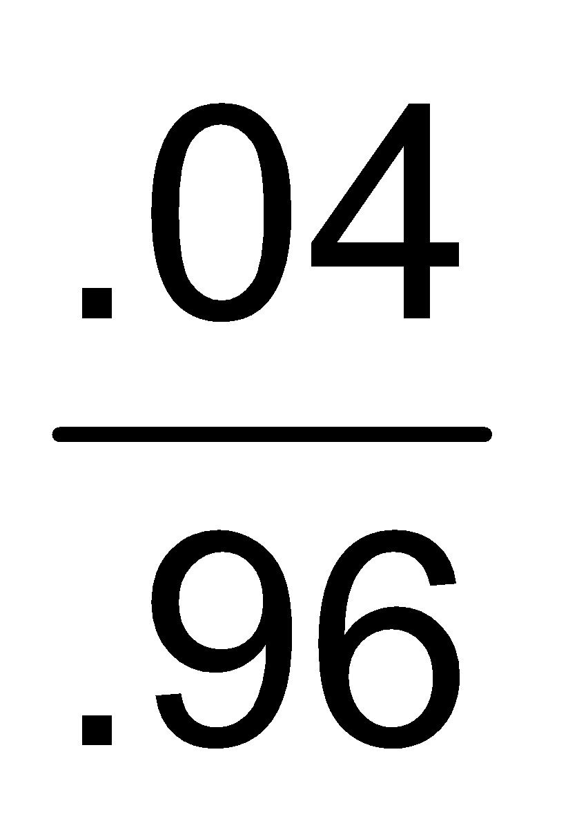= .042
if α = .5, thus, 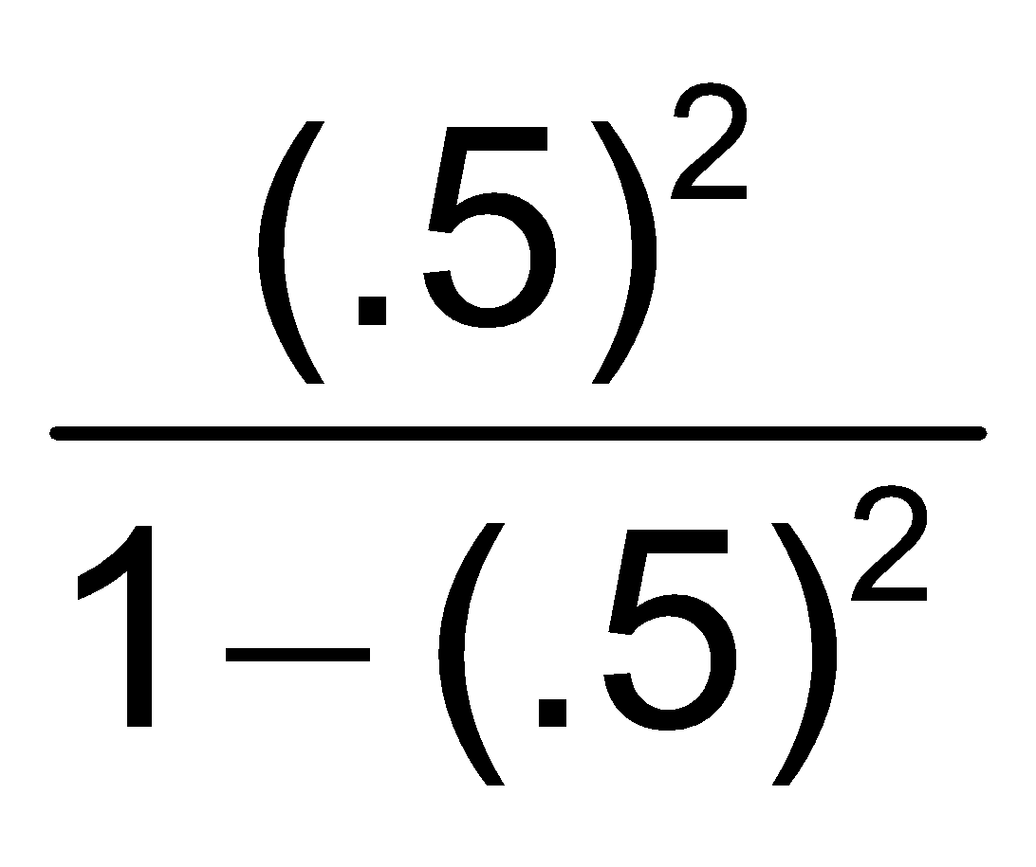× P = .042, P = .126

D-3. Consider the reactions
(i) PCl₅(g) PCl₃(g) + Cl₂(g)
(ii) N₂O₄(g) 2NO₂(g)
The addition of an inert gas at constant volume
(1) will increase the dissociation of PCl₅ as well as N₂O₄
(2) will reduce the dissociation of PCl₅ as well as N₂O₄
(3) will increase the dissociation of PCl₅ and step up the formation of NO₂
(4*) will not disturb the equilibrium of the reactions

Sol. Since inert gas addition has no effect at const. volume.
D-4. At 248º C , the k_{P} for the reaction , SbCl₅ (g) SbCl₃ (g) + Cl₂ (g) is 1.07 atm at a total pressure of 1 atm . Calculate the degree of dissociation of SbCl₅ .
(1) 0.516 (2*) 0.718 (3) 0.321 (4) None of these

Sol. SbCl₅(g) ⇒ SbCl₃(g) + Cl₂(g)
K_{P} = , P = 1 atm
10.7 = , α² = 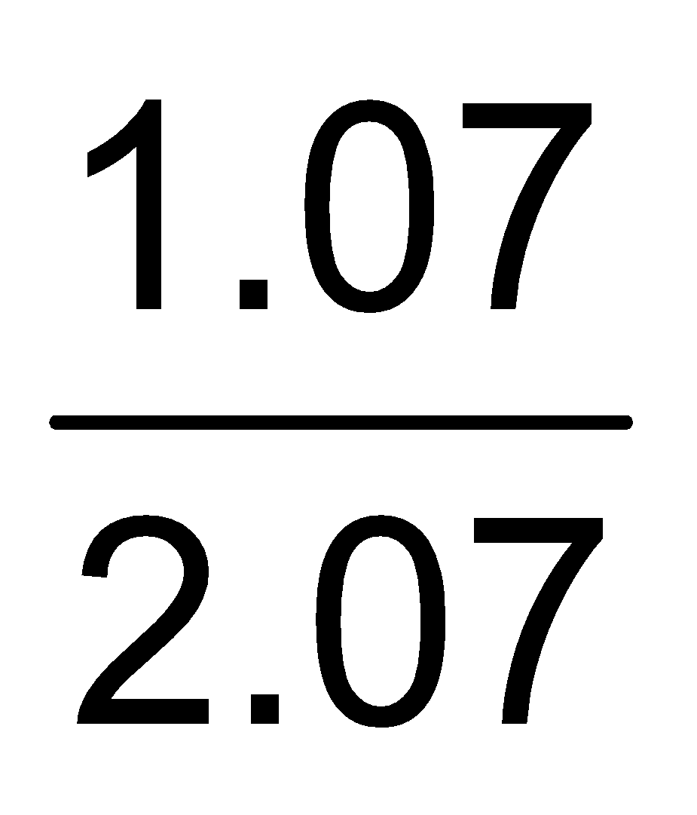, α = 0.718

D-5. 4 moles of A are mixed with 4 moles of B, when 2 moles of C are formed at equilibrium, according to the reaction, A + B C + D. The equilibrium constant is :

(1) 4 (2*) 1 (3) 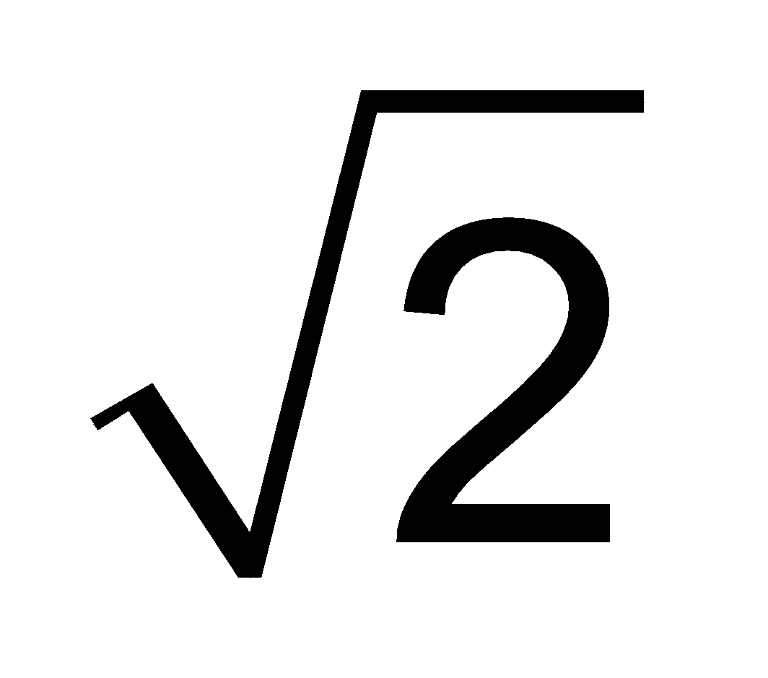 (4) 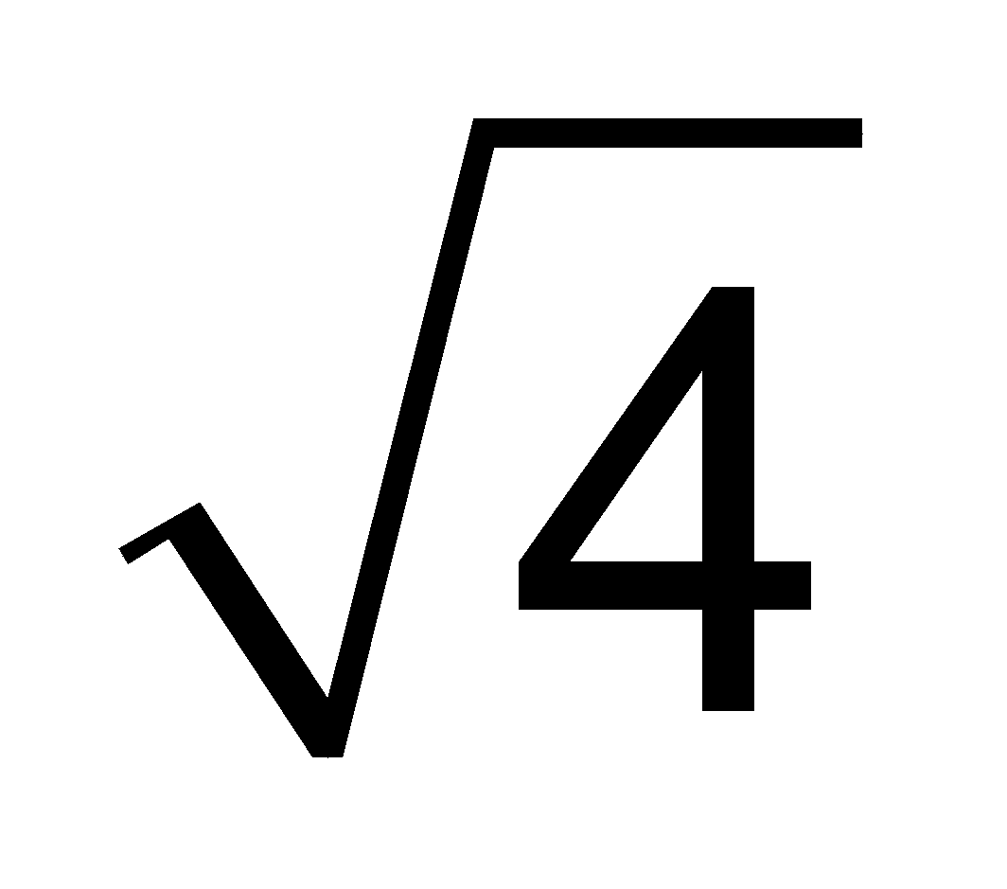
Sol. A + B C + D
t = 0 4 4 0 0
t = teq 4 – 2 4 – 2 2 2
K_{C} =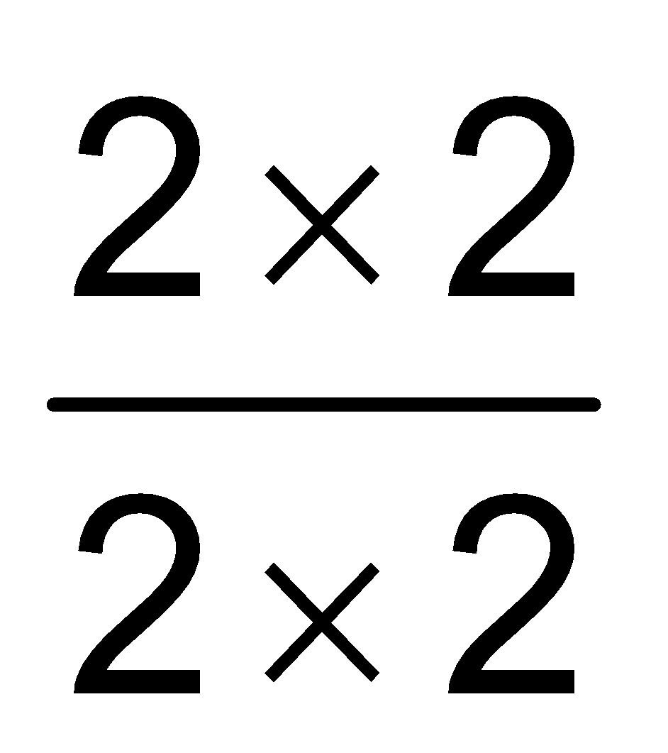= 1

D-6. 4 moles of PCl₅ are heated at constant temperature in closed container. If degree of dissociation for PCl₅ is 0.5 calculate total number of moles at equilibrium :

(1) 4.5 (2*) 6 (3) 3 (4) 4
Sol. PCl₅ PCl₃ + Cl₂
t = 0 4 0 0
t = eq 4 – 2 2 2 α = 5
Total molar 2 + 2 + 2 = 6

D-7. The dissociation of CO₂ can be expressed as 2CO₂ 2CO + O₂. If the 2 moles of CO₂ is taken initially and 40% of the CO₂ is dissociated equilibrium then total number of moles at equilirbrium :

(1*) 2.4 (2) 2.0 (3) 1.2 (4) 5
Sol. 2CO₂ 2CO + O₂
t =0 2 0 0
t =t_{eq.} 2 – 2 ×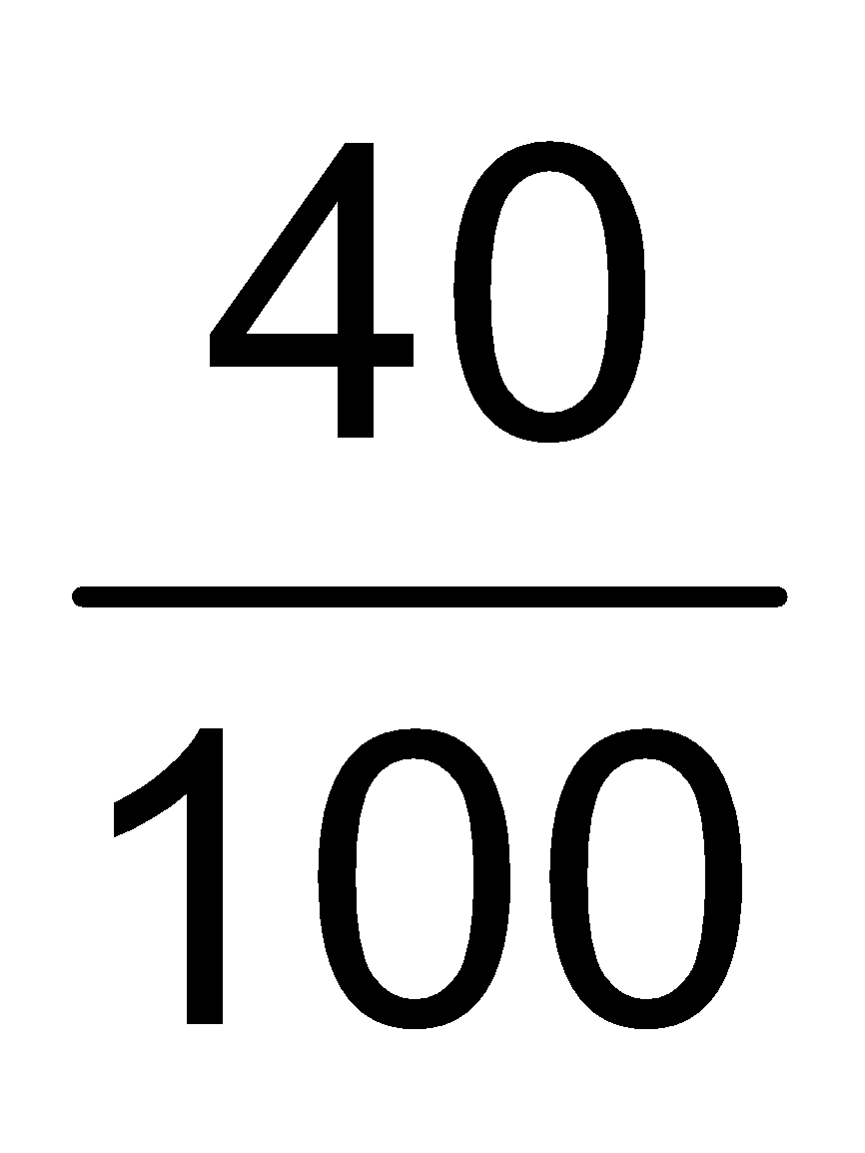 2 ×
Total moles at equilibrium () = 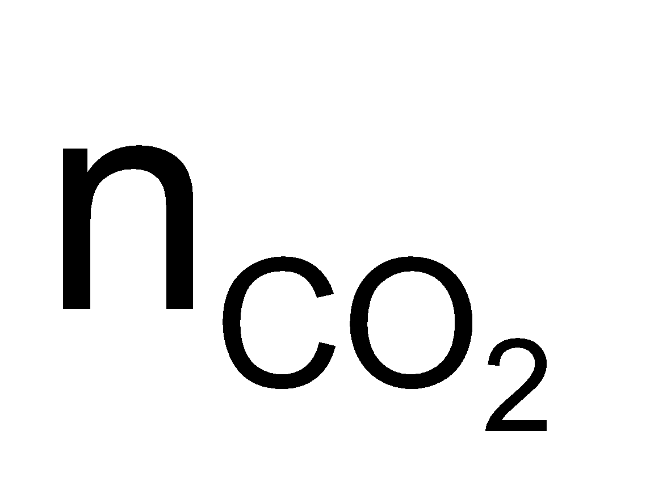+ 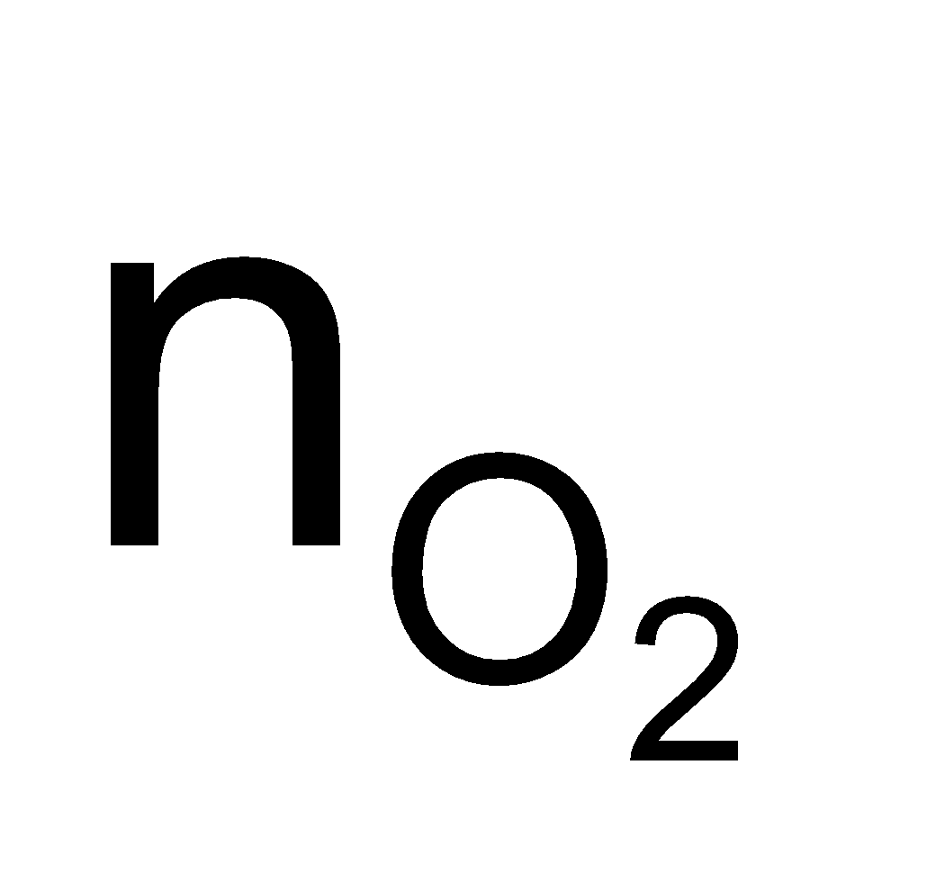+ 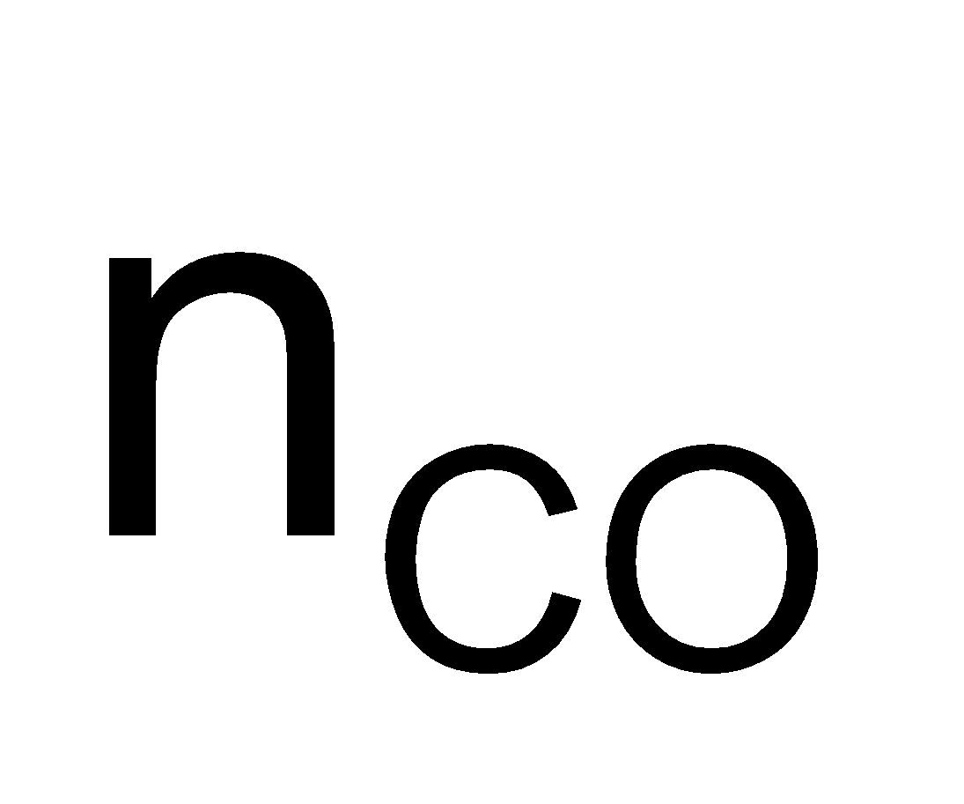
= 2 – 2 × + 2 × + = 2.4
D-8. In the reaction 2P(g) + Q(g) 3R(g) + S(g). If 2 moles each of P and Q taken initially in a 1 litre flask. At equilibrium which is true :
(1*) [P] < [Q] (2) [P] = [Q] (3) [Q] = [R] (4) None of these

Sol. 2P(g) + Q(g) 3R(g) + S(g)
t = 0 2 2 0 x/2
t = teq 2 – x 2 – x/2 3/2 x x/2
from above, at equilibrium 2 – x < 2 – x/2
∴ [P] < [Q] at equilibrium

D-9. In a 0.25 litre tube dissociation of 4 moles of NO is take place. If its degree of dissociation is 10%. The value of K_{p} for reaction 2NO N₂ + O₂ is :

(1*) 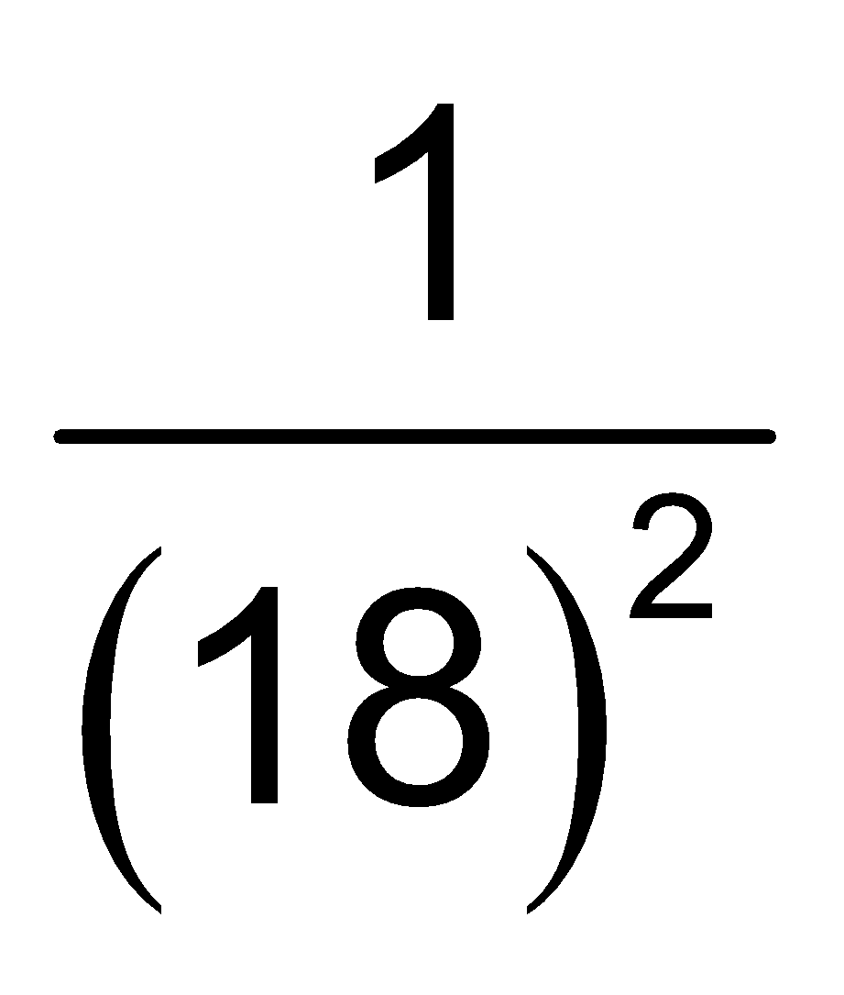 (2) 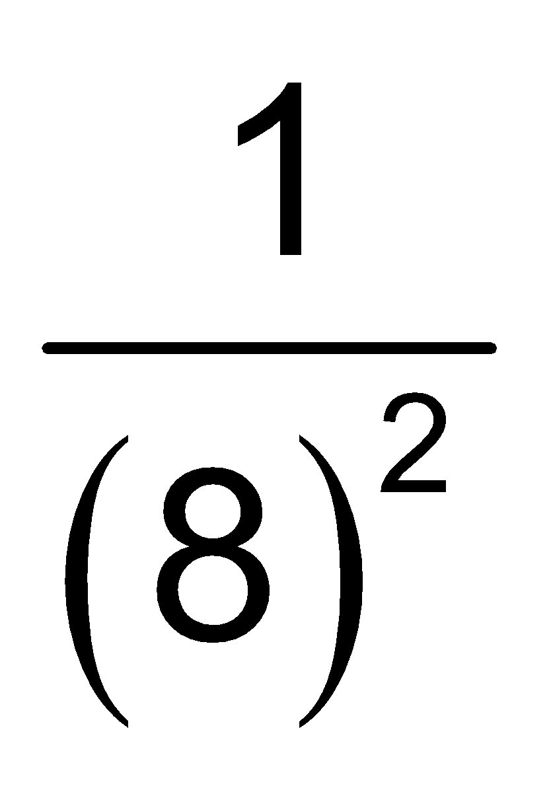 (3)  (4) 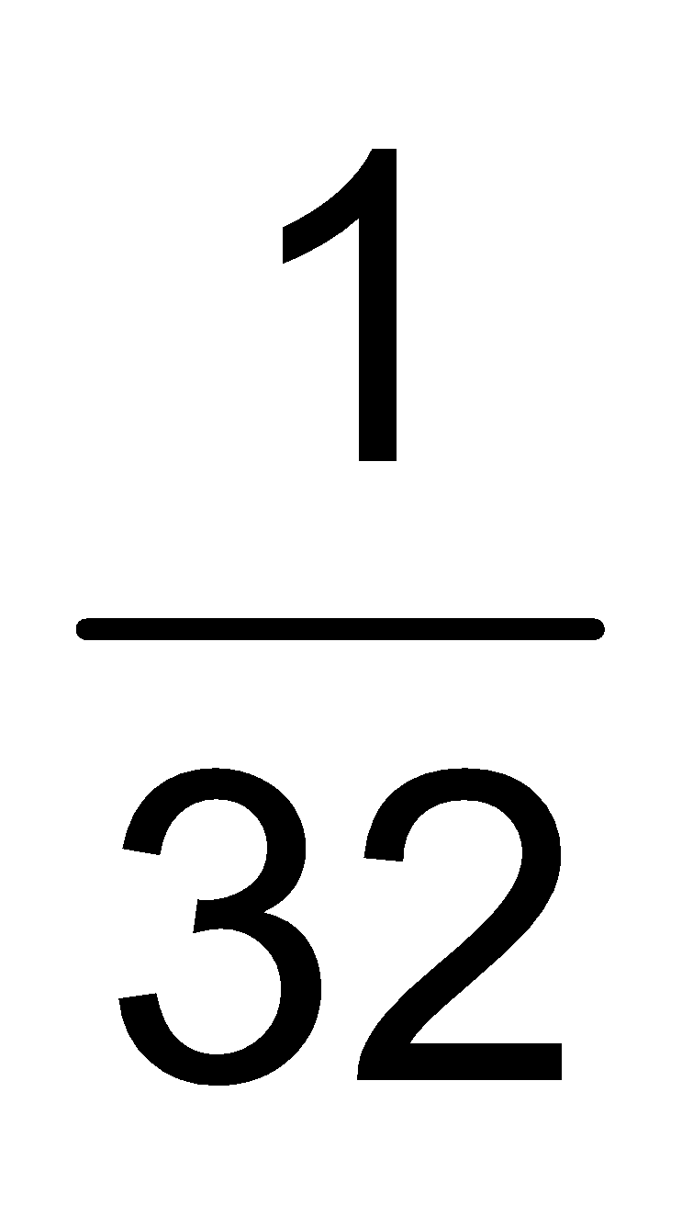
Sol. 2NO N₂ + O₂ α = 10%
t = 0 4 – .4 .2 .2
3.6 0.2 0.2
Δn = 0,
∴ K_{P} = K_{C}, K_{C} = 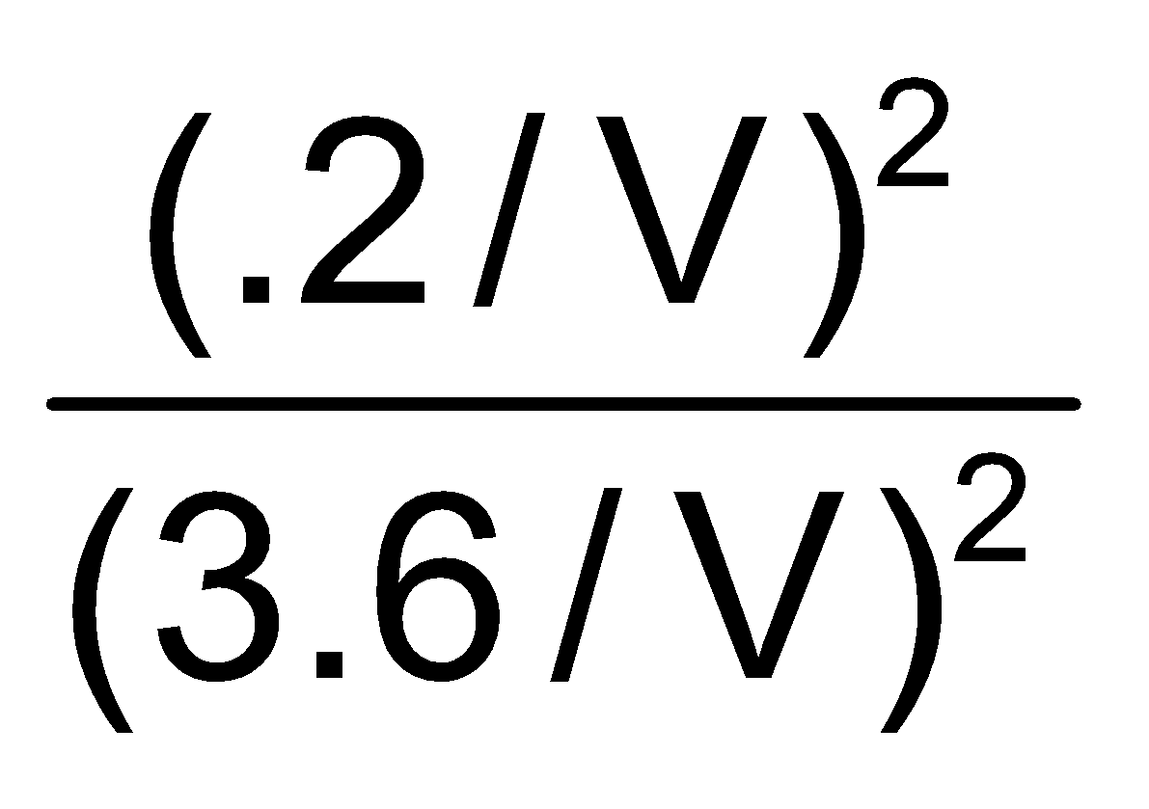=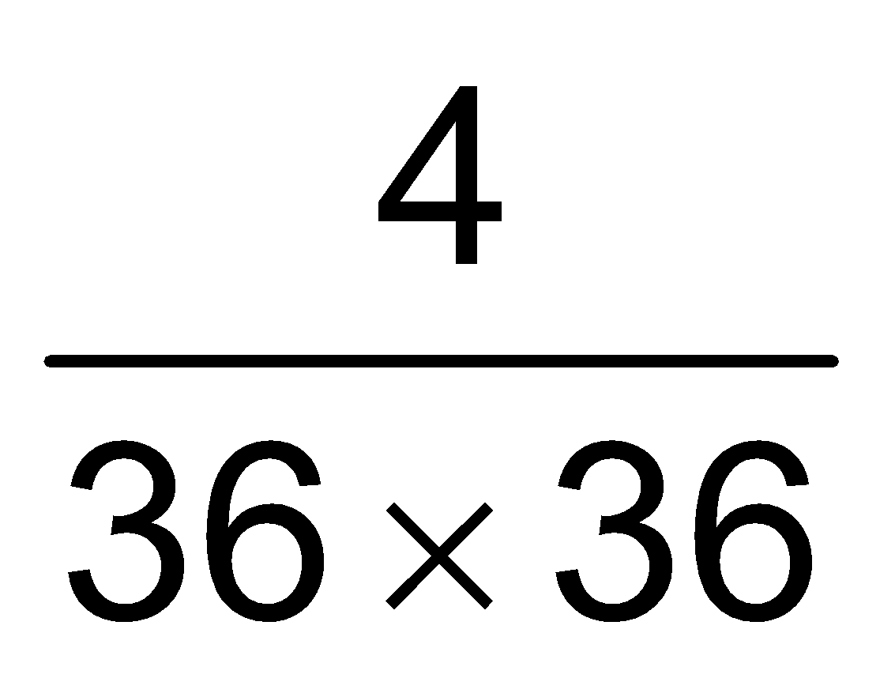

D-10. The vapour density of N₂O₄ at a certain temperature is 30. What is the percentage dissociation of N₂O₄ at this temperature ?
(1*) 53.3 % (2) 106.6% (3) 26.7% (4) none

Sol. α =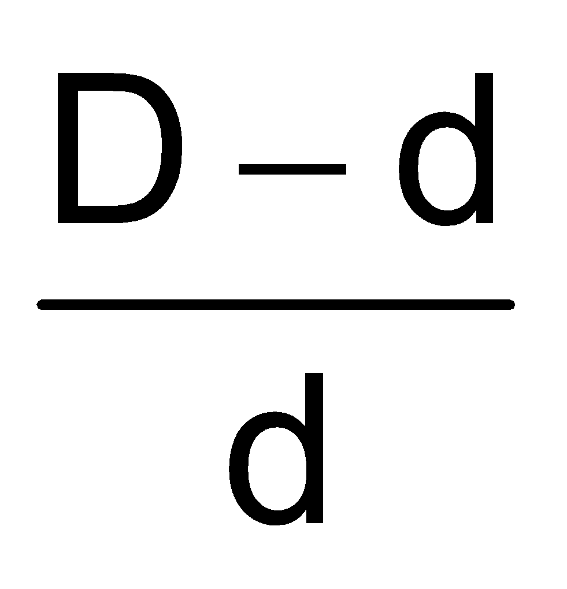=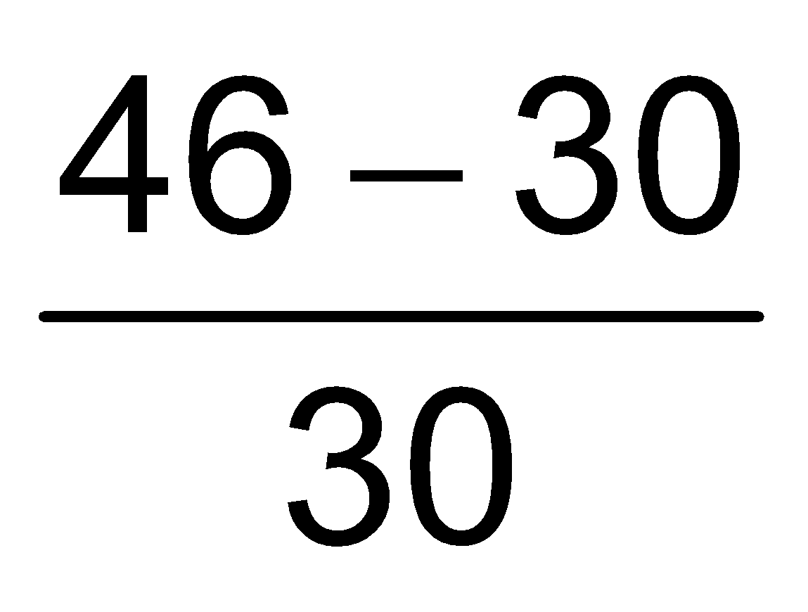= 0.533 = 53.3%

D-11. A sample of mixture of A(g), B(g) and C(g) under equilibrium has a mean molecular weight (observed) is 80.
The equilibrium is A(g) B(g) + C(g)
(mol. wt. = 100) (mol. wt. = 60) (mo. wt. = 40)
Find the degree of dissociation α for A(g).

(1*) 0.25 (2) 0.5 (3) 0.75 (4) 0.8
Sol. A(g) B(g) + C(g)
M_{Ob} = 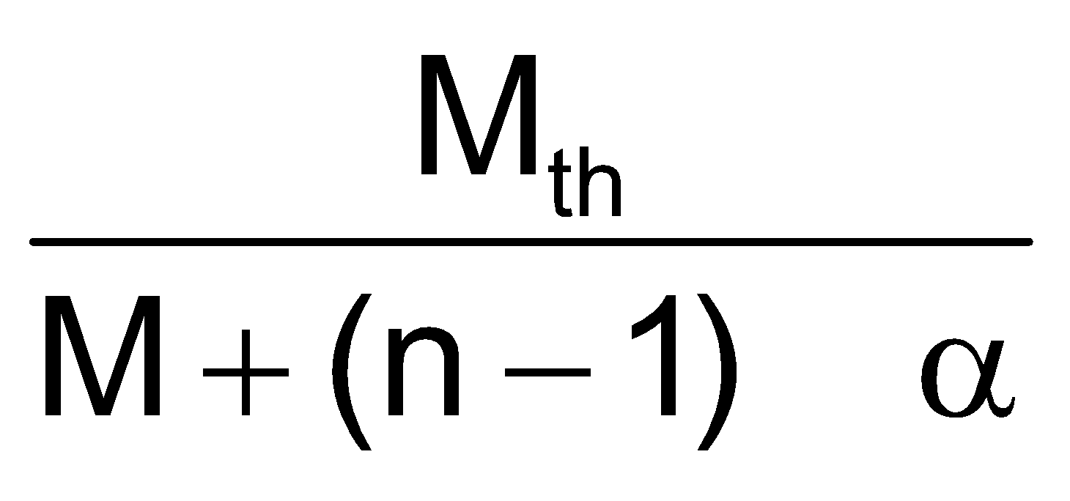 80 =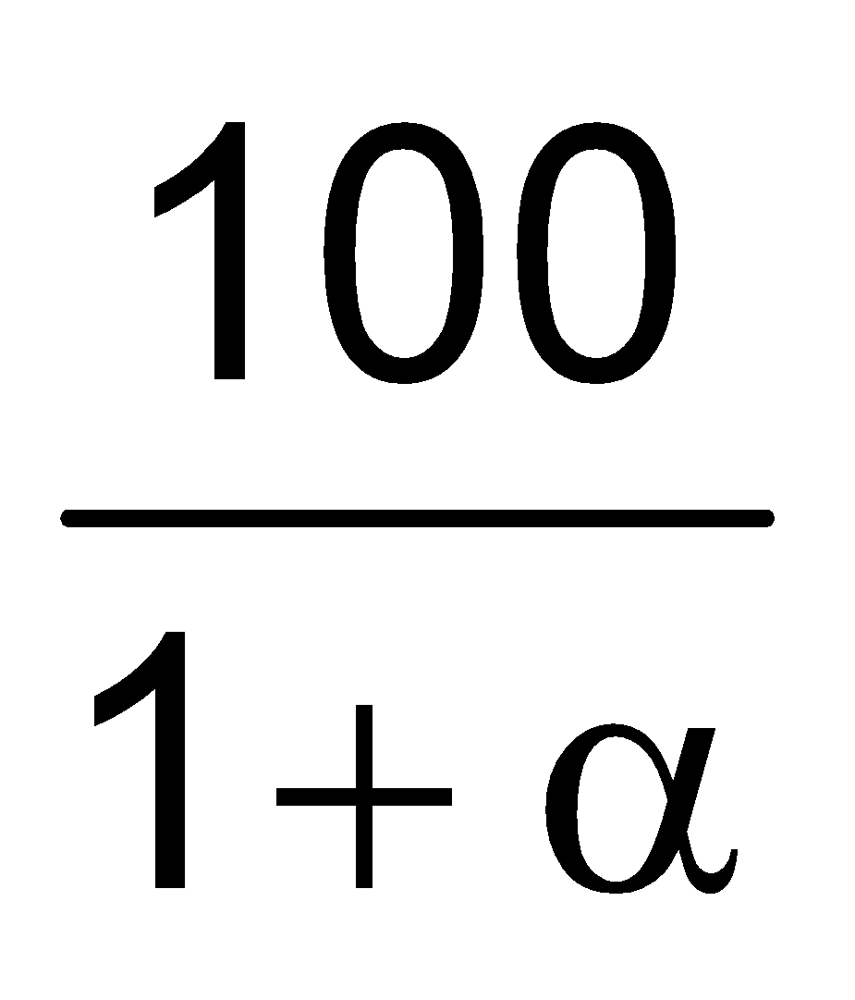 α = = 0.25

D-12. The degree of dissociation of PCl₅ (g) obeying the equilibrium, PCl₅ PCl₃ + Cl₂ , is approximately related to the presure at equilibrium by -

(1) α ∝ P (2*) α ∝ 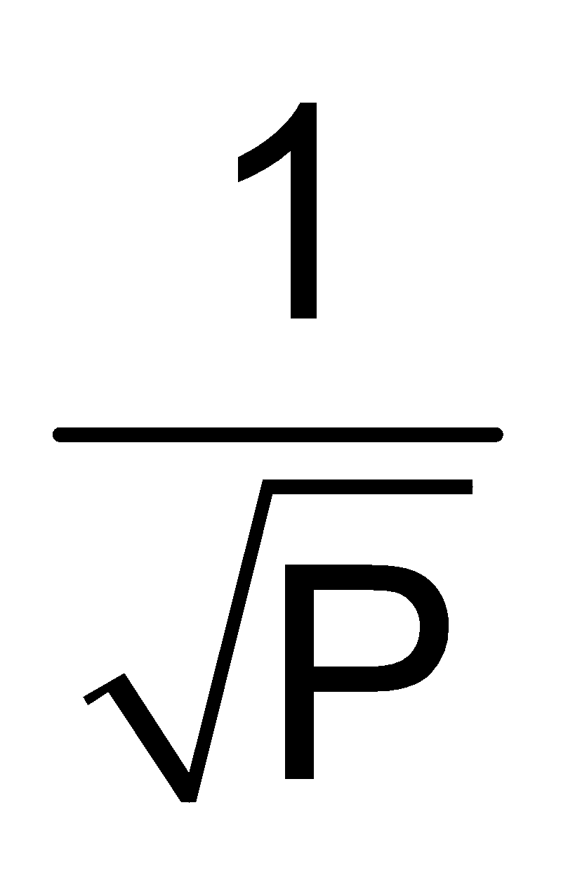 (3) α ∝ 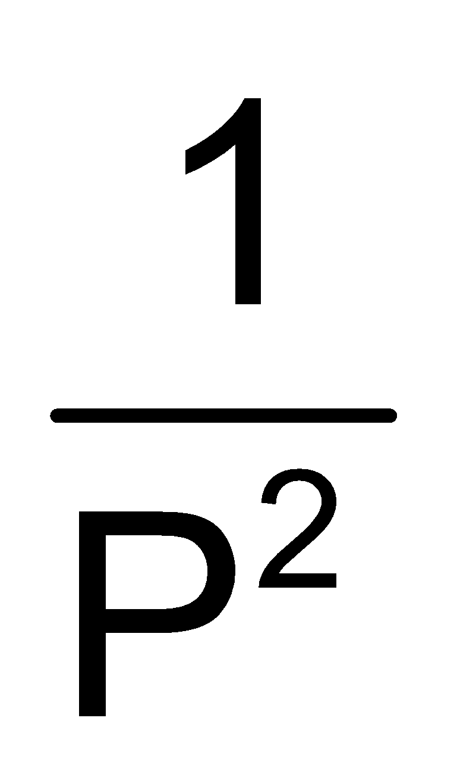 (4) α ∝ 
Sol. PCl₅ PCl₃ + Cl₂
t=0 1 0 0
t=t_{eq} 1–α α α

K_{P} = 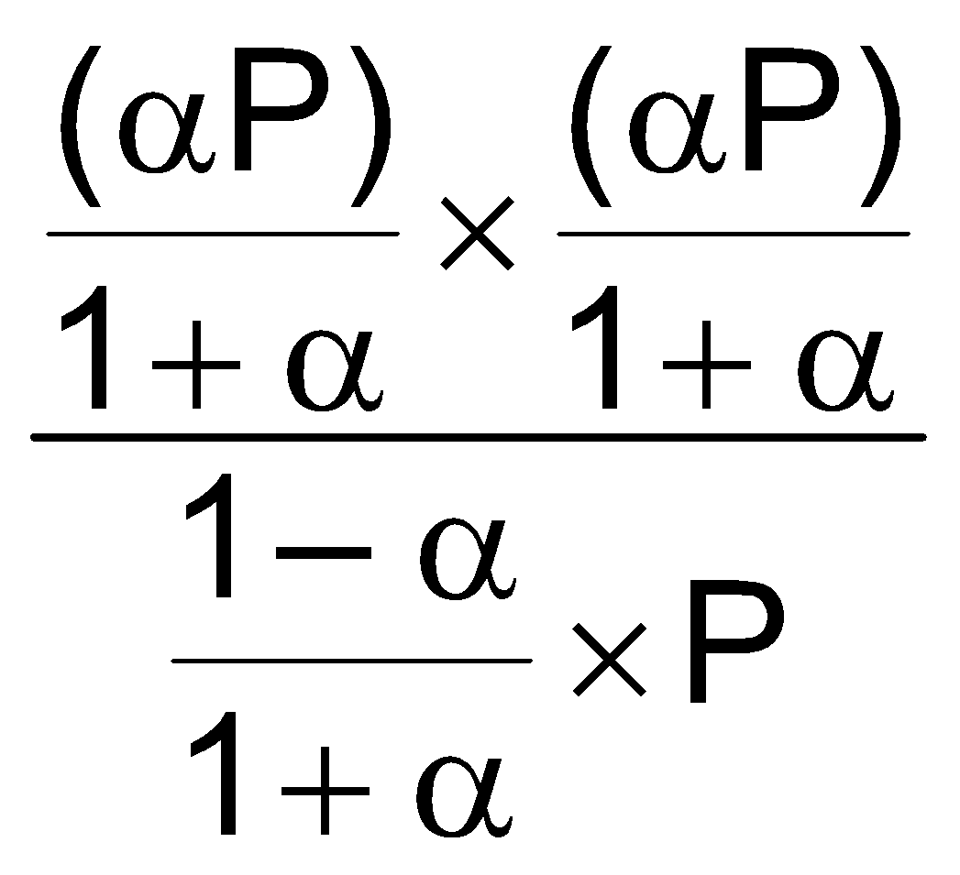=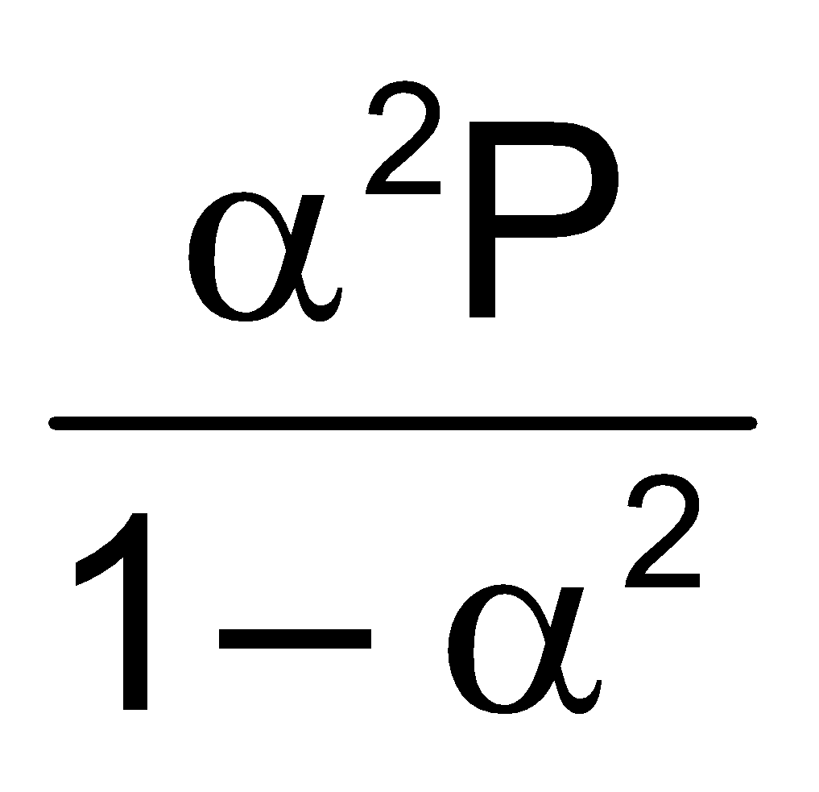 (α < < 1)
i.e. α ∝

D-13. PCl₅(g) PCl₃(g) + Cl₂(g)
In above reaction, at equilibrium condition mole fraction of PCl₅ is 0.4 and mole fraction of Cl₂ is 0.3. Then find out mole fraction of PCl₃

(1*) 0.3 (2) 0.7 (3) 0.4 (4) 0.6
Sol. PCl₅(g) PCl₃(g) + Cl₂(g)
t=0 1 0 0
t=t_{eq} 1 – x x x
Total moles = 1 + x
Given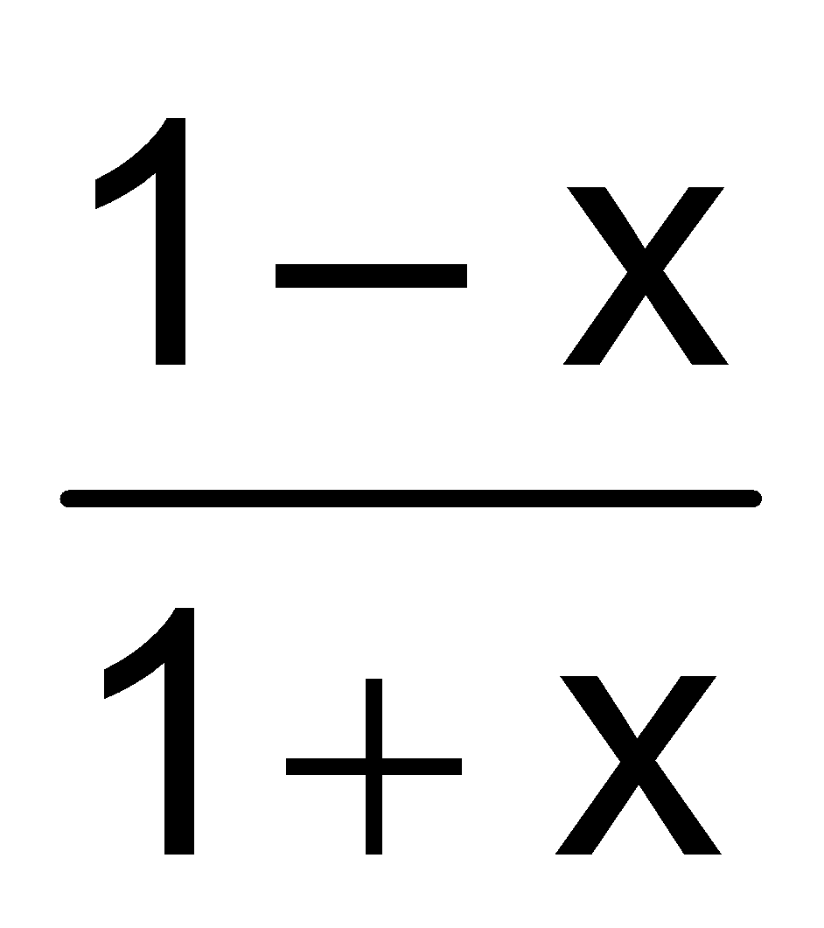= 0.4
x = 
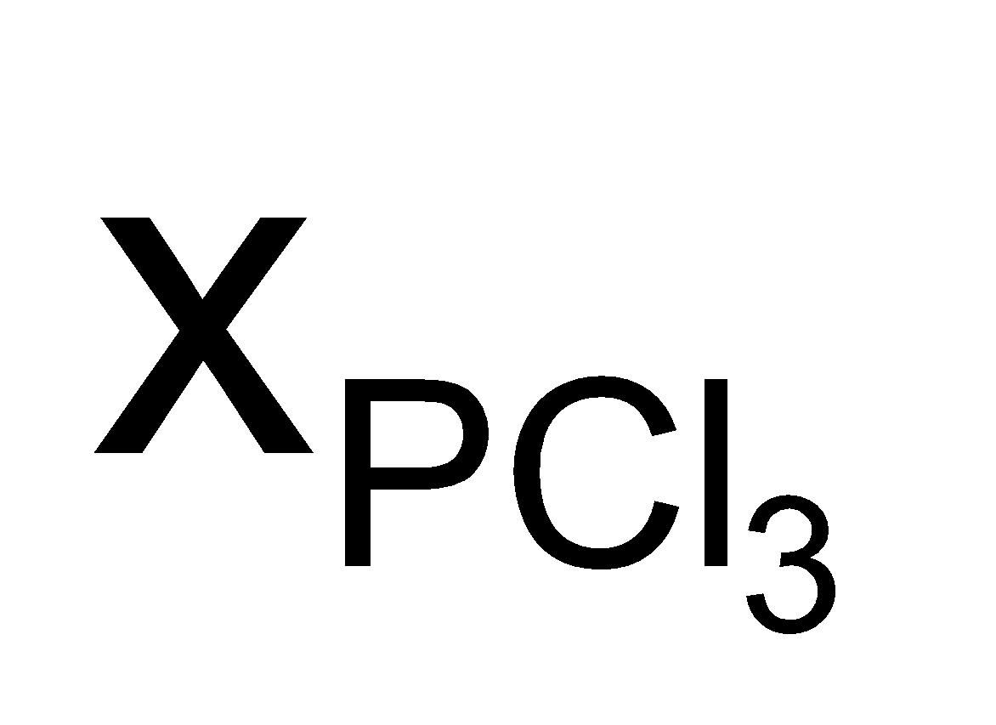= 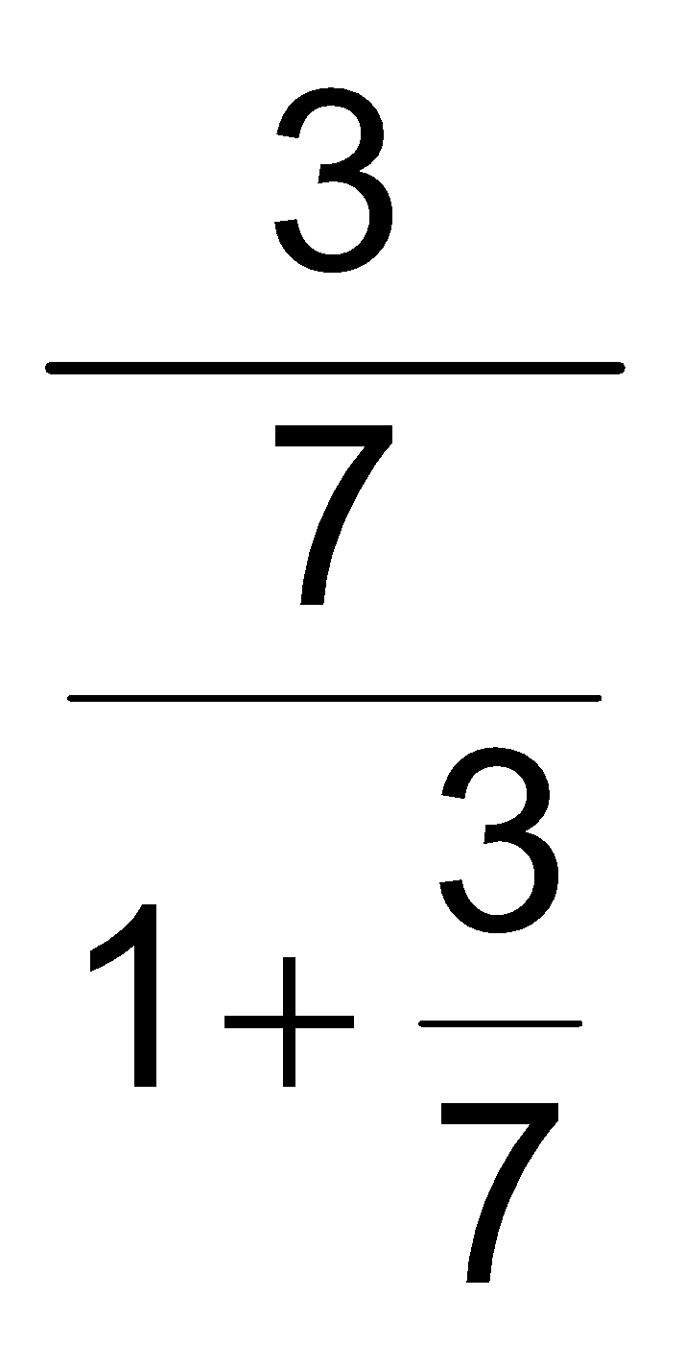 = 0.3.

D-14. N₂O₄(g)2NO₂(g) In this reaction the dissociation of N₂O₄ is X then the how much mole will of N₂O₄ and NO₂ at equilibrium : [RPMT 2001]
N₂O₄(g) 2 NO₂(g)

(1) (1 – x)² (2) 1 (3*) (1 + x) (4) 2
Sol. N₂O₄(g) 2 NO₂(g)
(1–x) 2x
(1 – x) + 2x = 1 + x

D-15. 5 moles of SO₂ and 5 moles of O₂ are allowed to react to form SO₃ in a closed vessel. At the equilibrium stage, 60% SO₂ is used up. The total number of moles of SO₂, O₂ and SO₃ in the vessel now is :

(1) 3.9 (2) 10.5 (3*) 8.5 (4) 10.0
Sol. SO₂ + O₂ SO₃
5 moles 5 moles 0
5 – 5 × 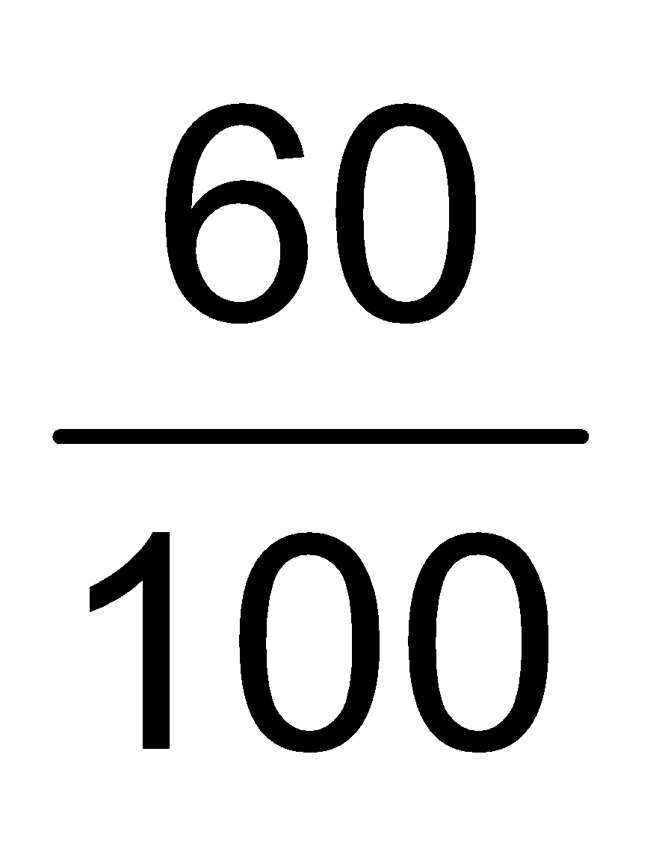 5 – × 5 × 5 ×
= 2 + 3.5 + 3 = 8.5 moles

D-16. A mixture of NO₂ and N₂O₄ has a vapour density of 38.3 at 300 K. What is the number of moles of NO₂ in 100 g of the mixture ? [Kerla PMT 2004]

(1) 0.043 (2) 4.4 (3) 3.4 (4*) 0.437
Sol. Suppose NO₂ = xg. Then N₂O₄ = (100 – x) g
Moles of NO₂ = 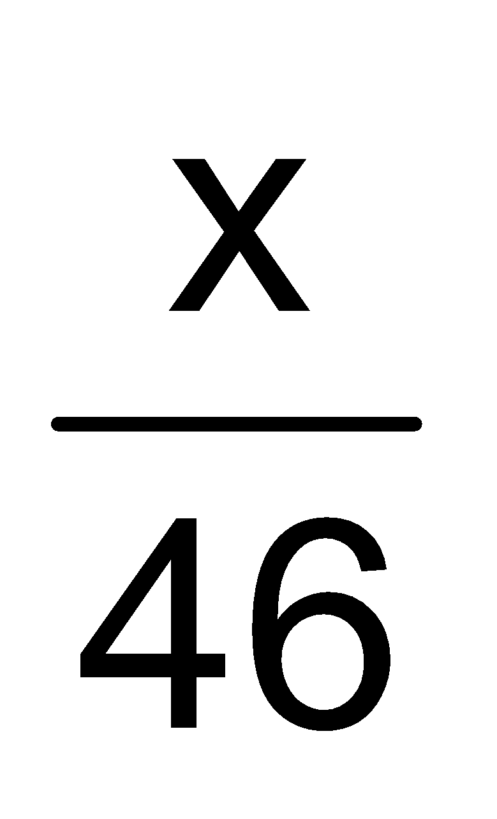, Moles of N₂O₄ = 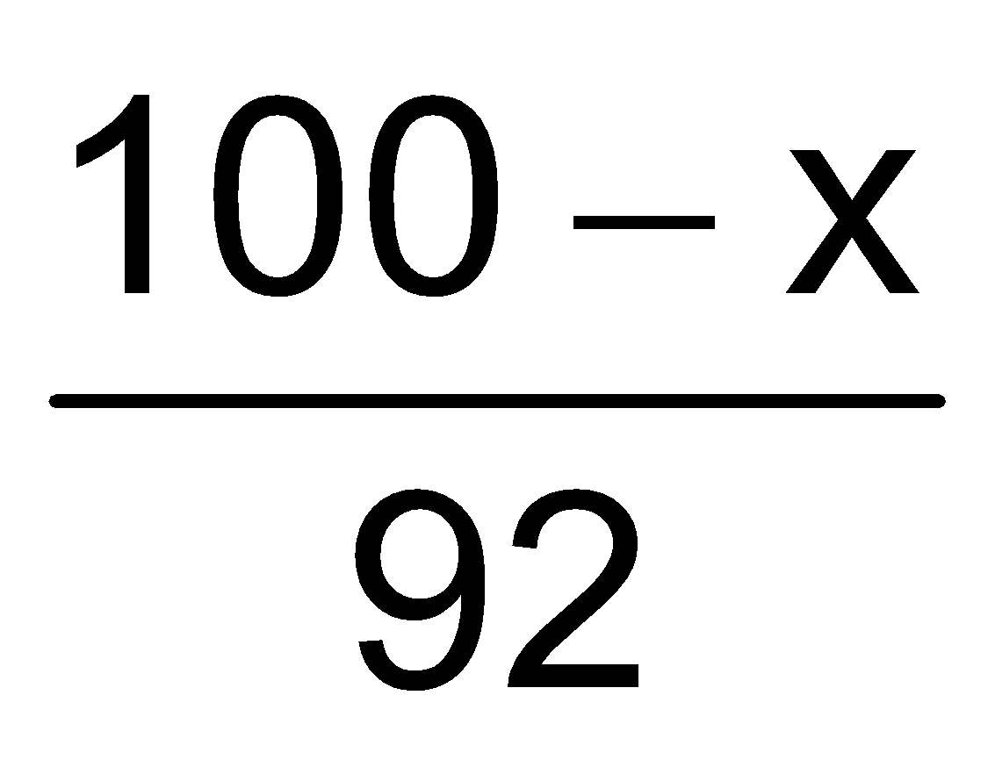
Mole fraction of NO₂ = 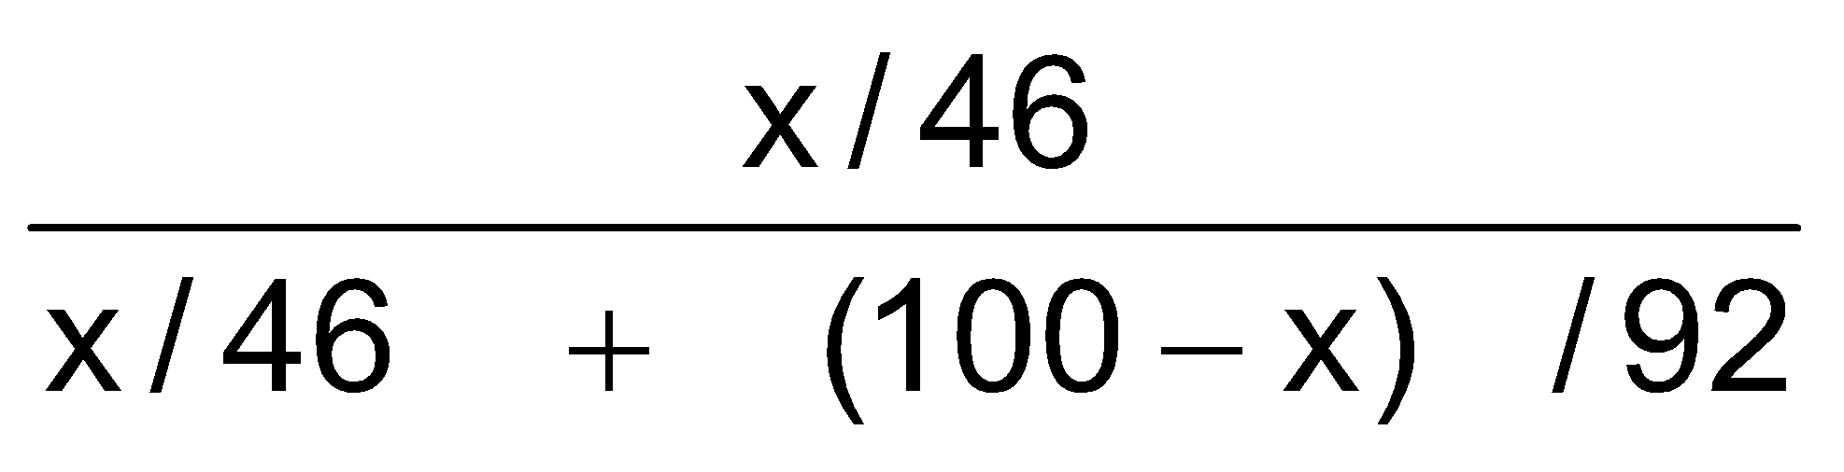= × 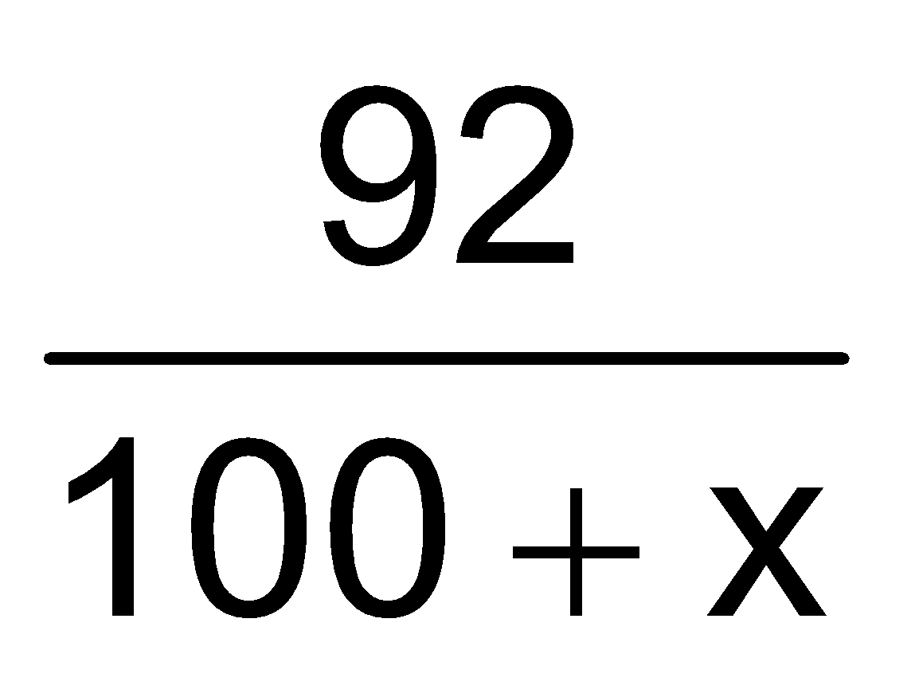 = 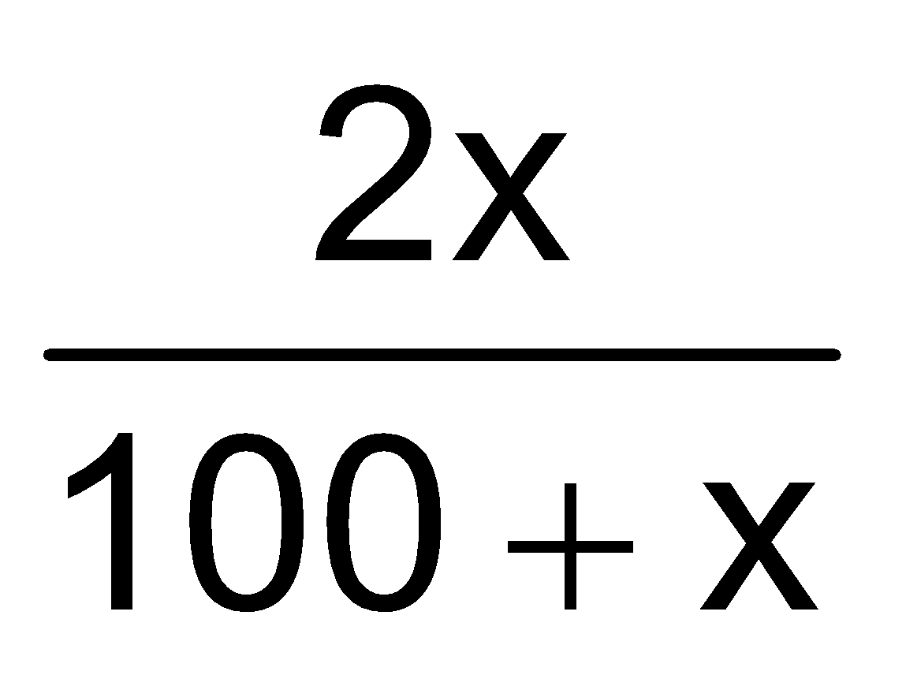
Mole fraction of N₂O₄ = 1 – 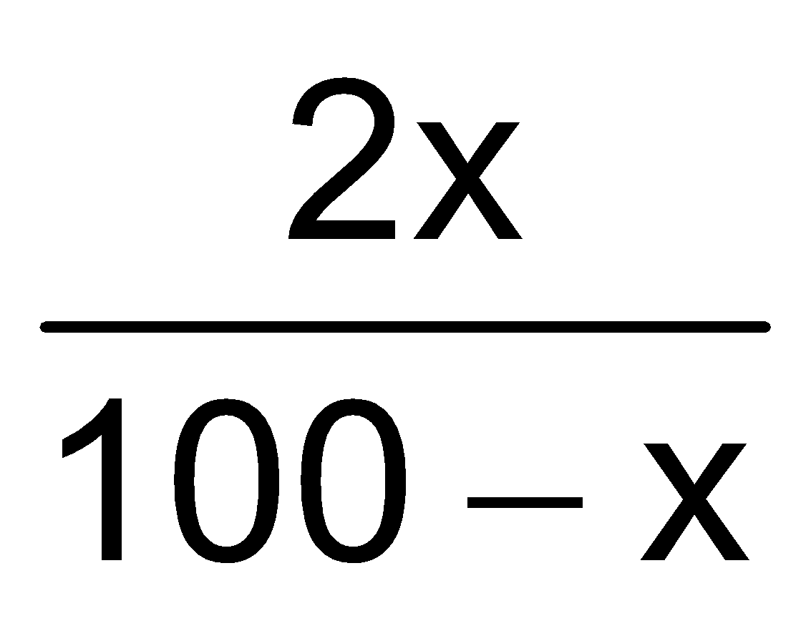= 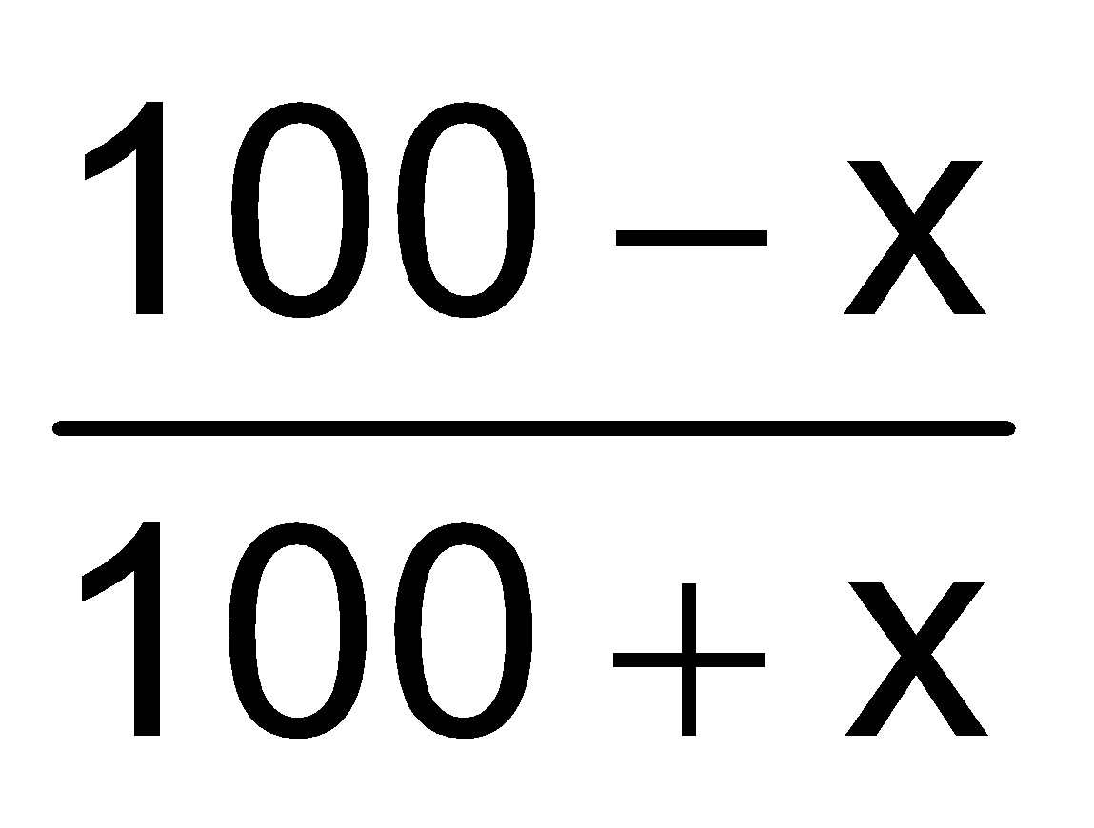
Molar mass of mixture = × 46 + × 92 =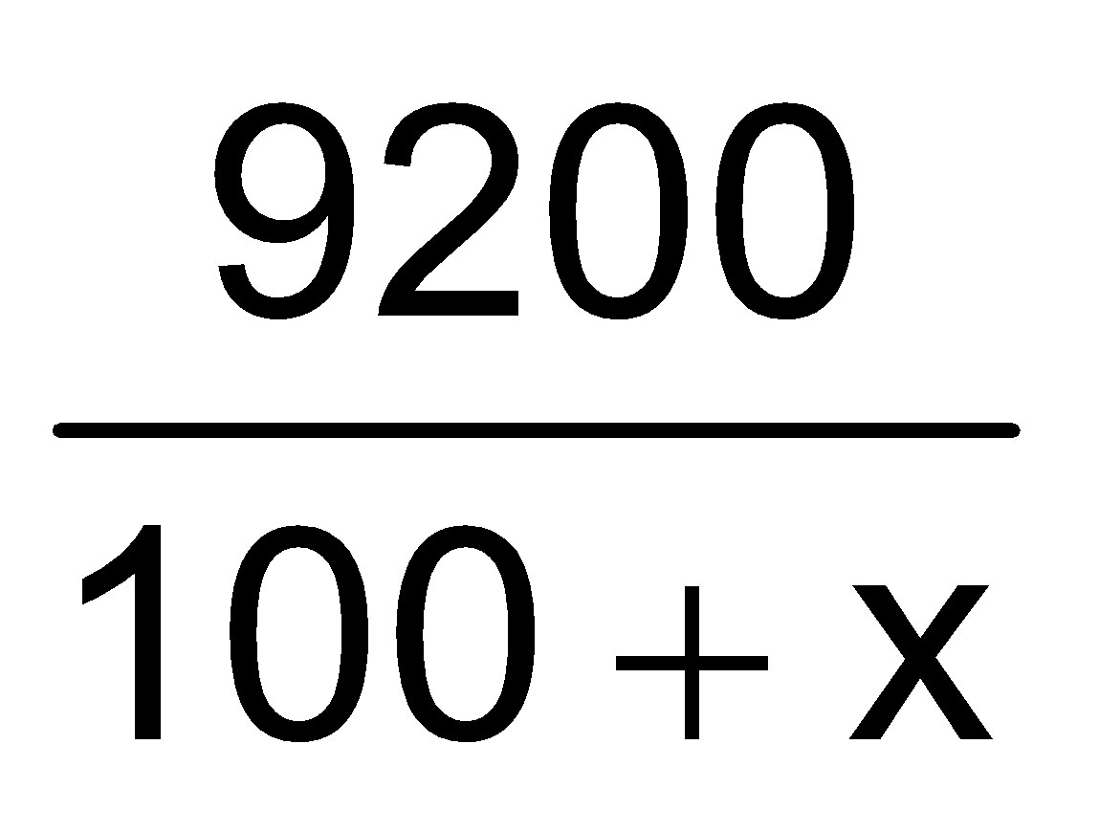
∴ = 2 × 38.3 = 76.6
or 76.6x = 9200 – 7660 = 1540
or x = 20.10 g
∴ moles of NO₂ =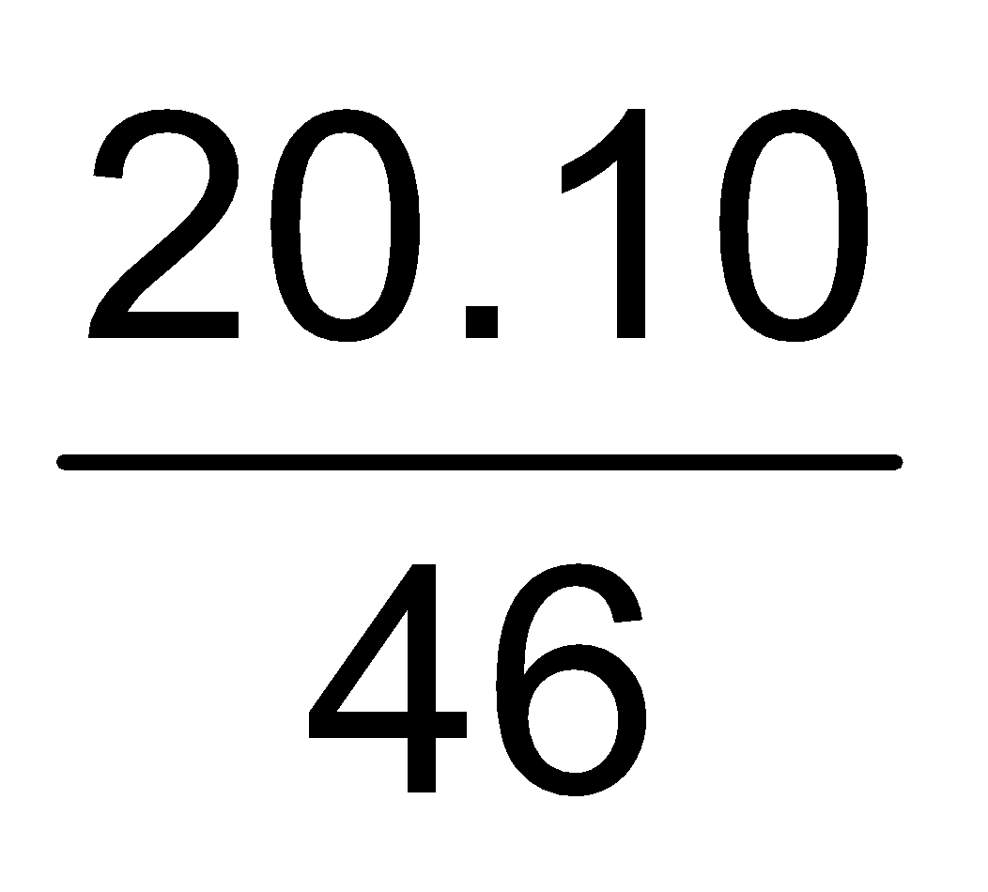= 0.437

Section (E) : Heterogenous Equilibrium

E-1. In the reaction C(s) + CO₂(g) 2CO(g), the equilibrium pressure is 12 atm. If 50% of CO₂ reacts then K_{p} will be :

(1) 12 atm (2*) 16 atm (3) 20 atm (4) 24 atm
Sol. C(s) + CO₂(g) 2CO(g)
P–P/2 P = 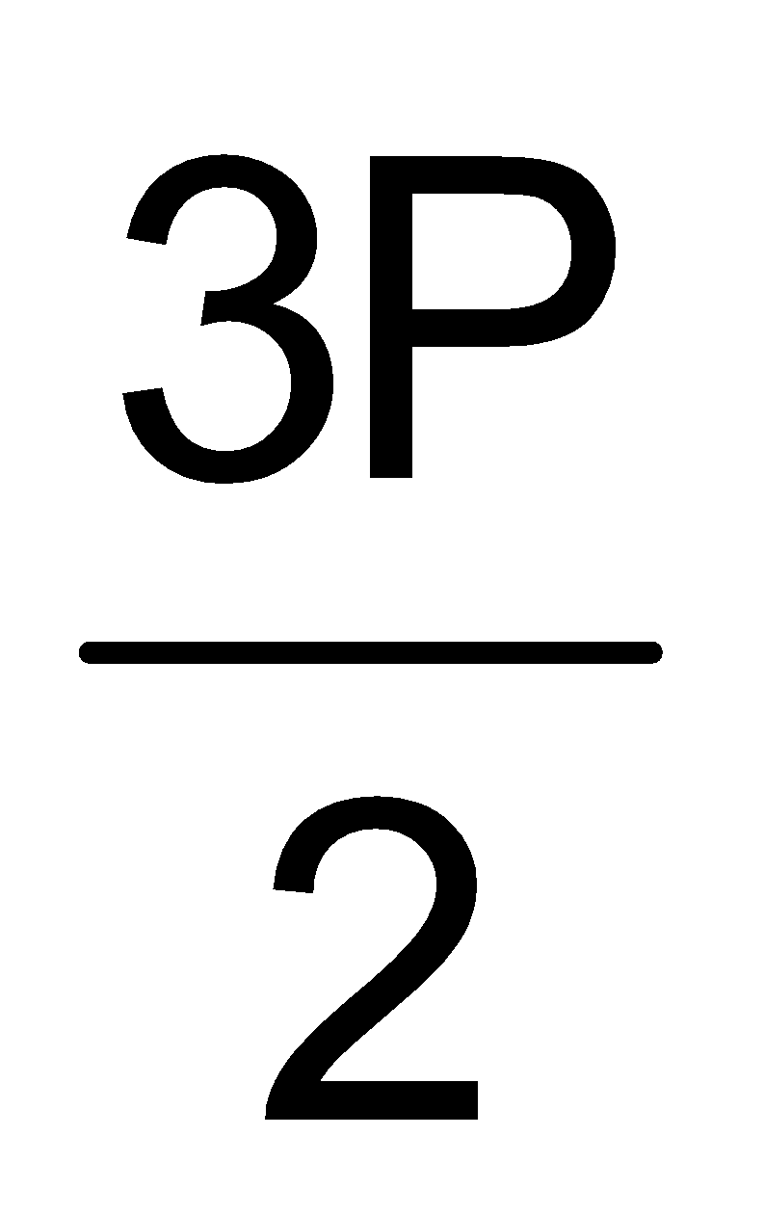= 12
so K_{P} = 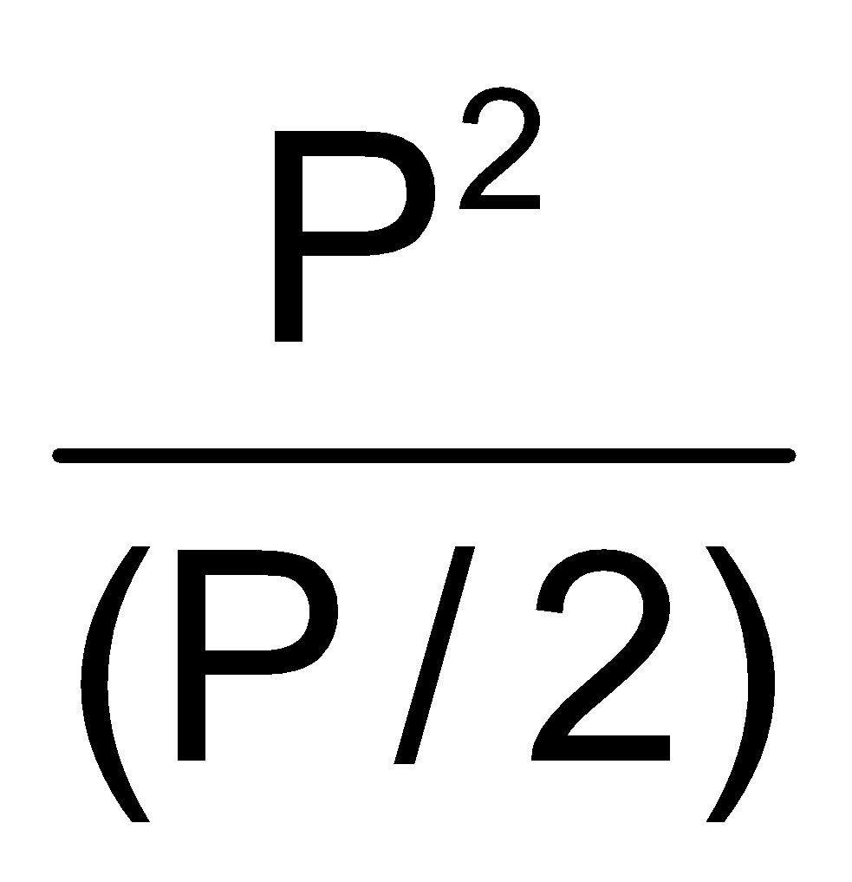= 2P = 2 × 8 = 16 atm.

E-2. What is the minimum mass of CaCO₃ (s), below which it decomposes completely, required to establish equilibrium in a 6.50 litre container for the reaction : CaCO₃(s) CaO(s) + CO₂(g) K_{c} = 0.05 mole/litre

(1*) 32.5 g (2) 24.6 g (3) 40.9 g (4) 8.0 gm
Sol. K_{C} = [CO₂] = 0.05 mole/litre
so moles of CO₂ = 6.50 × 0.05 moles = 0.3250 moles
CaCO₃ CaO + CO₂
1 mole of CO₂ = 1 mole of CaCO₃
0.3250 moles of CO₂ = 0.3250 moles of CaCO₃ = 0.3250 × 100 gm of CaCO₃ = 32.5 gm of CaCO₃

Section (F) : Thermodynamics of Equilibrium
F-1. The correct relationship between free energy change in a reaction and the corresponding equilibrium constant K is : [RPMT 2008]

(1*) – ΔGº = RT ln K (2) ΔG = RT ln K (3) – ΔG = RT ln K (4) ΔGº = RT ln K
Sol. Gibbs equation ΔG = ΔGº – RT ln K
at equilibrium ΔG = 0
– ΔGº = RT ln K

F-2. Which of the following is not favourable for SO₃ formation
2SO₂ (g) + O₂ (g) 2SO₃ (g); ΔH = – 45.0 kcal
(1) High pressure (2*) High temperature
(3) Decreasing SO₃ concentration (4) Increasing reactant concentration

Sol. ΔGº = ΔHº – TΔSº, here entropy change is –ve.
∴ ΔGº = ΔHº + TΔSº
ΔHº becomes less negative by increasing in the temperature & increase in temperature is not favourable for SO₃ formation.

F-3. In an equilibrium reaction for which ΔG° = 0, the value of equilibrium constant K =

(1) 0 (2*) 1 (3) 2 (4) 10
Sol. At equilibrium ΔG = 0
Given ΔG⁰ = 0
Gibbs equation ΔG = ΔGº – RT ln K
0 = 0 – RTlnK
K = e⁰ = 1

F-4. The effect of temperature on equilibrium constant is expressed as (T₂ > T₁)
log (K₂/K₁) = 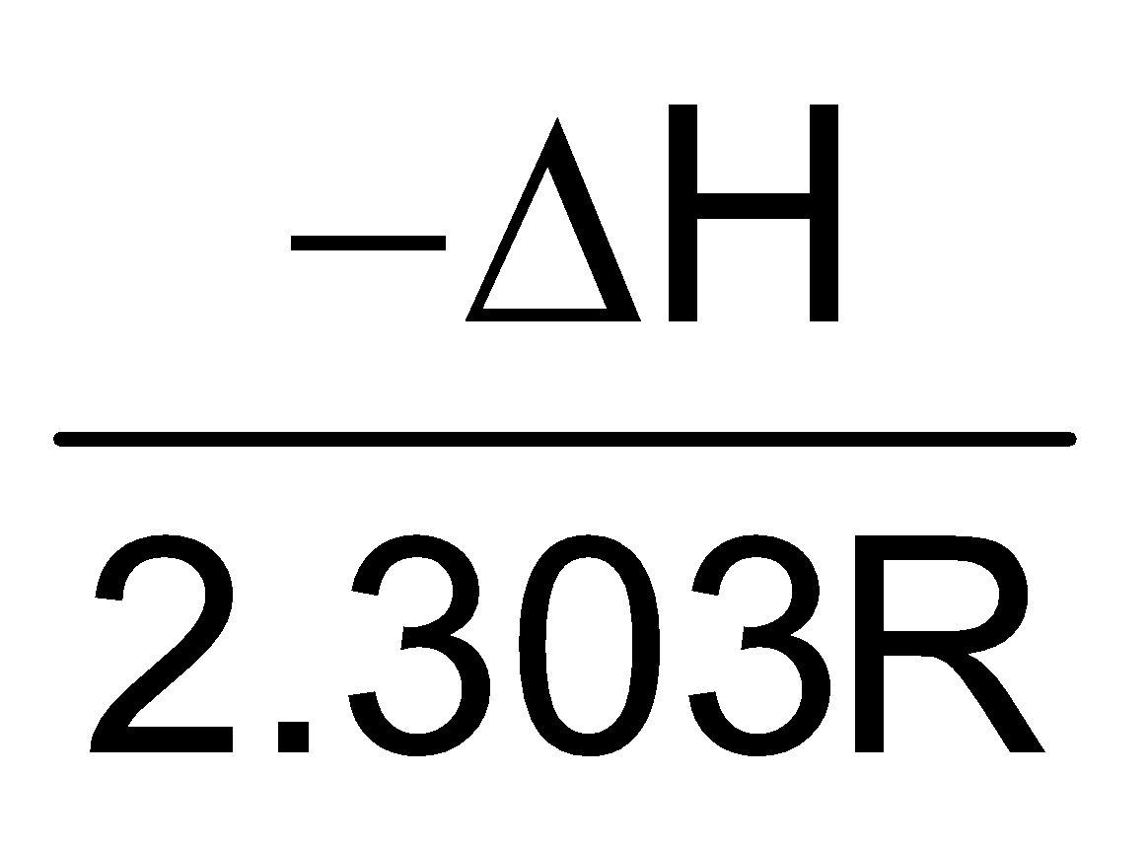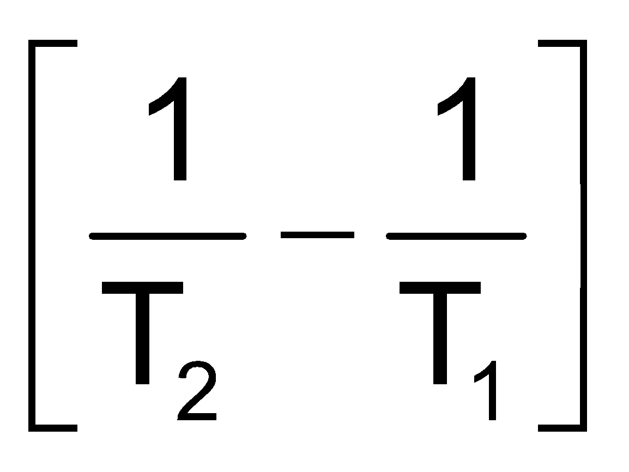. For endothermic reaction false statement is
(1*) = positive (2) ΔH = positive [Correction by AGA_25.9.17]
(3) log K₂ > log K₁ (4) K₂ > K₁

Sol. From equation it is given T₂ >T₁
∴ 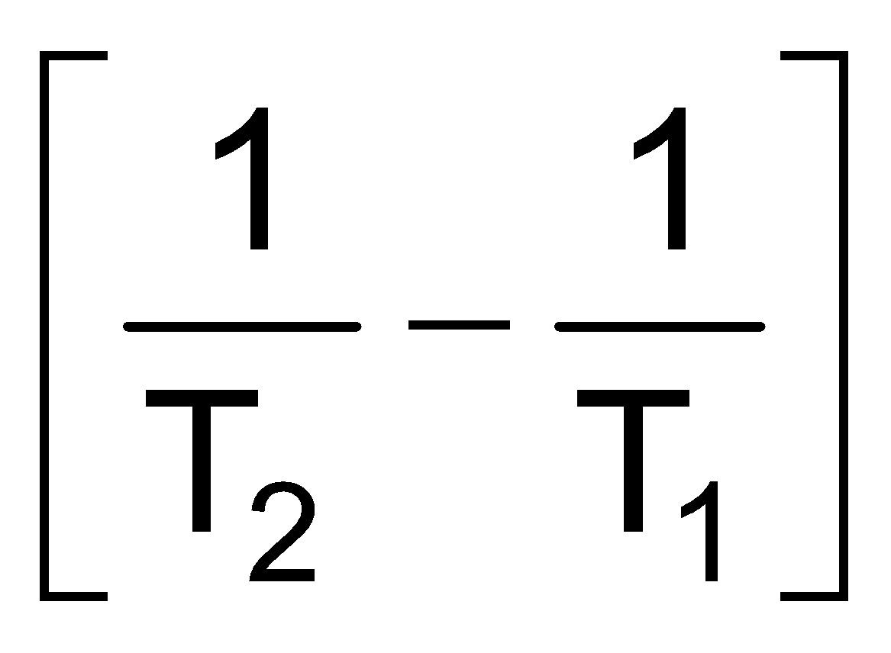= 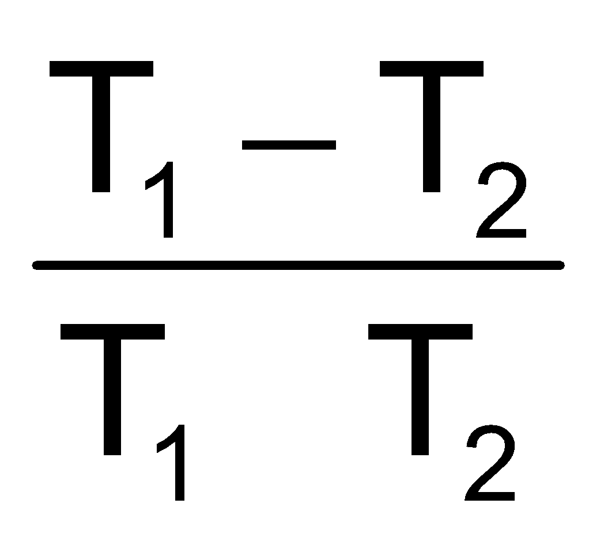= negative value

F-5. An exothermic reaction is represented by the graph :
(1) 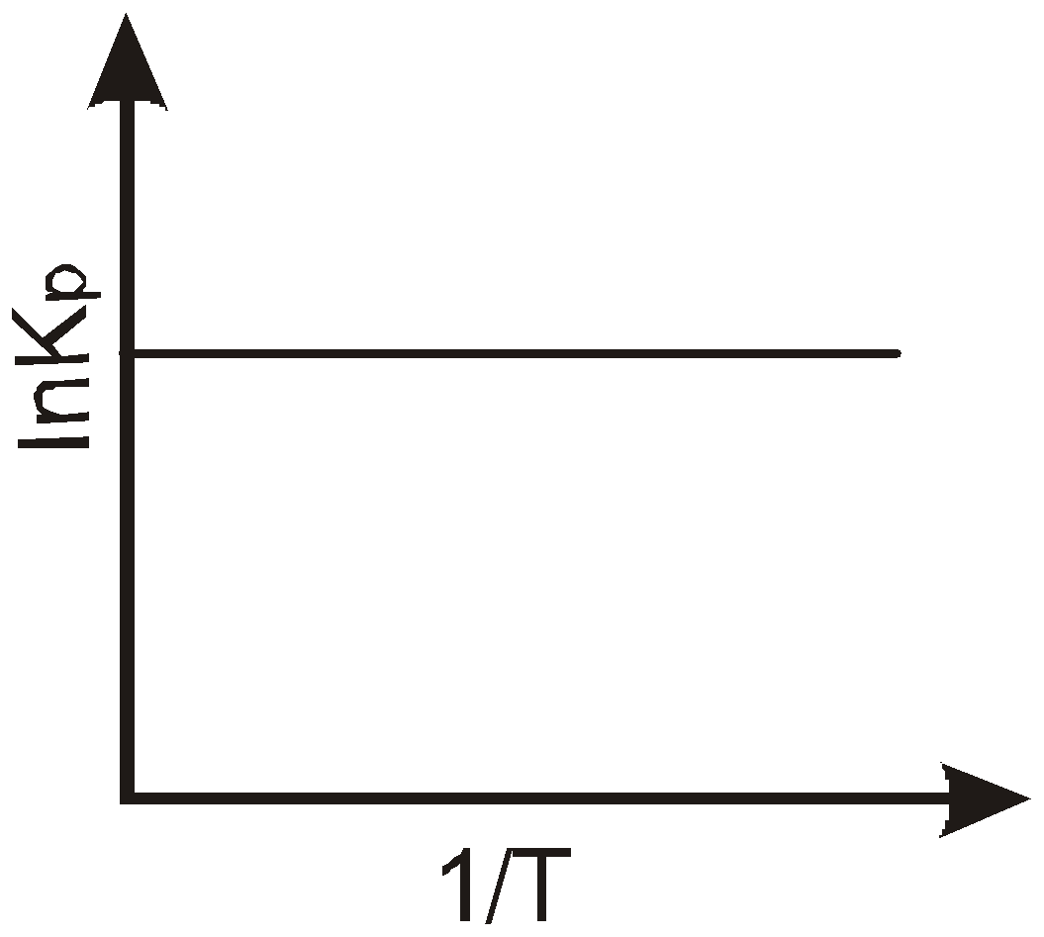 (2) 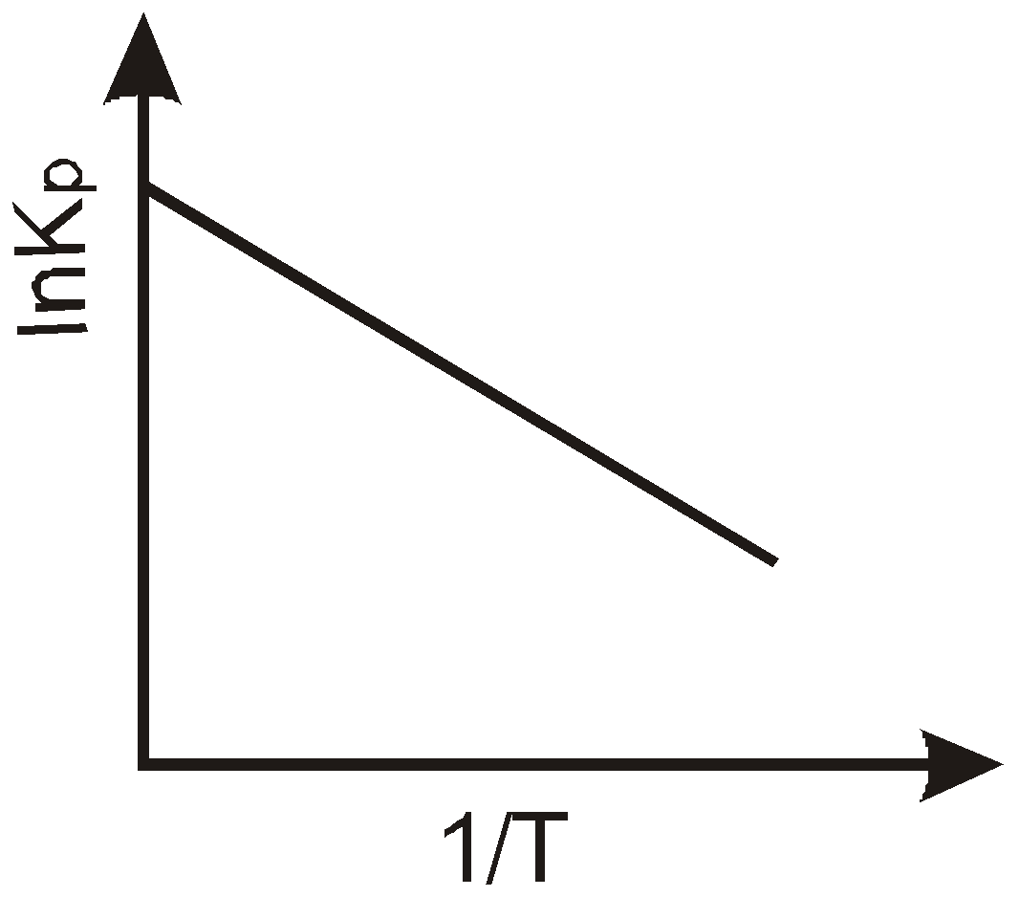 (3*) 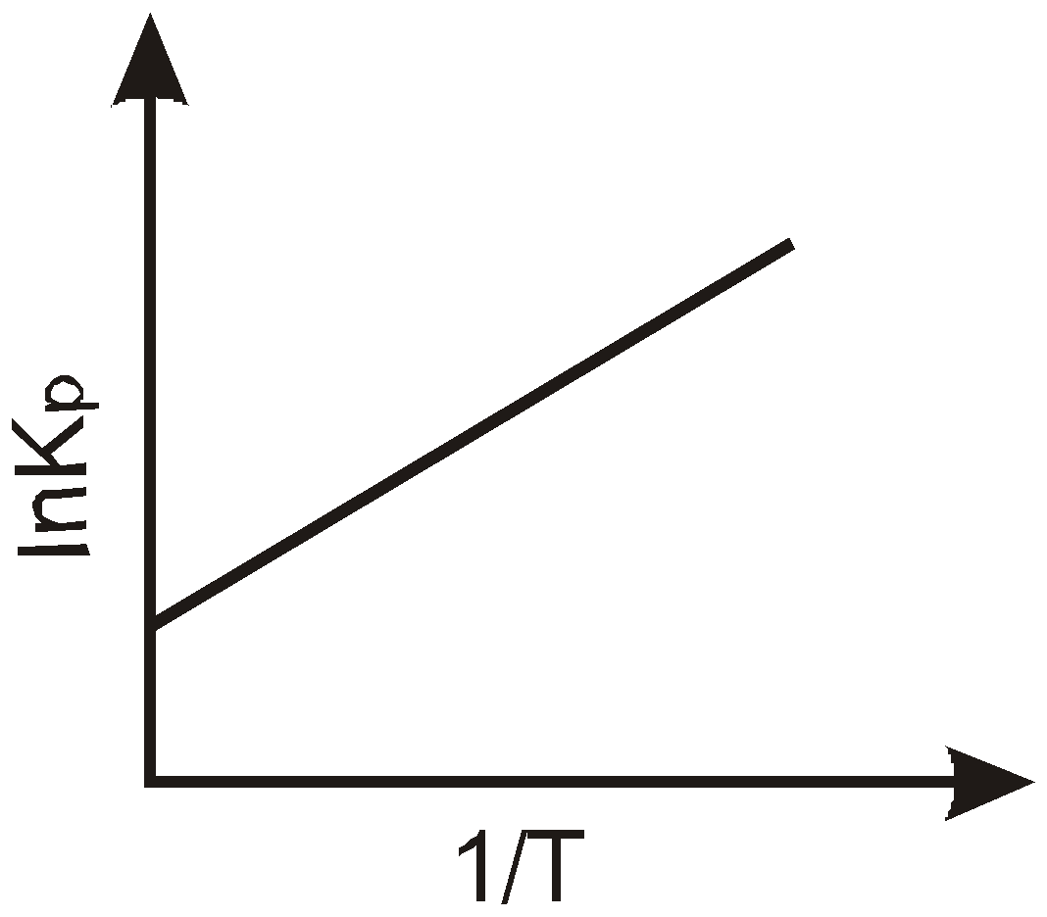 (4) None of these

F-6. An endothermic reaction is represented by the graph :
(1) (2*) (3) (4) None of these

F-7. The value of ΔG° for a reaction in aqueous phase having K_{c}= 1, would be:

(1) –RT (2) –1 (3*) 0 (4) + RT

F-10. The equilibrium constant for the reaction Br₂ 2Br at 500 K and 700 K are 1 × 10^{–10} and 1 × 10^{–5} respectively. The reaction is :
(1*) Endothermic (2) Exothermic (3) Fast (4) Slow

Sol. T K_{c} Endothermic

Section (G) : Le-chatelier's principle

G-1. A reaction in equilibrium is represented by the following equation –
2A_{(s)} + 3B_{(g)} 3C_{(g)} + D(g) + O₂ if the pressure on the system is reduced to half of its original value
(1) The amounts of C and D decreases (2*) The amounts of C and D increases
(3) The amount of B and D decreases (4) All the amounts remain constant

Sol. 2A(s) + 3B(g) 3C(g) + D(g) + O₂
If pressure on system is reduced to half its original value then equilibrium will shift in forward direction to increase no.of moles of gas to compensate reduction of pressure.
∴ Amounts of C & D will increase.

G-2. In which of the following equilibrium reactions, the equilibrium would shift to right side, if total pressure is decreased :

(1) N₂ + 3H₂ 2NH₃ (2) H₂ + I₂ 2HI
(3*) N₂O₄ 2NO₂ (4) H₂ + Cl₂ 2HCl
Sol. If total pressure is decrease equilibrium will shift in the direction in which no. of moles of gas will increase.
N₂O₂ 2NO₂

G-3. In a vessel containing SO₃, SO₂ and O₂ at equilibrium, some helium gas is introduced so that the total pressure increases while temperature and volume remain constant. According to Le-Chatelier principle, the dissociation of SO₃,
(1) Increases (2) Decreases (3*) Remains unaltered (4) None of these

Sol. 2SO_{2(g)}⁺ O_{2(g)} 2SO_{3(g)}
Inert gas addition has no effect at const. volume.

G-4. On cooling of following system at equilibrium CO₂(s) CO₂(g)
(1) There is no effect on the equilibrium state (2) More gas is formed
(3*) More gas solidifies (4) None of above

Sol. T↓, then V↓, then P↑, equilibrium shift in such direction so as to decrease pressure, i.e., Backward direction.

G-5. For an equilibrium H₂O(s) H₂O() which of the following statements is true.
(1) The pressure changes do not affect the equilibrium
(2*) More of ice melts if pressure on the system is increased
(3) More of liquid freezes if pressure on the system is increased
(4) The degree of advancement of the reaction do not depend on pressure.

Sol. If P↑, then V↓, then equilibrium will shift in a direction so as to increase volume i.e. forward direction more H₂O 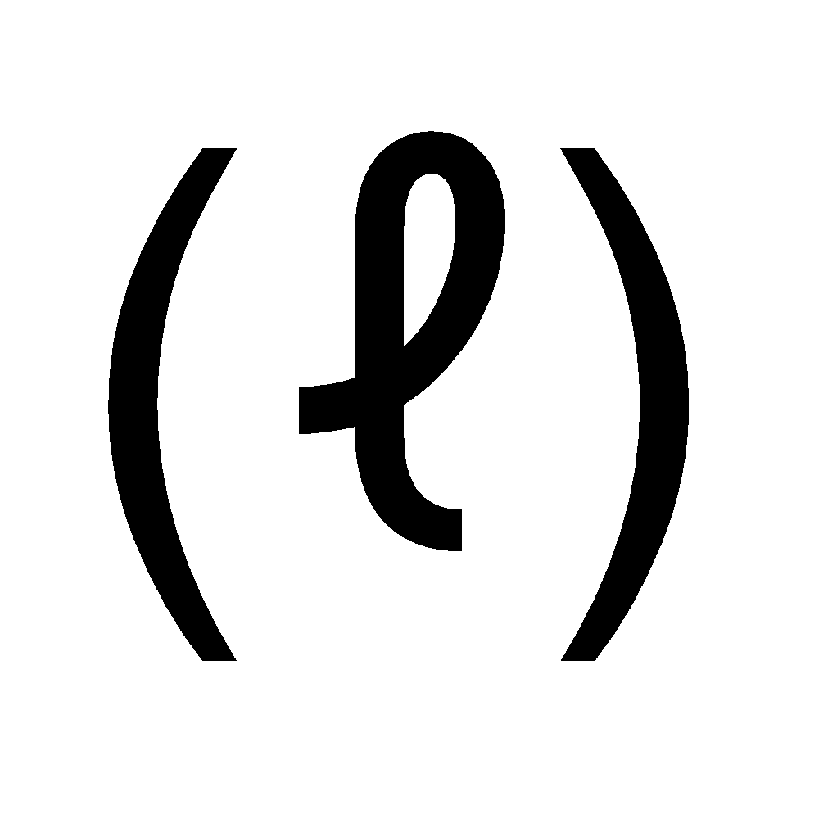will form.

G-6. In the Haber process for the industrial manufacture of ammonia involving the reaction,
N₂(g) + 3H₂(g) 2NH₃(g) at 200 atm pressure in the presence of a catalyst, a temperature of about 500ºC is used. This is considered as optimum temperature for the process because
(1) yield is maximum at this temperature
(2) catalyst is active only at this temperature
(3) energy needed for the reaction is easily obtained at this temperature
(4*) rate of the catalytic reaction is fast enough while the yield is also appreciable for this exothermic reaction at this temperature.

Sol. Rate of catalytic reaction is fast & yield is also appreciable for this exothermic reaction at this temperature.

G-7. The effect of increasing the pressure on the following equilibrium 2A + 3B 3A + 2B is -
(1) Forward reaction is favoured (2) Backward reaction is favoured
(3*) No effect (4) None of these

Sol. No. of moles are same on both sides, so no effect.

G-8. When NaNO₃(s) is heated in a closed vessel, O₂ is liberated and NaNO₂(s) is left behind. At equilibrium–
(1) Addition of NaNO₃(s) favours forward reaction (2) Addition of NaNO₂(s) favours reverse reaction
(3*) Increasing pressure favours reverse reaction (4) Decreasing temperature favours forward reaction

Sol. NaNO₃(g) NaNO₂ + 1/2 O₂(g)
↑ Pressure, reaction will shift in reverse direction so as to decrease pH effect.
G-9. aA + bB cC + dD
In above reaction low pressure and high temperature, conditions are shift equilibrium in back direction so correct set :
aA + bB cC + dD

Sol. aA + bB cC + dD
At high temp. & low pressure equilibrium is shifting in backward direaction. It means (a + b) > (c + d).

